Genes and metabolites to phenotypes:

eQTL mapping of glucosinolate production in Arabidopsis thaliana

Overview:

The first section of this practical used the scanone function to look for putative QTL that link the glucosinolate data to the genotype data for the population.

In the second section of this work we will now look at using variation in expression data as the trait data and use the scanone function to map putative eQTLs.

5 files are provided for the eQTL analysis section (download from module page):

bsrot.csv (the genotypes and expression data as the trait values)

BSATH2.coord.txt (the coordinates of the probes relative to the genetic map)

BSpgmap2.txt (the genetic map)

qtl.RData file (the results of running the eQTL analysis ** it would take too long for your computer to generate this file)

ArabidopsisLocusIDs file – lists all probes on the Affymetrix array with the genes that they probe for and descriptions of the genes

We will use the package ‘eqtl’ in R

library(eqtl)

For the eqtl analysis we need more information:

Again we need a cross object file (genotypes and the expression data as phenotypes) however we can not fit all the phenotypes onto the csv file as it is, so we use a csvr command to indicate that it’s a csv file but with the data matrix rotated:
(NB: the name assignments are not fixed; more what is useful to the user).

myCross<-read.cross("csvr", , "bsrot.csv", genotypes=c("A","B"))

class(myCross)[1] <- "riself"

To read in the physical coordinates of the probes:

myCoord<-read.table("BSATH2.coord.txt",header=T)

We can also use this to read in the genetic map of physical data of an Arabidopsis RIL population:

myPgMap<-read.table("BSpgmap2.txt",header=T)

Once the data is read in, we need to calculate the conditional genotype probabilities at each pseudo-marker, as in the QTL mapping earlier. We use sim.geno to simulate the sequences of genotypes from their joint probabilities.

## BSATH <- calc.genoprob(seed10, step=0.5, off.end=0, error.prob=0, map.function='kosambi', stepwidth='fixed')

## BSATH<- sim.geno(seed10, step=0.5, off.end=0, error.prob=0,map.function='kosambi', stepwidth='fixed')

We use the scanone function from Rqtl to perform our QTL analysis:

## myScan <- scanone(myCross,method='em',pheno.col=1:nphe(myCross),
+ model='normal')

or using HK which is faster:

## myScan <- scanone(myCross,method='hk',pheno.col=1:nphe(myCross),
+ model='normal')

To define the QTL with support LOD intervals from the scanone results (BaySha.em) use define.peak

myPeak <- define.peak(myScan,lodcolumn='all')

class(myPeak)

We have provided a *.RData file that contains the following:

myCoord = equivalent to BSATHcoord.txt
myCross = equivalent to Crossat.csv
myPgMap = equivalent to BSpgnap2.txt
myScan = scanone result,
myPeak= define.peak result and
myArray = the result of peak.2.array

In this case the calc.Rsq function was not run and the Rsq.2.array function was not used.

You can find some information about the operation done on peak object with the following commands
attributes(myPeak)$features
attributes(myPeak)$si # the support interval used
attributes(myPeak)$window # the exclusionary window in cM
attributes(myPeak)$scanone # that is the scanone used to create the peak object

In the data file is an updated version of the function “genoplot”.

To look for our genes of interest:

Gene Annotation Affymetrix expression probe ID

AOP2 At4g03060 255437_at
AOP3 At4g03050 255471_at
MAM1 At5g23010 249866_at
MAM2 At5g23020 249867_at

e.g. AOP2:

myPeak$X255437_at

myetrait.peak<- define.peak(myCross.hk,lodcolumn='X255437_at')

Selecting specific genes

> png(filename='AOP2.png',width=800,height=600)
> par(mfrow=c(1,5))
> define.peak(myScan, lodcolumn='X255437_at', graph=TRUE, chr=c(1:5))
> par(mfrow=c(1,1))
> dev.off()

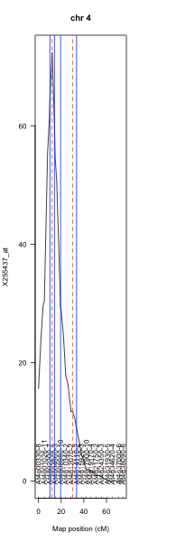

LOD profile for the phenotype ‘X255437_at’ (probe representing AOP2)

Or if you want to use just the target chromosome

> png(filename='AOP2.png',width=800,height=600)
> par(mfrow=c(1,5))
> define.peak(myScan, lodcolumn='X255437_at', graph=TRUE, chr=4)
> par(mfrow=c(1,1))
> dev.off()

It is best not to run genoplot at this stage since it can take some time to run, if you wish to use up a lot of your RAM overnight then you could try this (use the one in the .RData file).

The genoplot function returns graphical output for cis and trans acting QTL
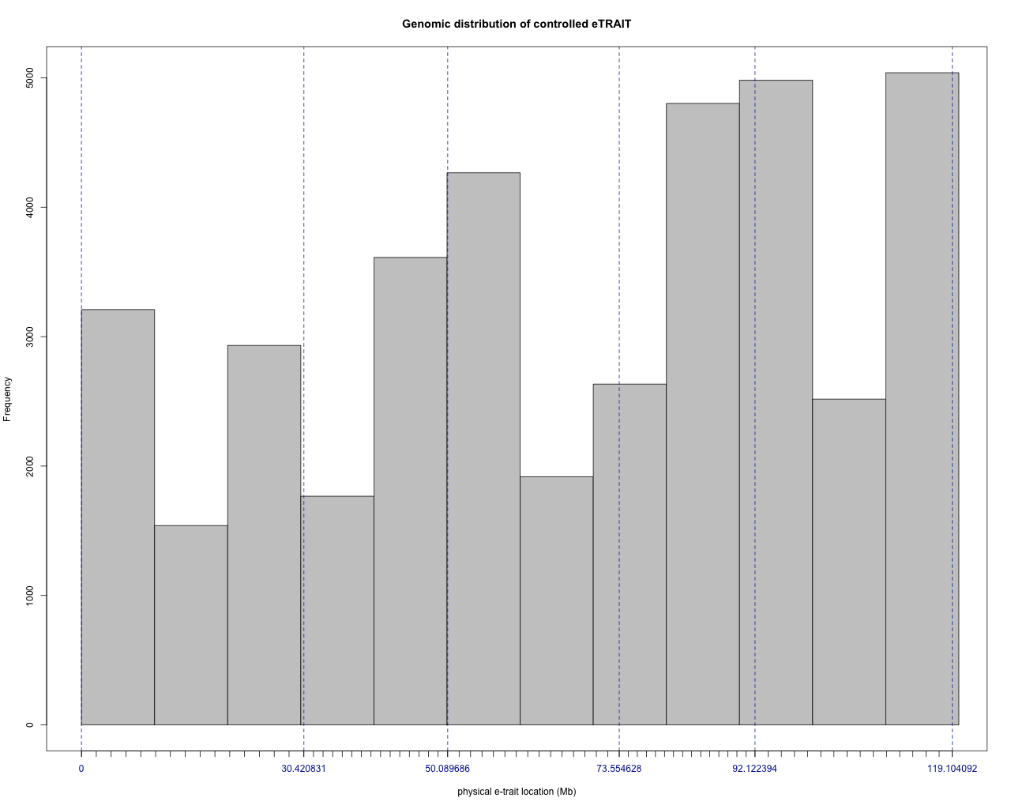

Genomic distribution of controlled eTrait
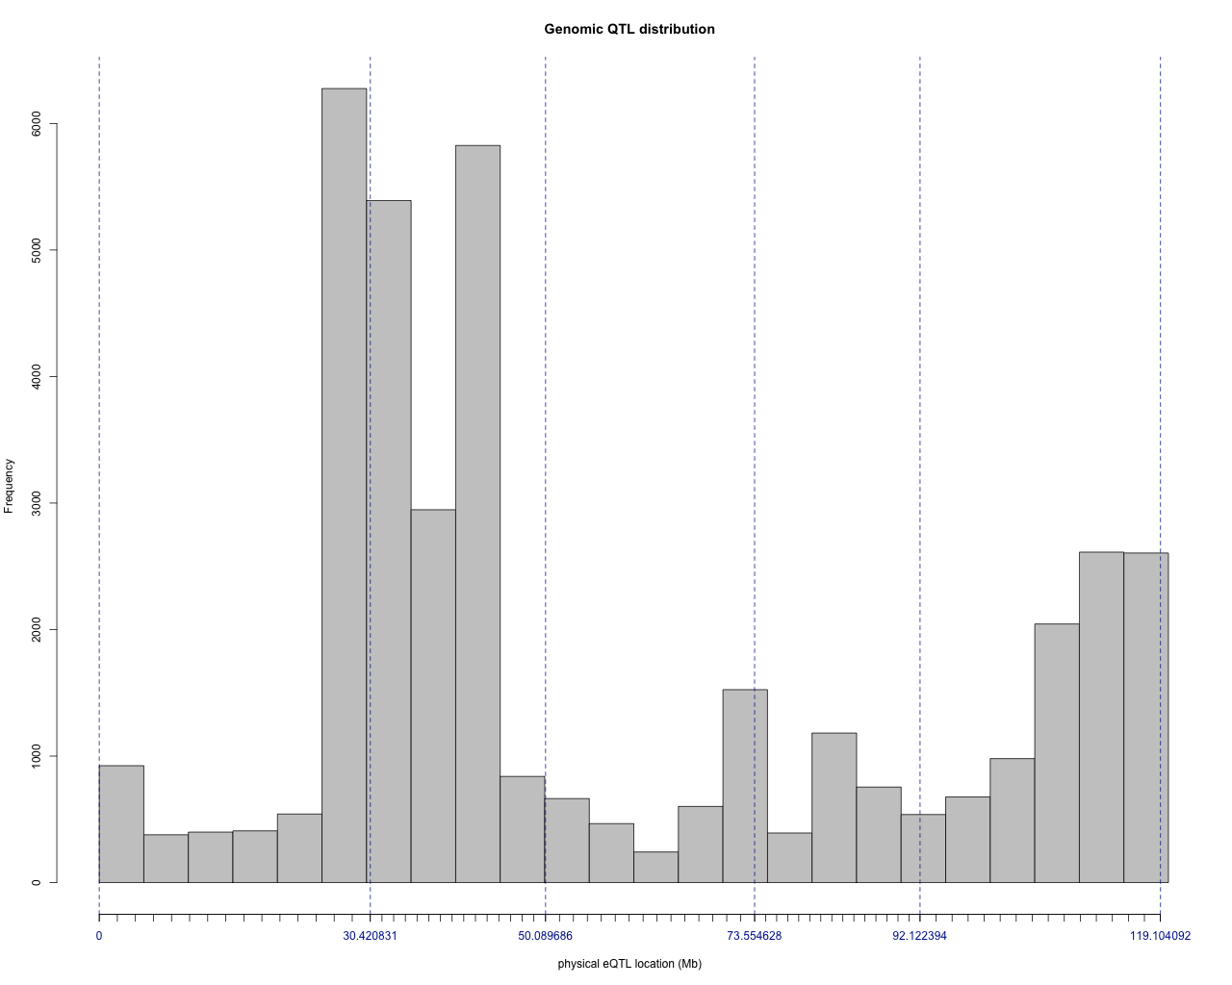

Genomic QTL distribution
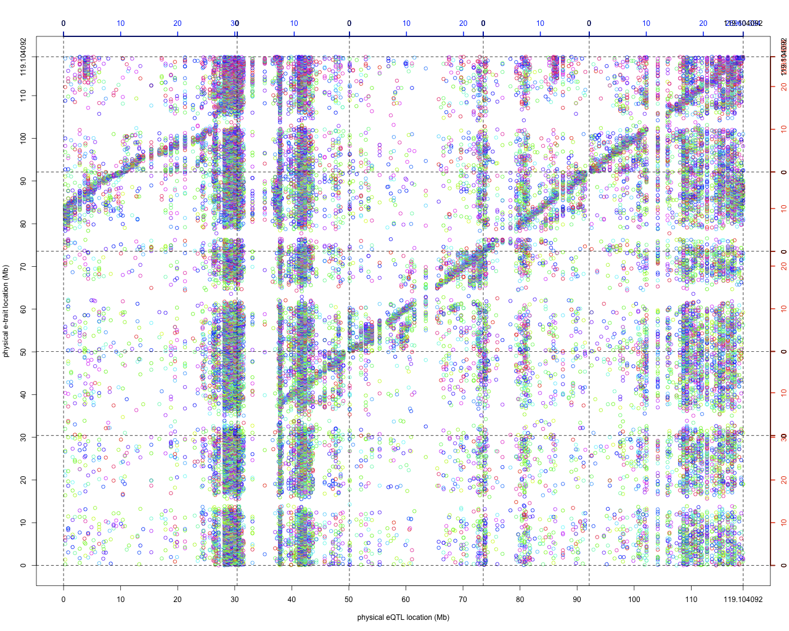
etrait x eQTL plot represented with LOD colour scale (green to red, with blue as the average score) plus an additive effect colour scale (green to red, yellow representing a null additive effect).

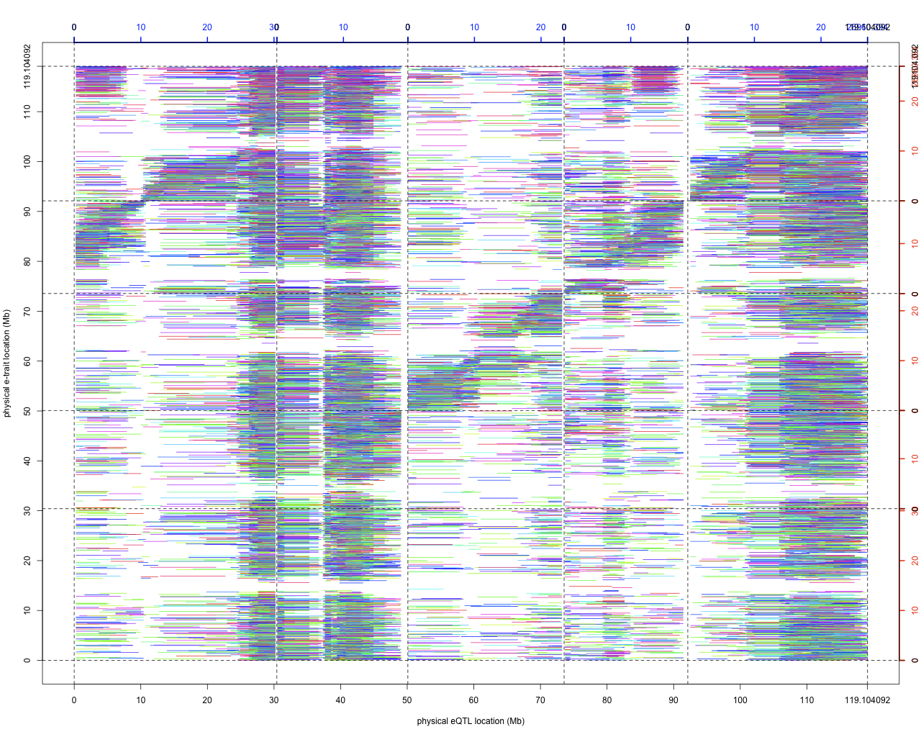
etrait x eQTL plot with eQTL confidence intervals; represented with LOD colour scale (green to red, with blue as the average score) plus an additive effect colour scale (green to red, yellow representing a null additive effect).

For all the etraits we can calculate a LOD significance threshold. This is performed using a permutation test.

>gpt(myCross, n_etrait=100, n_perm=1000)

n_perm of 100 might be a good place to start

Computes the Global Permutation Threshold which fits to a single-QTL scan (using scanone
function) by permuting the phenotypes while maintaining the genotype for a sample of individuals randomly chosen within an object of class cross. The GPT estimates the LOD score significance threshold if 1000 permutations at least are computed on 100 individuals at least (i.e. 100,000 permutations).

Notes

lod The peak’s LOD score.
mname.peak The maximum LOD peak’s (pseudo-)marker name.
peak.cM The maximum LOD peak’s genetic position in centiMorgan (cM).
mname.inf The (pseudo-)marker’s name corresponding to the inferior si bound.
inf.cM The genetic position of the inferior SI bound in centiMorgan (cM).
mname.sup The (pseudo-)marker’s name corresponding to the superior SI bound.
sup.cM The genetic position of the superior SI bound in centiMorgan (cM).

The subjective quality of the support interval

A QTL whose support interval can be reached and defined, has more weight than a QTL whose
support interval cannot and has been defined by its maximum size (argument m). This quality
information corresponds to symbols indicating, how each were defined by the bounds of the QTL support interval. The symbols on the right side gives the information for the superior SI bounds and so on for the left sided bounds:

’+’ indicates that the LOD-drop support interval has been reached.

’<-’ and ’->’ indicates that the LOD-drop SI hasn’t been reached before the maximum SI size
(defined by m argument) for the inferior and the superior bounds respectively.

’|’ indicates that the LOD-drop SI has been delimited by the beginning or the end of the LOD curve either for the inferior or superior bounds respectively. Therefore, the quality symbols ’|->’ indicates that the SI has been delimited on the left by the beginning of the LOD curve and on the right by the maximum SI size. Therefore, the drop of LOD score is not reached on either the left or right.

’+|’ indicates that the SI has been reached on the left but has been delimited on the right by the end of the LOD curve.

Symbols that are shown in some of the output

"++" - The QTL is bounded by a LOD-drop with both both SI sides reached.
"<->" - The QTL is bounded by the m parameter. The SI is not reached.
"+|" - The QTL is bounded by the end of the chromosome on the right and by a SI on the left.
"|+" - The QTL is bounded by the beginning of the chromosome on the left and by a SI on the
right.
"<-|" - The QTL is bounded by the end of the chromosome on the right and m/2 on the left.
"|->" - The QTL is bounded by the beginning of the chromosome on the left and m/2 on the right.

References:

Specific to this practical:

Wentzell et al. (2007) Linking Metabolic QTLs with Network and cis-eQTLs Controlling Biosynthetic Pathways. Plos Genetics 3(9): e162.

eqtl package manual (written by Hamid Khalili and annotated by Peter Walley).

General on eQTL analysis:

Klieberstein (2009) Quantitative Genomics: Analyzing Intraspecific Variation Using Global Gene Expression Polymorphisms or eQTLs. Annual Review Plant Biology 60:93–114.

