
Monitoring Points
In order to ensure that students are actively engaging with, and progressing on, their course of study the Department of Statistics in line with the revised University Good Practice Guide on Monitoring Student Attendance and Progress, has established a monitoring points scheme by reference to which a student’s performance during the academic year will be assessed. Students start the year with a clean sheet, but can lose points if, for example, they fail to attend tutorials or meet with their personal tutor.
A student who misses one or more of these points will be reported to the University, unless he or she has provided acceptable mitigating evidence to explain why the monitoring point was missed. Such evidence may include the submission of a satisfactory medical note or self-certification for illness lasting less than 1 week etc. Please see the Department's procedures for requesting authorised absence.
Students who miss three monitoring points in an academic year will receive a letter from the Academic Office of the University reminding them of their obligations to actively engage with their course. Students will also receive an email and letter from the Department with a slip that must be signed by their personal tutor at their next Personal tutor meeting. The signed slip needs to be returned to the UG Support office. Students subject to immigration control will additionally be reminded that they may be jeopardizing their leave to remain in the UK.
Students who miss six monitoring points in an academic year will receive a more strongly worded letter setting out the steps which will be taken if their engagement with the course does not improve immediately. The students will also receive an email/letter from the Department asking them to meet with the senior tutor. Appointments can be booked via the UG Support office and again, a slip needs to be signed and returned to the UG Support office. Failure to meet the requirements of a course of study may result in a student being required to leave the University. Students subject to immigration control will additionally be required to attend an interview with the Immigration Service in the International Office.
A list of your monitoring points can be accessed using your Tabula account (https://tabula.warwick.ac.uk). Click on the tab labelled ‘My Monitoring Points’ to show the webpage. These will be updated at regular intervals so you can view how many points have been passed/missed on Tabula as well as how many have been excused due to illness etc.
If you are unable to attend a tutorial, it is your resposibility to report your absence to the UG Support office. This needs to be done before the tutorial takes place. Similarly, if you attend another session i.e. not the one registered on Tabula, it is your responsibility to tell the UG Support office before it is due to take place. If you are intending to swap your tutorial permanently, you need to ask the UG Support office to make the change on Tabula for you. If the above is not done, the monitoring will be set as ‘missed (unauthorised)’ and will not be changed.
Any medical evidence needs to be submitted to the UG Support office. This can be handed in after the tutorial, providing an email/phone call has been received before the tutorial is due to take place.
P.T.O

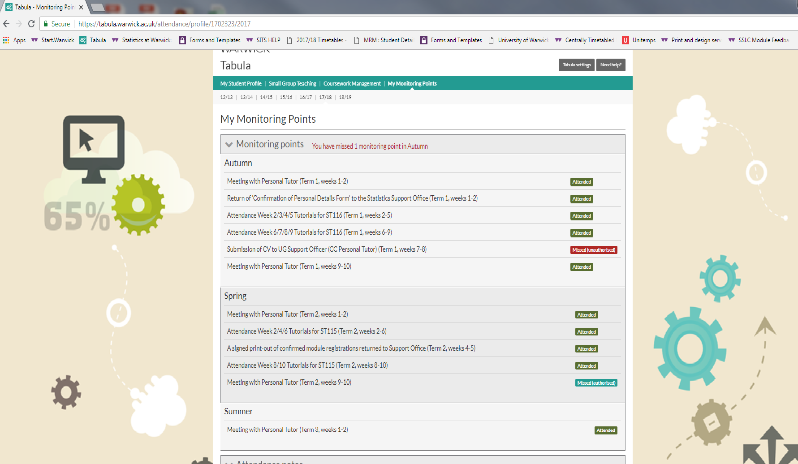
(See above screenshot)
Monitoring points for all three terms are listed on the ‘My monitoring points’ screen on Tabula. Each point details what must be met/done before the point can be set as attended. An example is below:
Attendance Week 2/3/4/5 Tutorials for ST116 (Term 1, weeks 2-5) | Students must attend all tutorials between weeks 2-5 in term 1 for ST116. If a student misses 1 tutorial, the point will be set as missed.
Meeting with Personal Tutor (Term 1, weeks 1-2) | Students needed to book a meeting with their personal tutor. The Personal Tutor will confirm with the office when the meeting has taken place.

A list of all 1st year monitoring points can be found on the next page.

1st Year Monitoring Points:
Term 1
Point | Weeks | Requirements
Meeting with personal tutor in weeks 1 or 2 | 1&2 | Arrange a meeting with your personal tutor
Attendance Week 2/3 Tutorials for ST116 | 2&3 | 100% Mandatory Attendance
Attendance Week 4/5Tutorials for ST116 | 4&5 | 100% Mandatory Attendance
Attendance Week 6/7 Tutorials for ST116 | 6&7 | 100% Mandatory Attendance
Attendance Week 8/9Tutorials for ST116 | 8&9 | 100% Mandatory Attendance
Personal tutor meeting to discuss CV (9&10) | 9&10 | Arrange a meeting with your personal tutor and produce a CV in preparation for meeting.

Term 2
Point | Weeks | Requirements
Meeting with personal tutor in weeks 1 or 2 | 1&2 | Arrange a meeting with your personal tutor
A signed print-out of confirmed module registrations to be returned to the Statistics Support Office by Thursday, Week 5 | 5 | Print and sign a copy of your module registrations and hand in to the UG office by Thursday in Week 5 (7/2/2019)
Attendance Week 2/4/6 Tutorials for ST115 | 2,4&6 | 100% Mandatory Attendance
Attendance Week 8/10 Tutorials for ST115 | 8&10 | 100% Mandatory Attendance
Meeting with personal tutor during weeks 9 or 10 | 9&10 | Arrange a meeting with your personal tutor

Term 3
Point | Weeks | Requirements
Attendance at ST104 Summer Examination | TBC | Attend and sit the ST104 exam in term 3.

- Attendance at Personal Tutor meetings with be recorded by the tutor and submitted to the UG Support office.
- Attendance at the tutorials will be recorded by the tutor and submitted online via Tabula. If you are attending a tutorial you are not registered for, please inform the UG support office before or immediately after the tutorial. If this is not done, you will be recorded as absent.
- Attendance at the ST104 Summer Examination will be done by the invigilators at the exam and passed to the UG Support Office.
- Students will be reminded via their warwick.ac.uk email address when the CV/ printed and signed module registration form are due.

