Title in lower case letters except for first word and proper nouns
Firstname Firstauthorfamilyname^{1(a)}, Firstname Secondauthorfamilyname^{2(b)} and Firstname Thirdauthorfamilyname²
¹ Author’s Institute, Author’s University - Street and number, Postal Code City, Country
² Another Institute, Another University - P.O. Box, City, Country

received and accepted dates provided by the publisher
other relevant dates provided by the publisher

PACS nn.mm.xx – First pacs description
PACS nn.mm.xx – Second pacs description
PACS nn.mm.xx – Third pacs description

Abstract – Insert your abstract here. No quotation of references is allowed in the abstract.

First section heading. – This is the bodytext. This is the bodytext. This is the bodytext. This is the bodytext. This is the bodytext. This is the bodytext.

Section heading followed immediately by. –

A subsection. This is the bodytext. This is the bodytext. This is the bodytext. This is the bodytext.

And another subsection. This is the bodytext. This is the bodytext. This is the bodytext. This is the bodytext. This is the reference to table 1. This is the bodytext. This is the bodytext. This is the bodytext.
This is the bodytext. This is the bodytext. This is the bodytext. This is the bodytext. This is the bodytext. This is the bodytext. This is the bodytext. This is the bodytext. This is the bodytext. This is the bodytext. This is the bodytext. This is the bodytext. This is the bodytext. This is the bodytext. This is the bodytext. This is the bodytext.

(1)

This is the bodytext. This is the bodytext. This is the bodytext. This is the bodytext. This is the bodytext. This is the bodytext. This is the bodytext.

Third section heading. – This is the bodytext [1]. This is the bodytext. This is the bodytext [2,3].

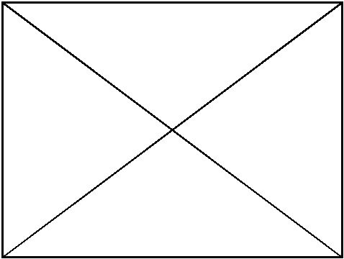
Fig. 1: (Colour on-line) to be added for all figures to appear in colour in the on-line version only. This is the figure caption.

Table 1: The caption of the table.
Description 1^{(a)} | Description 2 | Description 3
Row 1, Col 1 | Row 1, Col 2 | Row 1, Col 3
Row 2, Col 1 | Row 2, Col 2 | Row 2, Col 3
^{(a)} The legend of the table.

This is the bodytext. This is the reference to fig. 1. This is the bodytext [3-6]. This is the bodytext. This is the bodytext. This is the bodytext. This is the bodytext. This is the bodytext.

***
Acknowledgments to be inserted before references.
REFERENCES
[1] Firstauthorfamilyname F. M., Secondauthorfamilyname P. G. D. and Lastauthorfamilyname C., Abbreviated journal name, volume (year) page.
[2] Examplename F. and Anotherauthorname I. E., Phys. Status Solidi A, 1 (2050) 111.
[3] Firstauthorname A., Secondauthorname B. and Thirdauthorname C., Here Goes the Title of the Book (Publisher, City) year, p. 111.
[4] Firstauthorname A., Secondauthorname B. and Thirdauthorname C. (Editors), Here Goes the Title of the Edited Book (Wiley-VCH, Berlin) 2050, p. 111.
[5] Contributorname D., in The Title of the Book, edited by Firsteditorname A., Secondeditorname B. and Thirdeditorname C., Followed by the Title of the Series of Books, Vol. 1 (Publisher, City) year, Chapt. 1, p. 111.
[6] Examplename F. and Anotherauthorname I. E., in Proceedings 1st XXXX Conference on Citation Formatting, City, Country, year, Part A (Publisher, City) year, pp. 1–11.

