Objectives
• Find out what is inside a battery
• Look at how chemical reactions can store energy
• Explore how battery research can help us stop climate change
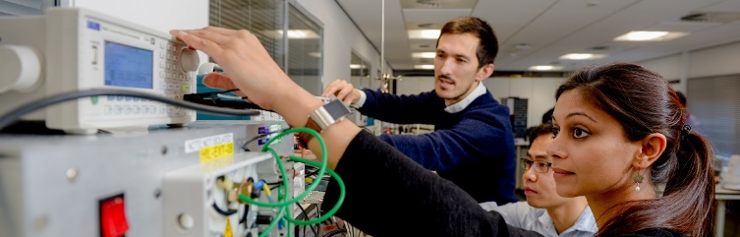

Watch the first video where Anisha describes what the insides of a battery are like.

Task: Make notes in this box about Anisha’s talk and answer the three questions below.
Click or tap here to enter text.

Questions
1— Which particle does Anisha say has to move to generate electricity?

Electrons ☐ Protons ☐ Neutrons ☐

2— Which gas is the leading cause of global warming?
Carbon Dioxide ☐ Methane ☐ Nitrogen ☐

3— Describe what happens when the battery is short circuited.

Click or tap here to enter text.

Objectives
• Find out what is inside a battery
• Look at how chemical reactions can store energy
• Explore how battery research can help us stop climate change


Watch the second video where Melanie describes how batteries have revolutionised technology in the last 30 years.

Task: Make notes in this box about Melanie’s talk and answer the three questions below.
Click or tap here to enter text.

Questions
1— Which element has been crucial to the revolution in battery technology?

Lithium ☐ Chlorine ☐ Hydrogen ☐
Li
7
3
Pb
207
82
2— Looking at a periodic table, can you think of an advantage of using lithium (Li) instead of lead (Pb)? Melanie mentions this as one of the reasons lithium is used in batteries.

Click or tap here to enter text.

3— What year was the first electric vehicle made?

Choose an item from this drop down box.

Objectives
• Find out what is inside a battery
• Look at how chemical reactions can store energy
• Explore how battery research can help us stop climate change
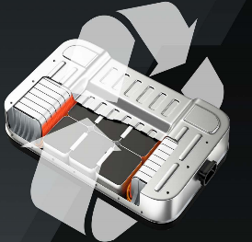

Watch the third video where Puja explains what a circular economy is and discusses what happens when all these batteries get old.

Task: Make notes in this box about Puja’s talk and answer the three questions below.
Click or tap here to enter text.

Questions
1— Describe the concept of a ‘circular economy’ that Puja mentions.

Click or tap here to enter text.

2— Why can’t we put batteries into landfill?

Click or tap here to enter text.

3— We’ve mentioned lithium already – so write down two more materials that Puja describes as ‘valuable materials’ in batteries.

Valuable material 1 Valuable material 2

Objectives
• Find out what is inside a battery
• Look at how chemical reactions can store energy
• Explore how battery research can help us stop climate change


Watch the fourth and final video where Evé talks about how energy storage might help us make all our electricity renewable.

Task: Make notes in this box about Evé’s talk and answer the three questions below.
Click or tap here to enter text.

Questions
1— Why does the energy produced by wind and solar power go up and down each year?

Click or tap here to enter text.

2— Evé mentions an application that is perfect for the kind of power that batteries can output. What is it?

Boiling a kettle ☐ Lighting street lights ☐

3— Given your answer to Q1 and Evé’s talk, explain why energy storage will be important to making renewable electricity generation really successful.

Click or tap here to enter text.

