Inside my mobile

Find out what is inside a mobile phone by building your own paper model.

- Create your own mobile phone by folding the second page in half and half again.

- Cut out the components below and find out where they fit in your mobile phone.

- Design an app for your mobile phone using the ‘my app’ page.

Things that are inside my mobile phone:




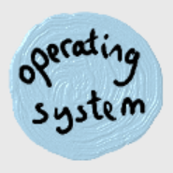
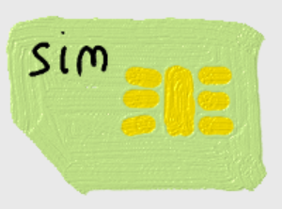


This can be easily turned into a 2 player game using a dice and two copies of the activity sheet. Take turns throwing the dice, to collect parts of your own phone: 6 = CPU, 5 = Memory, 4= Battery, 3 = Sim, 2 = Camera, 1 = Operating System


“Inside my mobile” resources created by Margaret Low,
WMG, University of Warwick. M.j.low@warwick.ac.uk
www.warwick.ac.uk/wmgoutreach/technology
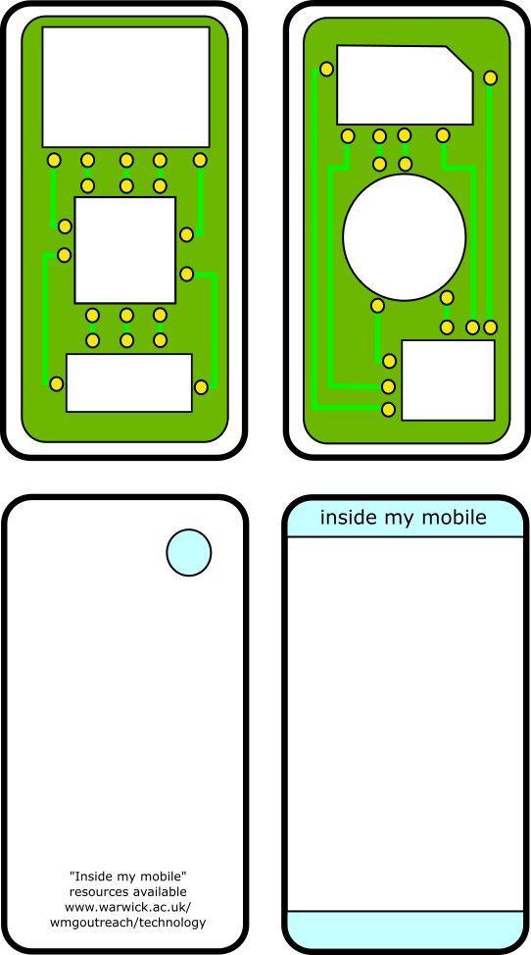

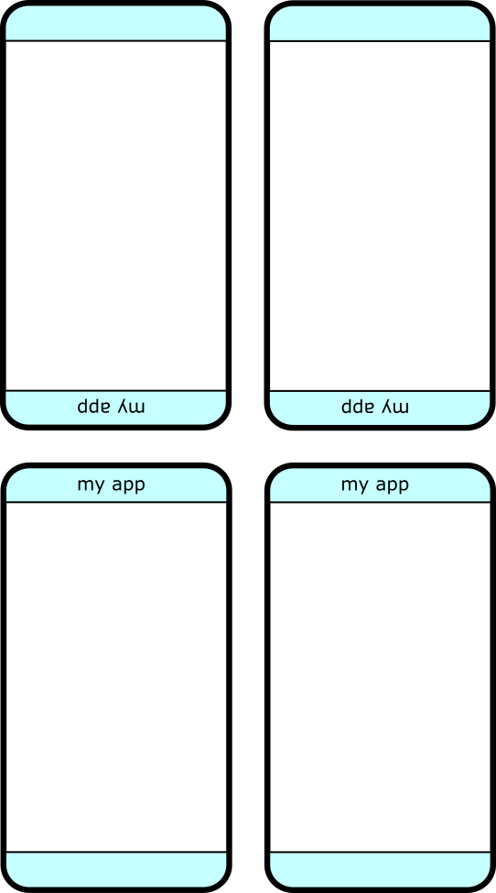

Game: Things that are inside my mobile phone. With a partner, take turns at throwing a dice to collect key pieces to complete your own mobile phones.

6 =

5 =

4 =

3 =

2 =

1 =

“Inside my mobile” resources created by Margaret Low,
WMG, University of Warwick. M.j.low@warwick.ac.uk
www.warwick.ac.uk/wmgoutreach/technology

