The Fireplace

Decorated Pop-up Card

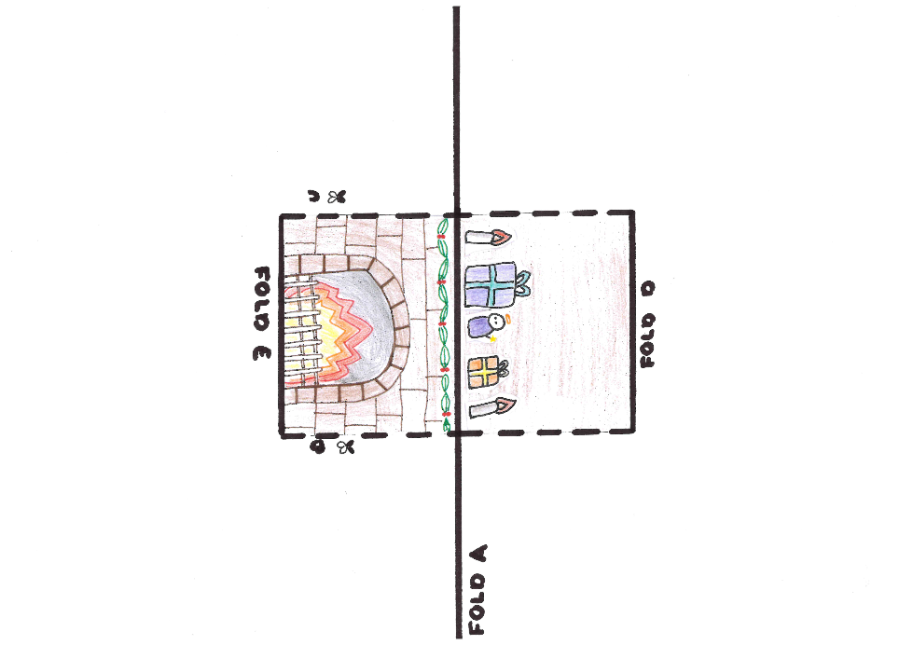
The template:

Instructions:
- Find the printed version of the card shown in the image above.
- Fold the card over the solid line A. Make sure your creases are really firm by running a ruler over them! Keep the page folded and hold it so you can see the side with the printed lines.
- Cut the page along dotted lines B and C.
- Fold the cut sections along lines D.
- Turn the card over.
- Fold the cut sections along lines E.
- Open the card back out.
- Gently fold the card along line A so the printed pattern is inside.
- Open the card back out halfway. You should be able to see the pattern printed.
- Push the cut sections from the back of the card towards you so they pop out towards you.
- Gently fold the card closed.
Optional:
- Cut out the additional items for the mantelpiece.
- Fold along the dotted line, and glue or tape the bottom tab onto the mantlepiece.
