Gingerbread People

Decorated Pop-up Card

The template:
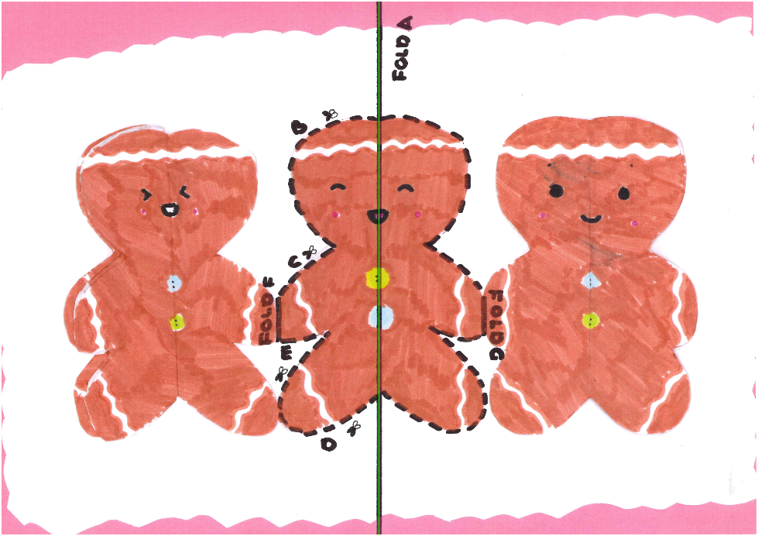

Instructions:
- Find the printed version of the card shown in the image above.
- Fold the card along the solid line A. Make sure your creases are really firm by running a ruler over them!
- Cut the page along dotted lines B, C, D, and E.
- Fold the cut sections along lines F and G.
- Turn the card over.
- pen the card back out.
- Gently fold the card along line A so the printed pattern is inside.
- Open the card back out halfway. You should be able to see the pattern printed.
- Push the cut sections from the back of the card towards you so that they pop out towards you.
- Gently fold the card closed.
Optional:
- Decorate the card
- Stick a piece of paper to the back of the card.

