The Bow

Decorated Pop-up Card

The template:
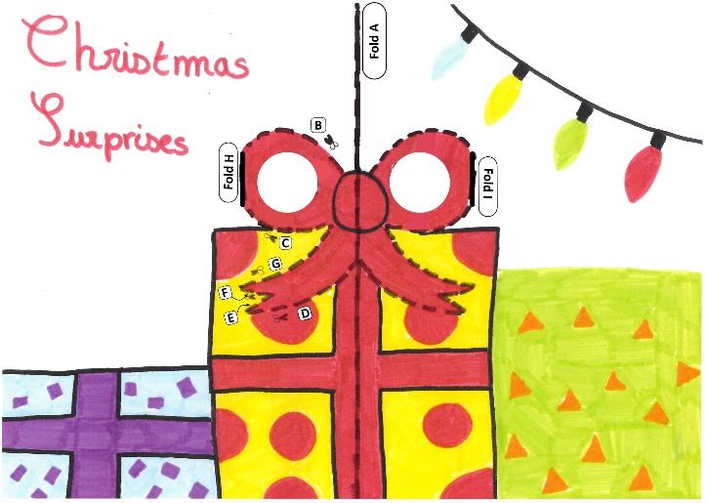

Instructions:

- Find the printed version of the card shown in the image above.
- Fold the card over the solid line A. Make sure your creases are really firm by running a ruler over them! Keep the page folded and hold it so you can see the side with the printed lines.
- Cut along line B.
- Cut along lines D, E, F, G and then C to finish the bow.
- Lift the bow section upwards and fold over line H.
- Flip the card over and fold the bow over line I.
- Open the card out.
- Gently fold the card along line A so the printed pattern is inside.
- Open the card back out halfway. You should be able to see the pattern printed.
- Push the cut sections from the back of the card towards you so that they pop out towards you.
- Gently fold the card closed.

Optional:
- Decorate the card
- Stick a piece of paper to the back of the card.

