Santa

Decorated Pop-up Card

The template:
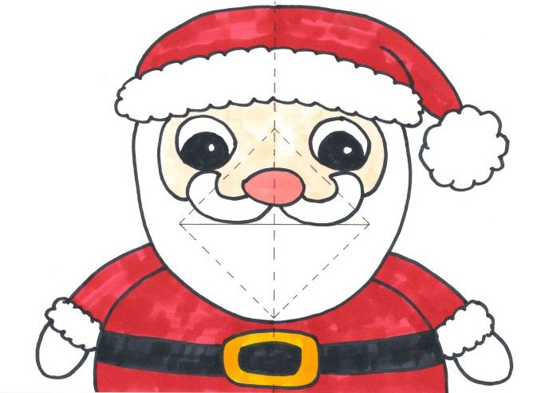
A
D
C
B

Instructions:
- Find the printed version of the card shown in the image above.
- Fold the card over the centre dotted line A. Make sure your creases are really firm by running a ruler over them! Keep the page folded and hold it so you can see the side with the printed lines.
- Cut along line B
- Fold a triangle by pulling the top half of the 'mouth’ towards you and folding over line C.
- Fold another triangle by pulling the bottom half of the ‘mouth’ towards you and folding it over line D.
- Flip the card over and fold the top half of the 'mouth’ over itself.
- Fold the bottom half of the ‘mouth’ over itself.
- Open the card out
- Gently fold the card along line A so the printed pattern is inside.
- Open the card back out halfway. You should be able to see the pattern printed.
- Push the cut sections from the back of the card towards you so that they pop out towards you.
- Gently fold the card closed.
Optional:
- Decorate the card.
- Stick a piece of paper to the back of the card.

