Snowflake 2

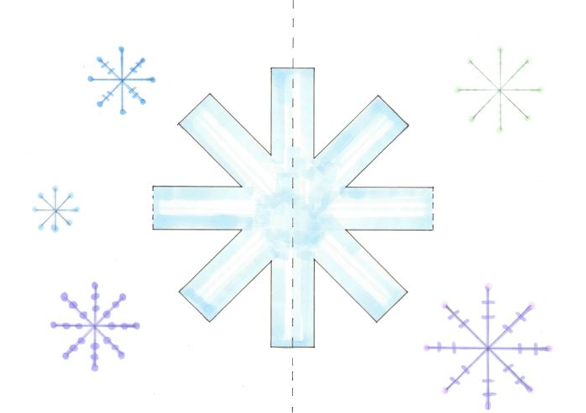
Decorated Pop-up Card

The template:
A

C
B

Instructions:
- Find the printed version of the card shown in the image above.
- Fold the card over the centre dotted line A. Make sure your creases are really firm by running a ruler over them! Keep the page folded and hold it so you can see the side with the printed lines.
- Cut along the solid lines of the centre snowflake. Stop cutting when you get close to dotted lines B and C.
- Lift the snowflake section upwards and fold over line B.
- Flip the card over and fold the snowflake over line C.
- Open the card out
- Gently fold the card along line A so the printed pattern is inside.
- Open the card back out halfway. You should be able to see the pattern printed.
- Push the cut sections from the back of the card towards you so that they pop out towards you.
- Gently fold the card closed.

Optional:
- Decorate the card, add glitter
- Stick a piece of paper to the back of the card.

