The Snowflake

Decorated Pop-up Card

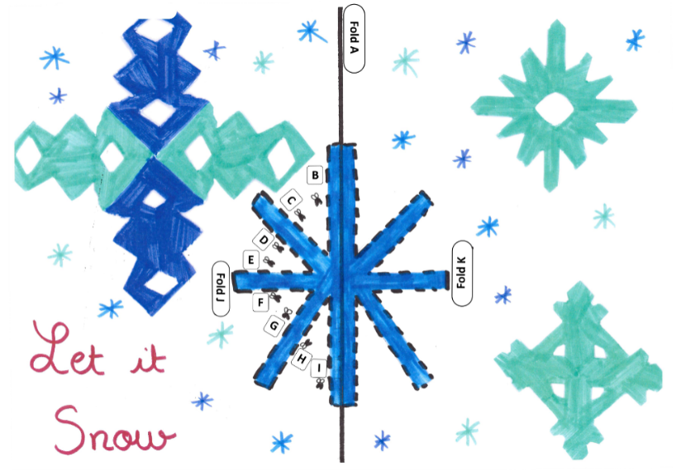
The template:

Instructions:
- Find the printed version of the card shown in the image above.
- Fold the card over the solid line A. Make sure your creases are really firm by running a ruler over them! Keep the page folded and hold it so you can see the side with the printed lines.
- Cut along lines B, C, D and E. Stop cutting when you get close to line J.
- Cut along lines I, H, G and F. Stop cutting when you get close to line J.
- Lift the snowflake section upwards and fold over line J.
- Flip the card over and fold the snowflake over line K.
- Open the card out
- Gently fold the card along line A so the printed pattern is inside.
- Open the card back out halfway. You should be able to see the pattern printed.
- Push the cut sections from the back of the card towards you so that they pop out towards you.
- Gently fold the card closed.

Optional:
- Decorate the card
- Stick a piece of paper to the back of the card.
- Cut out the additional snowflakes
- Put some glue only in the centre of the existing printed design and paste the snowflakes on top.

