The Snowmen

Decorated Pop-up Card

The template:
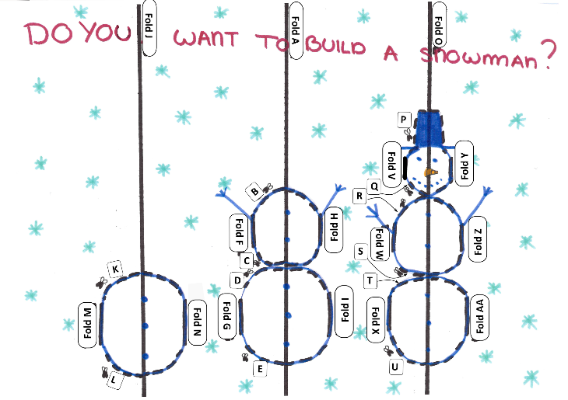

Instructions:
- Find the printed version of the card shown in the image above.

Creating the middle snowman:
- Fold the card over the solid line A. Make sure your creases are really firm by running a ruler over them! Keep the page folded and hold it so you can see the side with the printed lines.
- Cut along line B, then cut line C, now cut line D and finally cut line E.
- Lift the top snowman section upwards and fold over line F.
- Lift the bottom snowman section upwards and fold over line G.
- Flip the card over and fold the top section over line H and the bottom one over line I.
- Open the card out
Creating the left snowman
- Fold the card over the solid line J. Make sure your creases are really firm by running a ruler over them! Keep the page folded and hold it so you can see the side with the printed lines.
- Cut along line K and then cut along line L.
- Lift the snowman section upwards and fold over line M.
- Flip the card over and fold the section over line N.
- Open the card out

(Please turn over)

Creating the right snowman
- Fold the card over the solid line O. Make sure your creases are really firm by running a ruler over them! Keep the page folded and hold it so you can see the side with the printed lines.
- Cut along lines P, Q, R, S, T and U.
- Lift the top snowman section upwards and fold over line V.
- Lift the middle snowman section upwards and fold over line W.
- Lift the bottom snowman section upwards and fold over line X.
- Flip the card over and fold the top section over line Y, the middle section over line Z and the bottom one over line AA.
- Open the card out.
Assemble the card
- Gently fold the card along line A so the printed pattern is inside.
- Open the card back out halfway. You should be able to see the pattern printed.
- Push the cut sections from the back of the card towards you so that they pop out towards you.
- Repeat the same process along lines J and O.
- Gently fold the card closed.
Optional:
- Decorate the card
- Stick a piece of paper to the back of the card.

