Project Submission Pro-Forma

(to be bound in front of the submitted Dissertation)

NAME: ……………………………………………………………………

Student ID: …………………………………………………………………….

I wish the dissertation to be considered for (tick one only)

MSc in Cybersecurity Engineering 
MSc in Cybersecurity & Management 
MSc in e-Business Management 
MSc in Engineering Business Management 
MSc in Healthcare Operations Management 
MSc in Innovation & Entrepreneurship 
MSc in International Trade Strategy & Operations 
MSc in International Technology Management 
MSc in Management for Business Excellence 
MSc in Manufacturing Systems Engineering & Management 
MSc in Programme & Project Management 
MSc in Service Management & Design 
MSc in Supply Chain & Logistics Management 
MSc in Sustainable Automotive Engineering 

I have checked that my modules meet the requirements of the above award 

I confirm that I have included in my dissertation:

An abstract of the work completed 
A declaration of my contribution to the work and its suitability for the degree 
A table of contents 
A list of figures & tables (if applicable) 
A glossary of terms (where appropriate) 
A clear statement of my project objectives 
A full reference list 

I am willing for my marked dissertation to be used for staff training purposes 

Signed: ……………………………………………. Date: ………………..

PROJECT TITLE

by

John Smith, BSc
(Student Number)

Dissertation submitted in partial fulfilment for the Degree of Master of Science in delete this text and enter your degree title here

name/department of collaborating partner if applicable |  | WMG  University of Warwick

Submitted month, year

Abstract

This section should not extend beyond a single A4 side, and to facilitate this, single spaced typing is permitted for the summary only. The purpose of the summary according to Hussey and Hussey (1997 p. 286) is:

- “to introduce the topic
- to describe how you did the research
- to discuss the results of what was done
- to explain the implications of the results.”
There should be nothing in this section which is not covered in the main body of the dissertation somewhere

Acknowledgements

This section is optional – it should be short and thank those who have helped you with your project. It is particularly important to thank any companies that have provided assistance.

Declaration

I have read and understood the rules on cheating, plagiarism and appropriate referencing as outlined in my handbook and I declare that the work contained in this assignment is my own, unless otherwise acknowledged.

No substantial part of the work submitted here has also been submitted by me in other assessments for this or previous degree courses, and I acknowledge that if this has been done an appropriate reduction in the mark I might otherwise have received will be made.

Signed candidate__________________________________________________

You are required to justify your submitted thesis against the degree definition for which you are registered. This needs to be downloaded and pasted into the box below.

Project definition for my degree (as copied from http://www2.warwick.ac.uk/fac/sci/wmg/globalcontent/general/project/requirement/)

PASTE THE PROJECT DEFINITION FOR YOUR DEGREE HERE INSTEAD OF THIS SENTENCE

My project relates to this definition in the following way:

This section should also be deleted before submission:

Below are some approaches that you could take to do this but others may be equally acceptable.
- indicate how this project will help if you gained employment in the area covered by the definition
- Show how the thesis contributes to the general understanding of the area covered by the above definition
- Show how the outcomes of your work would help others gain a deeper or new understanding in the area show in the definition.
In most cases referring to other people’s published material would not be sufficient to justify your work. You should concentrate on what you have contributed or achieved

This declaration should be limited to no more than ONE page

Contents
Chapter 1 Introduction 4
1.1 Broad view of the general research area 4
1.2 Explanation of how your research fits into this broad area – 4
1.3 The research question, hypotheses and the specific objectives of your research – 4
1.3.1 A sub-sub-heading 4
Chapter 2 A Justification of the Research Methods Used 4
Chapter 3 Review of Literature 4
Chapter 4 Results 4
Chapter 5 Analysis 4
Chapter 6 Discussion 4
Chapter 7 Conclusions 4
Chapter 8 Future Work 4
References 4
Bibliography (if required) 4

List of Figures
Figure 3.1 Money on trees (source xx) 4

List of Tables
Table 3.1 Information in a table 4

Introduction

The Introduction Chapter should contain the following:

Broad view of the general research area
you are trying to demonstrate how important this general area of research is to the world.

Explanation of how your research fits into this broad area –
now you are trying to demonstrate how your research is going to contribute to this general area.

The research question, hypotheses and the specific objectives of your research –
usually under a separate sub-heading so that they stand out to the reader (and examiner).

A sub-sub-heading

Review of Literature

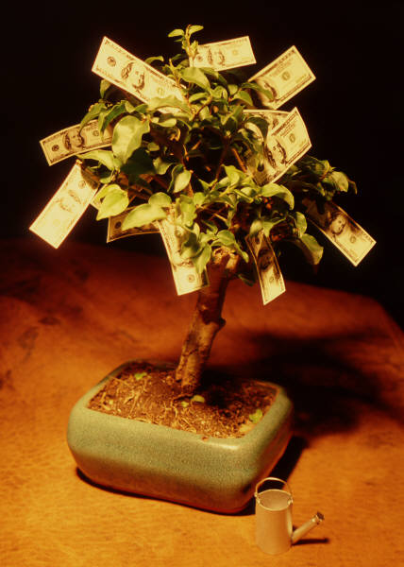
Figure 3.1 Money on trees (source xx)
Captions:

To include figure and table captions, which will then appear in the table of figures/tables in the preliminary pages,
- Click on the figure or table where you want the caption to appear.
- On the References tab, click the InsertCaption button.
- In the Caption window, in the Label menu, select the label Figure or Table.
- In the Position menu, select where you want the caption to appear (the usual convention is figures below the diagram and tables above).
- Click the Numbering button.
- In the Captioning Numbering window, in the Format menu, select 1,2,3…
- If you want to include the chapter number in the table/figure caption number, checkmark the Include chapter number box. If you select this option, two more options will appear:
- In the Heading starts with style: menu, select Heading 1.
- In the Use separator menu, select the punctuation you want to appear between the chapter number and the figure/table number.
- Click OK.
- Back in the Caption window, click OK. The caption label will appear above/below the table or figure. To add the text of your caption, click after the table/figure number and enter your text.
Table 2.1 Information in a table

A Justification of the Research Methods Used

This chapter may come before or after the literature review, depending on the project. The more usual case is that the choice of research methods MUST BE informed by the literature review, in which case the literature review chapter should come first, as in this example. However, if the research method is literature based, then this chapter should come BEFORE the literature review, as because the methods will state how the full literature review is performed it needs to therefore explain in depth how the literature is reviewed and analysed prior to any detailed coverage of the literature.

Results

Analysis

Discussion

Conclusions

Future Work

This could be a sub-section in the Conclusions chapter

References

Bibliography (if required)

First Appendix

