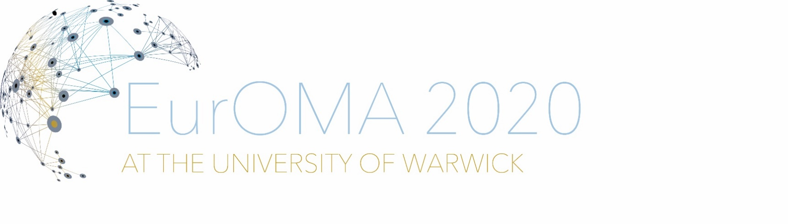

COVID-19: 27th Euroma Call for Virtual Special Session Proposal
Lisa Ellram, Barb Flynn, Christine Harland, Gyöngyi Kovács, Joe Sarkis and Wendy Tate

The COVID-19 pandemic has caused devastation to people’s health, safety, and livelihoods and is one of the biggest challenges of recent times. There have been well publicized shortages of medical supplies and goods driven by challenges in both demand and supply underpinned by the length and fragility of global supply chains. It has also caused our supply chains to be reevaluated. The concerns are pervasive and supply chain fragilities became conspicuous. These concerns have caused supply chain academics and practitioners to evaluate the situation and provide insights into potential solutions. Because the opportunities to meet face-to-face to discuss the COVID-19 are limited, a group of concerned academics sponsored an open forum on “An Action Agenda for Effective Post-Covid-19 Supply Chains”. A YouTube video recording exists for this here.
Before, during and after the Forum, participants presented ideas on what was important for them to discuss, both practically and academically. There were over 500 international registrants and about virtual 300 participants on Zoom and Youtube livestreaming – the discussion was lively, concerned, and compelling. A summary report was developed regarding the conversations and grouped the topics into areas of importance. The report is available upon request.
During the open forum, the organizers found ways to engage a relatively large number of participants in the conversation. Using questions and topics formulated by the participants both when they registered and a tool called online questions.org, the participants were engaged in the topics that they were interested in. These topics helped us to guide the forum discussion around source, make and deliver issues. The knowledge of how to deliver a high quality and high-level learning experience for the participants is valuable. Using Zoom technology, live streaming, real time updates to google docs with questions from participants and identifying people from the registrants who can contribute was important to keep the high level of engagement.
The participants – both academics and practitioners – had a number of topics that arose through the two-hour session and became important, real-time threads of discussion. The participants frequently commented during these threads and have answered a follow-up survey of what was important to them. This EurOMA session would be delivered in a way that is similar to the open forum, using the same techniques, including invited speakers. However, this forum would take an in-depth look at some of the topics that generated the most interest. What we realized is that this is a learning opportunity as well as a teaching opportunity across disciplines. This session would look at the learning side. And focus on the topics of what can we learn…? We can go in depth into one or all three of these topics depending on interest and time.
From Material Science: how can we perform a stress test on our supply chains, to know when it might break?
From Humanitarian Supply Chains: Agility, flexibility, and responsiveness are at the core of humanitarian supply chains. Preparedness as well as cross-sectoral collaboration are key to rapid mobilization and response. Local sub-optimization such as export and travel bans, panic buying, bullwhipping, and speculative pricing undermine the global pandemic response.
From Industrial and Commercial Supply Chain Dynamics: Problems in supply chains for toilet paper, food and PPE. How can we introduce structural versus dynamic flexibility? Inflexible commercial supply chains led to great waste and great scarcity.

