CENTS: A Research Network
for the Sustainable Transport Community

Circular Economy Network+ in Transportation Systems
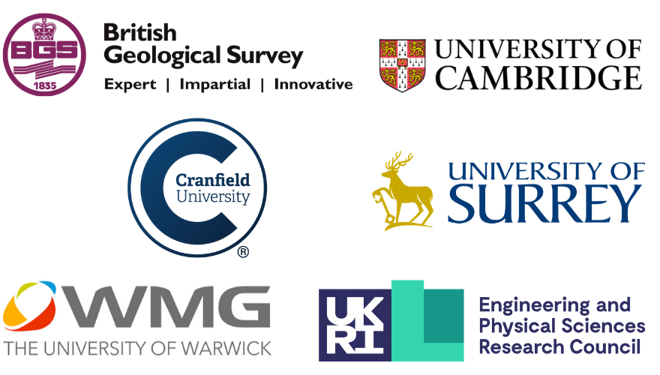
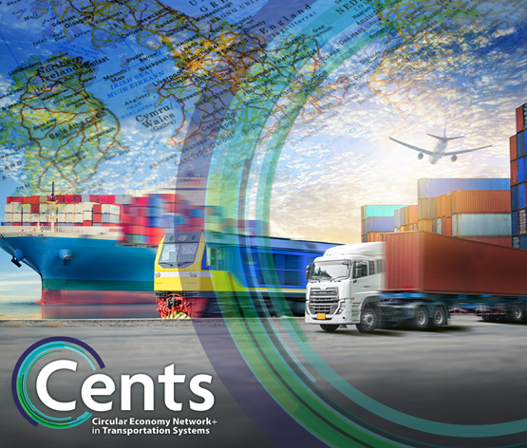

Application Form for CENTS Feasibility Funding

Title of Feasibility Study:
Lead Institution:
Principal Investigator:
Email:
Proposed start date and duration:
☐ Please tick here if you have already joined the CENTS Network

- Provide a brief summary of the intended activity, including a list of roles and responsibilities, desired outputs, outcomes and measures of success (max 300 words)

- Amount of funding requested (£ GBP)

- Project team (including external collaborators /industry partners/ other sources of funding (if any)
Please indicate which members of the academic team are Early Career Researchers

- Breakdown of expenditure (please detail proposed expenses)
Applicant | Institution

Costs
Investigator/ researcher  time | £0.00
Travel and subsistence | £0.00
Consumables | £0.00
Other | £0.00
Total 100% | £0.00
To claim 80% | £0.00

- Case for support
This can be a maximum of 1,000 words and include up to three figures. References are not required to be included in the word count.

- Project background and national importance

- Project team relevant track record

- Aims and objectives

- Benefits of the proposed work for industry
- Novelty
- Project plan (eg. Gantt chart) and deliverables
- Follow on funding

Declaration

I understand that if I am awarded funding, I will be required to provide a short case study (by 30th November 2020) to illustrate outcomes of the awards and to a provide a brief account of expenditure.

Please note that the information on this form will only be used for the purposes of assessing the funding application and will only be shared with the CENTS review panel for consideration/awarding.

Names of applicants:

Signatures:

Lead institution approval (Head of Department): I confirm that I have seen and authorise this application

Print Name:

Signature:

Please send the completed proforma (as .pdf) to circulartransport@warwick.ac.uk by 17:00 on Thursday 7th May 2020.

