Circular Economy Network+ in Transportation Systems
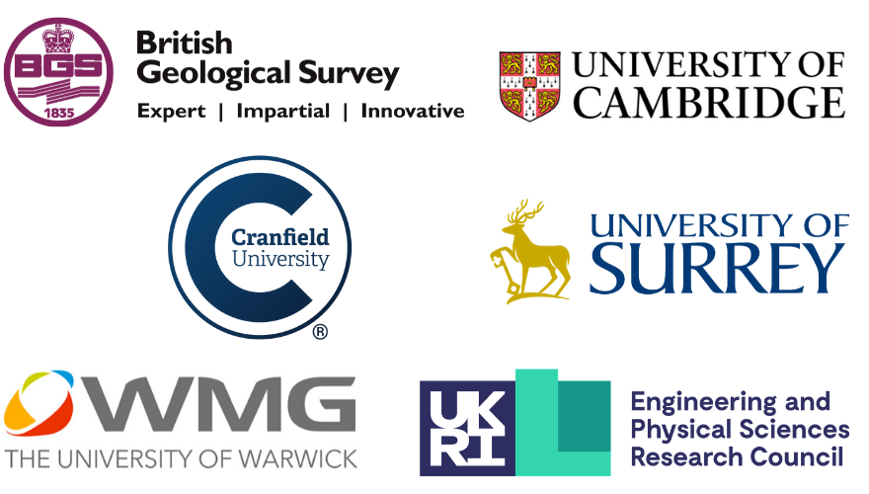
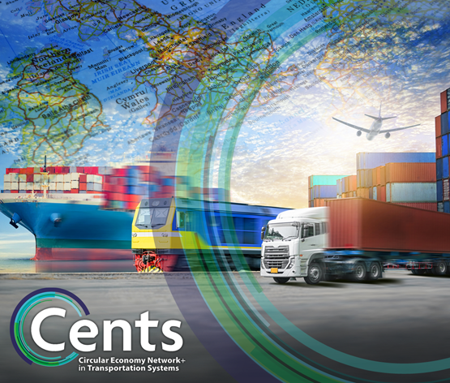
Feasibility Studies Round 2 – Call for Proposals
Closing date: Wednesday 31 March 2021 5 pm

Background
The CENTS network has received funding from the EPSRC to build a community of academic, industry and policy experts to deliver future designs, business models and manufacturing approaches so that emergent transport systems are inherently circular. A key focus of the network will be the informed design and utilisation of more environmentally friendly, reusable, renewable and/or recyclable materials to enable regenerative resource cycles and build resilience across the UK’s transport systems and sustainable manufacturing capabilities. By considering different transport systems in a single outward-looking network, it is more likely that a cascading chain of materials supply could be realised - something that has historically been very difficult within just a single sector.
Transport systems, whether on road, rail, air or sea are material intensive and utilise a range of resources, primarily supplied from natural sources. Our global vision of low carbon transport and fast approaching Net Zero targets introduce changes in technologies that have direct implications on the material requirements of transportation systems. The move towards Autonomous, Connected, Electric, and Shared (ACES) transport and the need to decarbonise fleets but retain and increase performance is influencing the range of material needs. Our future transport systems will likely contain a different configuration of materials. At the same time, current vehicles are coming to their End-of-Life and it is important that resources are recovered and managed sustainably to allow the transition to Net Zero. There is now more than ever the need to make better use of our resources, and the Circular Economy (CE) has a pivotal role to play in that.
Circular Economy Definition
A circular economy is an alternative to a traditional linear economy (make, use, dispose) in which we keep resources in use for as long as possible, extract the maximum value from them whilst in use, then recover and regenerate products and materials at the end of each service life. (Source: WRAP)

Feasibility study funding call

The CENTS research network invites proposals for collaborations between academic and industry partners that will enable cross-disciplinary, foresightful and risky early stage research. Applications involving Early Career Researchers (ECRs), and proposing interdisciplinary and cross sector research are particularly encouraged. The expectation is to fund up to four projects of up to a maximum value of £50,000 at full Economic Cost (fEC), with funding to be awarded at 80% fEC. Projects are expected to be approximately 6 months in length, and must complete before the end of Jan 2022.

Fit with the CENTS Network

In this second round, we again welcome applications from a wide range of disciplines addressing circular economy challenges in transport that fall within our 5 Research Strands. We would also be interested in proposals that tackle some of the key challenges identified in our material requirement roadmapping survey and workshops.

5 Research Strands:

Material stocks and flows in transportation | Research into materials (eg. industrial/technology metals, plastics, glass etc.)
Whole life design | End-of-Life recycling, reuse and recovery processes
Circular Economy Decisions | Social, economic, political, financial and logistical barriers to making improved Circular Economy decisions
Circular Economy Transitions | Delivery of Circular Economy at a sector level, using coordinated action by separate economic and civil entities
Digital Circularity | Potential roles of data in the Circular Economy (eg. Big Data, Blockchain technologies connecting transport supply chains, building trust and facilitating data exchange.)
Examples of challenges identified in roadmapping workshops:

Material Requirements for Transport Systems | Economic modelling of CE material routes; Material leasing; Policy requirements to incentivise CE in transport
Role of the Circular Economy in satisfying material requirement | Designing design, e.g. modular design; Material passports; Labelling & standardisation; LCA studies; Dynamic technologies able to handle diverse materials at the EoL stage;
Supply Chains with CE principles | Environmental footprint of materials in transport; Industrial symbiosis for supply chain resilience
Social Trends and their Influence on Material Choices for Transport | Role of ownership to the future of transport; Design of service

More research questions generated by the network are available on the CENTS website.
Application Process

Applicants must submit an application form which will be reviewed by the CENTS Management team and a panel of interdisciplinary industry experts.

Each feasibility study is expected to produce a tangible piece of work that would deliver a specific
(normally publishable) output, such as a discipline-bridging state-of-the-art review, early stage concept
development, or demonstrator technology.

The studies are also expected to lead to further deliverables such as large-scale collaborative proposals to the EPSRC, Innovate UK and other funders.

Selection criteria

The review panel will use the following criteria to rank proposals:
- Quality (Novel, ambitious, and timely; Plausible hypothesis and clearly identified objectives and outcomes)
- Importance (Meets national strategic and economic needs by establishing or maintaining a unique world leading research)
- Interdisciplinarity/Cross-sectoral impact
- Involvement of industry partner(s)
- Involvement of Early Career Researchers
- Potential for follow on funding
- Pathway to accelerate knowledge transfer to industry partner(s)

Key dates

15 February 2021 | Call for proposals opens
31 March 2021 | Deadline for submission (5 pm)
1 June 2021 | Successful proposals announced
All feasibility studies must complete by end of January 2022

Eligibility

Project leads should be employed by a UK university or UK higher education institution and be eligible to receive EPSRC funding. Applications involving Early Career Researchers (ECRs) are particularly encouraged, as is collaboration with industry. CENTS is committed to Equality, Diversity and Inclusion. We particularly welcome applications from teams which are diverse in terms of protected characteristics and disciplinary areas. ECRs are defined here as researchers transitioning to or establishing independence. There are no eligibility rules based on years since PhD. Lead applicants are expected to hold a doctorate by the start date of the funding being awarded.

What can the funding be used for?

As the CENTS Network is funded by EPSRC, our focus is on fundamental ideas that have potential to be developed into future applications. Therefore, proposals should address challenges at low Technology Readiness Levels (TRLs 1-3). The budget outline for the proposed feasibility studies can include investigator/ researcher
time, travel and subsistence appropriate to delivery of the project, and consumables. As the grant holder, the University of Warwick is responsible for allocating funding to successful proposals and will reimburse subcontracting organisations at 80% full economic costing. Academic institutions will be required to itemise bills based on 100% FEC and then invoice at 80% FEC.
Submitting proposals
Feasibility study applications should be submitted, using the application form provided in .pdf format, via
email to circulartransport@warwick.ac.uk by 5pm on Wednesday 31 March 2021.

Additional information

In addition to specific outputs detailed in your proposal, each successful project team is required to work with the CENTS Network Manager to produce a case study (template to be provided) and to present their work at the CENTS annual conferences.
Each research team will also be assigned a mentor from the CENTS leadership team and will be expected to organise regular progress meetings throughout the project.
The team also agree to acknowledge support of the work by the EPSRC and CENTS grant (grant number EP/S036237/1) in dissemination outputs, including articles, papers, presentations and interviews. The EPSRC and CENTS branding should be visible and included on presentations.
For any queries, please get in touch with the CENTS Network Manager (Dr Rika Nair) by email (circulartransport@warwick.ac.uk)
If you haven’t already, please Join the Network to ensure you don't miss announcements about further opportunities

Application Form for CENTS Feasibility Funding

Title of Feasibility Study:
Lead Institution:
Principal Investigator:
Email:
Proposed start date and duration:
☐ Please tick here if you have already joined the CENTS Network

- Provide a brief summary of the intended activity, including a list of roles and responsibilities, desired outputs, outcomes and measures of success (max 300 words)

- Amount of funding requested (£ GBP)

- Project team (including external collaborators /industry partners/ other sources of funding (if any)
Please indicate which members of the academic team are Early Career Researchers

- Breakdown of expenditure (please detail proposed expenses)
Applicant | Institution

Costs
Investigator/ researcher  time | £0.00
Travel and subsistence | £0.00
Consumables | £0.00
Other | £0.00
Total 100% | £0.00
To claim 80% | £0.00

- Case for support
This can be a maximum of 1,000 words and include up to three figures. References can be provided as an appendix and are not required to be included in the word count.

- Project background and national importance
- Project team relevant track record
- Aims and objectives
- Benefits of the proposed work for industry
- Novelty
- Project plan (eg. Gantt chart) and deliverables
- Follow on funding

Declaration

I understand that if I am awarded funding, I will be required to provide a short case study to illustrate outcomes of the awards and to a provide a brief account of expenditure.
I will also be required to organise regular progress meetings with a mentor assigned from the CENTS Leadership team.

I understand that for awarded projects, a collaboration agreement will be put in place based on standard terms.

Please note that the information on this form will only be used for the purposes of assessing the funding application and will only be shared with the CENTS review panel for consideration/awarding.

Names of applicants:

Signatures:

Lead institution approval (Head of Department): I confirm that I have seen and authorise this application

Print Name:
Signature:

Please send the completed proforma (as .pdf) to circulartransport@warwick.ac.uk by 17:00 on Wednesday 31st March 2021.

