Circular Economy Network+ in Transportation Systems


CENTS: Circular Economy Network+ in Transportation Systems
Linking academic creativity and industry insight to reduce the environmental burden of transportation systems across their lifecycle

Call for White Paper Proposals

Background
The CENTS network has received funding from the EPSRC to build a community of academic, industry and policy experts to deliver future designs, business models and manufacturing approaches so that emergent transport systems are inherently circular. A key focus of the network is the informed design and utilisation of more environmentally friendly, reusable, renewable and/or recyclable materials to enable regenerative resource cycles and build resilience across the UK’s transport systems and sustainable manufacturing capabilities. By considering different transport systems in a single outward-looking network, it is more likely that a cascading chain of materials supply could be realised - something that has historically been very difficult within just a single sector.
Transport systems, whether on road, rail, air or sea are material intensive and utilise a range of resources, primarily supplied from natural sources. Our global vision of low carbon transport and fast approaching Net Zero targets introduce changes in technologies that have direct implications on the material requirements of transportation systems. The move towards Autonomous, Connected, Electric, and Shared (ACES) transport and the need to decarbonise fleets but retain and increase performance is influencing the range of material needs. Our future transport systems will likely contain a different configuration of materials. At the same time, current vehicles are coming to their End-of-Life and it is important that resources are recovered and managed sustainably to allow the transition to Net Zero. There is now more than ever the need to make better use of our resources, and the Circular Economy (CE) has a pivotal role to play in that.
Circular Economy Definition
A circular economy is an alternative to a traditional linear economy (make, use, dispose) in which we keep resources in use for as long as possible, extract the maximum value from them whilst in use, then recover and regenerate products and materials at the end of each service life. (Source: WRAP)
Call for White Paper Proposals

The CENTS research network invites white paper proposals from working groups (to include a mix of partners) who will collaborate creatively to produce positional papers to address challenges and facilitate change towards a more Circular Economy within the transportation sector.

Fit with the CENTS Network

CENTS held a series of workshops in December 2020 and produced a roadmap in May 2022 to move from the current state to a future vision of a circular economy for transport systems. The key messages and challenges from the workshop are summarised and captured within a ‘rich picture’ below, full details including the narrative can be seen here.
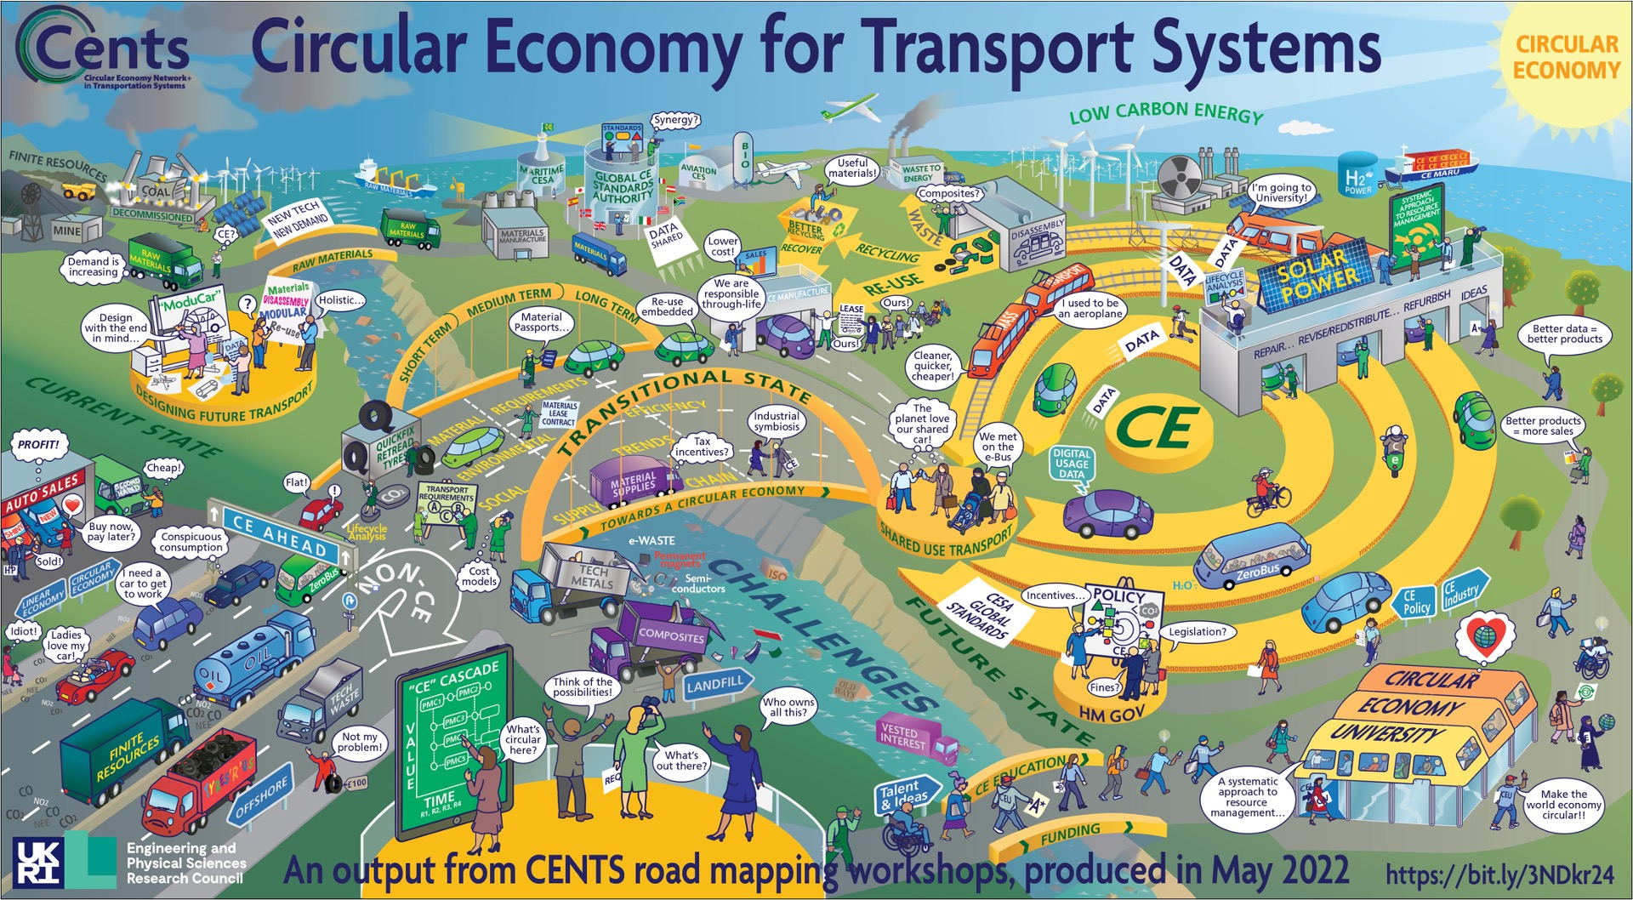
CENTS also has 5 Research Strands outlined below:

Material stocks and flows in transportation | Research into materials (eg. industrial/technology metals, plastics, glass etc.)
Whole life design | End-of-Life recycling, reuse and recovery processes
Circular Economy Decisions | Social, economic, political, financial and logistical barriers to making improved Circular Economy decisions
Circular Economy Transitions | Delivery of Circular Economy at a sector level, using coordinated action by separate economic and civil entities
Digital Circularity | Potential roles of data in the Circular Economy (eg. Big Data, Blockchain technologies connecting transport supply chains, building trust and facilitating data exchange.)
White paper guidelines

The white paper should be designed to maximise its impact. It should include:

- A cover page which includes the title and names of PI
- A main body no more than 20 pages in length including tables/graphics/photos etc with a minimum font size of 11
- A bibliography of up to 2 pages
- A back cover page listing the members and institution of the team
- A separate executive summary
- Other evidence to back up the white paper may also be provided
Funding

Proposals should be submitted up to a maximum value of £10,000 at full Economic Cost (fEC), with funding to be awarded at 80% fEC ie £8,000. White papers are expected to be completed within a 2-3 month time frame before the end of December 2022.

Application Process

Applicants must submit an application form which will be reviewed by the CENTS Management team and Steering Group

Selection criteria

The review panel will use the following criteria to rank proposals:
- Quality (novel, clarity, ambitious, and timely)
- Relevance (challenges identified by CENTS)
- Interdisciplinarity/Cross-sectoral impact
- Involvement of early Career Researchers
- Potential impact

Key dates

21 July 2022  11 September 2022 | Call for white paper proposals opens  Submission deadline
Applicants will normally be advised of the outcome within 2 weeks of the submission deadline.

All white papers must completed by the end of December 2022

Eligibility

Lead applicants should be employed by a UK university or UK higher education institution and be eligible to receive EPSRC funding. Collaboration with public bodies and industry are especially encouraged. CENTS is committed to Equality, Diversity and Inclusion. We particularly welcome applications from teams which are diverse in terms of protected characteristics and disciplinary areas. Lead applicants are expected to hold a doctorate by the start date of the funding being awarded.

What can the funding be used for?

The budget for the proposed white papers can be used for workshops/focus groups, travel, and consumables. As the grant holder, the University of Warwick is responsible for allocating funding to successful proposals and will reimburse subcontracting organisations at 80% full economic costing. Academic institutions will be required to itemise bills based on 100% FEC and then invoice at 80% FEC.
Submitting proposals
White paper proposals should be submitted, using the application form provided in .pdf format, via
email to circulartransport@warwick.ac.uk by 5pm on 11th September

Additional information

In addition to specific outputs detailed in your proposal, each successful working group is required to present their white paper at a high profile event organised by CENTS in 2023.
The groups agree to acknowledge support of the work by the EPSRC and CENTS grant (grant number EP/S036237/1) in dissemination outputs, including articles, papers, presentations and interviews. The EPSRC and CENTS branding should be visible and included on presentations.
For any queries, please get in touch with the CENTS Network Manager (Sue Gibson) by email (circulartransport@warwick.ac.uk)
If you haven’t already, please Join the Network to ensure you don't miss announcements about further opportunities

Please see the next page for the application form

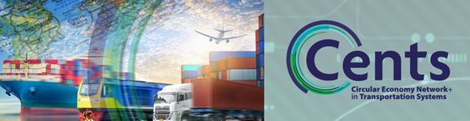

Application Form for CENTS White Paper Funding

Topic of proposed white paper:
Lead Institution:
Principal Investigator:
Email:
Proposed start date and duration:
☐ Please tick here if you have already joined the CENTS Network

- Provide a brief summary of your proposed white paper desired outputs, outcomes and measures of success (max 500 words)
- Fit with CENTS
- National relevance
- Aims and objectives
- Benefits of the proposed white paper
- Project plan (may be in addition to 500 words)

- Amount of funding requested (£ GBP – will be allocated at 80%)

- Working group members (including external collaborators /industry partners/ other sources of funding (if any) institution and experience
Please indicate which members of the academic team are Early Career Researchers

- Breakdown of expenditure (please detail proposed expenses)
Applicant | Institution

Costs
Workshops etc | £0.00
Travel and subsistence | £0.00
Consumables | £0.00
Total 100% (max £10,000) | £0.00
To claim 80% | £0.00

Declaration

I understand that if I am awarded funding, I will be required to attend the high profile event in2023 and to a provide a brief account of expenditure.

I understand that for awarded projects, an agreement will be put in place place.

Please note that the information on this form will only be used for the purposes of assessing the funding application and will only be shared with the CENTS review panel for consideration/awarding.

Names of applicants:

Signatures:

Lead institution approval - I confirm that I authorise this application

Print Name:
Signature:

Please send any queries and the completed proforma (as .pdf) to circulartransport@warwick.ac.uk

