PROGRAMME & PRACTICAL INFORMATION BOOKLET
(FINAL VERSION OF 07/09/17)
http://dnc2.discourseanalysis.net




DiscourseNet Congress #2

Interdisciplinary Discourse Studies

Theory and Practice

#DNC2

University of Warwick, Westwood campus

Coventry CV4 8EE, United Kingdom

September 13-15, 2017

 |  |  |  | 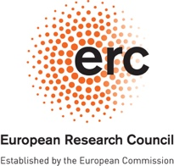
DiscourseNet Congress #2
Interdisciplinary Discourse Studies Theory and Practice
University of Warwick, Westwood campus
September 13-15, 2017
University of Warwick, Coventry CV4 7AL, United Kingdom

  Wednesday September 13
  Time | Session | Room | Title | Speaker
  10:00-10:30 | Registration & Coffee (Foyer Westwood Teaching Centre)
  10:30-11:00 | Opening Remarks (Room Westwood Lecture Theatre, WLT)
  11:00 | 1 | WLT | Discursive Shifts, Recontextualisation and the Multi-Level Critique of Discourse:  Challenges in Critical Discourse Studies | KRYŻANOWSKI
  12:30 | LUNCH (not provided)
  14:00-15:00 | 2-4 | WLT | Media in Corpus | FURKÓ / ORFANÒ / KRINNINGER
  14:00-15:00 | 2-4 | WT0.05 | Inclusion/Exclusion in Political Discourse | BECKER / ZIEROLD / MOELLER
  14:00-15:00 | 2-4 | WT0.02 | Identity & Culture | PORSCHÉ / ZAMRI / BARDAOUI
  14:00-15:00 | 2-4 | WT0.03 | The Politics of Representation | ANGERMULLER / NONHOFF / RICHARDSON
  14:00-15:00 | 2-4 | WT0.04 | Power in Discourse | SJÖGREN / RODERICK / MULDERRIG
  15:30 | TEA BREAK (WT FOYER)
  16:00-18:00 | 5-8 | WT0.05 | The Subject in Discourse | PASCUAL & BULLO / ZEZULKA / CHEONG
  16:00-18:00 | 5-8 | WT0.02 | Culture and Activism | JIMÉNEZ / WAY / LUDLEY
  16:00-18:00 | 5-8 | WT0.03 | Political Negotiations through Discourse | WU / RICHARD /  SHUTOVA / KERBOUA
  16:00-18:00 | 5-8 | WT0.04 | Discursive Practices in Higher Education | DUFOUR / MADSEN / TOMASKOVA
  Thursday September 14
  Time | Session | Room | Title |  | Speaker
  9:30-11:30 | 9-12 | WT0.05 | Political Discourse and the Cognitive Turn |  | HART / KAAL / CHILTON / KOLLER & MIGLBAUER
  9:30-11:30 | 9-12 | WT0.02 | Discourse as a Clinical Practice |  | IVANCIC / WEIGHTMAN / PHIRI / DROUET & RICHARD
  9:30-11:30 | 9-12 | WT0.03 | Performing Acts in Discourse |  | GHARBI & AMOR / YANAGIDA / TRINDADE / VILAR-LLUCH
  9:30-11:30 | 9-12 | WT0.04 | Science in Discourse |  | VIRTANEN / HAH / ZAPLETALOVÁ / HORROD
  11:30 | BREAK (WT FOYER)
  12:00-13:00 | 13 | FOYER Westwood Teaching Centre | Poster Session | GARCÍA-JEREZ / TRINDADE / SEMENIUK / OLECHOWSKA / LIAQAT / ROCHFORD & CRIBB
  13:00 | LUNCH (not provided)
  14:30-15:30 | 14 | WLT | Narratives and the Psychosocial in Discourse Studies |  | PHOENIX
  15:30 | TEA BREAK (WT FOYER)
  16:00-18:00 | 15-18 | WT0.05 | Discursive Construction of Identities |  | UHLENDORF / OHIA & NOWAK / TAHA / KRASNOPEYEVA
  16:00-18:00 | 15-18 | WT0.02 | Beyond Discourse |  | BORRELLI / KESZEI, BRÓZIK & DÚLL / KELSEY / FRAGONARA
  16:00-18:00 | 15-18 | WT0.03 | Language and Politics |  | SHARAFUTDINOVA / SPIESSENS / CLYNE / PARKER
  16:00-18:00 | 15-18 | WT0.04 | Discourse and the Academic Order |  | WRÓBLEWSKA / MIRONOVA & GRONSKAYA / TEMMAR / BADOI
  16:00-18:00 | 15-18 | WLT | Round Table:  Experiences and Challenges with Groups and Associations |  | HART, KRYŻANOWSKI, NONHOFF, PARKER, STACHOWIAK, HAILONG TIAN
  18:30 | DiscourseNet Assembly – Everybody is welcome! (WT0.02)
  Friday September 15
  Time | Session | Room | Title | Speaker
  9:30-11:00 | 19-21 | WT1.05 | Methodologies for the Analysis of Political Discourse | HUSSON / ZIENKOWSKI / RHEINDORF
  9:30-11:00 | 19-21 | WT0.02 | Images and Field Work | WIENERS & WEBER / PAGE & RETTBERG / SINGH
  9:30-11:00 | 19-21 | WT0.03 | Discourse Analysis - From Theory to Application to Impact | GEORGAKOPOULOU / STIBBE / ANGOURI
  9:30-11:00 | 19-21 | WT1.04 | Relationships between Semiotics and Discourse | HERRERA / GASPARD / BADIR
  11:00 | BREAK (WT FOYER)
  11:30-12:30 | 22-23 | WT1.05 | Methodologies for the Analysis of Political Discourse | CASTELLÓ TARIDA & MUÑOZ FALCONI / FARRELLY
  11:30-12:30 | 22-23 | WT0.02 | Words of the Economy | STACHOWIAK / EFTHYMIADOU
  11:30-12:30 | 22-23 | WT0.03 | Integration and Exclusion | ELSAYED / HAILONG
  12:30 | LUNCH (not provided)
  14:00-15:30 | 24-26 | WT1.05 | Methodologies for the Analysis of Discourse | NACUCCHIO / YIP / SCHOLZ
  14:00-15:30 | 24-26 | WT0.02 | Educational Discourses | KIM / MAHESHWARI / PORSTNER
  14:00-15:30 | 24-26 | WT0.03 | Political Discourse | ZAPPETTINI / ZAPF / SCHROETER
  15:30-17:00 |  | WLT | Concluding discussion and the future of DISCOURSENET  followed by DISCOURSENET pub night in the  Varsity Pub (on campus)
FULL PROGRAMME

WEDNESDAY, 13 SEPTEMBER
10:00 – 10:30
Registration & Coffee (Foyer Westwood Teaching Centre)
10:30 – 11:00
Opening Remarks (Room Westwood Lecture Theatre, WLT)
Helen Spencer-Oatey, Johannes Angermuller and N.N.
11:00 – 12:30
SESSION 1: PLENARY (Room WLT)
Michał Krzyżanowski
Discursive Shifts, Recontextualisation and the Multi-Level Critique of Discourse:
Challenges in Critical Discourse Studies
12:30 – 14:00
LUNCH (not provided)
14:00 – 15:30
SESSION 2-4
Room WLT | Media in corpus  Chair:  Ronny Scholz | PETER FURKÓ  Manipulative Reports in Mediatized Political Discourse | BÁRBARA ORFANÒ  The Use of Pragmatic Markers in Spoken Interlanguage: A Corpus-Based Study of a Group of Brazilian University Students | STEFANIE KRINNINGER  Art Discourses and Aesthetic Practice “Before the Era of Art” – A Corpus Analytic Approach
RoomWT  0.05 | Inclusion/ exclusion in political discourse  Chair:  Michael Kranert | MATTHIAS JAKOB BECKER  Antisemitic Parlance in Readers' Comments of the Left-Liberal Newspapers Die Zeit and The Guardian | ALEXANDRA ZIEROLD  Pushing Boundaries with Discursive Pragmatics: The “Refugee Crisis” as A Crisis of Consciousness | CHRIS MOELLER  The Normalisation of Food Charity in the UK: Discourse and Dispositive Analysis as Practised Critique
Room WT  0.02 | Identity and culture  Chair:  Christina Efthymiadou | YANNIK PORSCHÉ  Public Representations of Immigrants in Museums – Exhibition and Exposure in France and Germany | NORAZRIN ZAMRI  The ‘Good Mother’ – Expectations Versus Realities: Discursive Identity Construction among Malaysian New Mothers. | ISMAIL BARDAOUI  A Linguistic Analysis of the Political Discourse of the Justice and Development Party’s Pre-Government and In-Government Discourse
Room WT  0.03 | Discourse and the social order  Chair:  Marta Wróblewska | JOHANNES ANGERMULLER  Discourse and social antagonism. For a Strong Programme in Discourse Studies | MARTIN NONHOFF  Populism and the Promise of Radical Democracy | JOHN RICHARDSON  Sharing Values to Safeguard the Future: British Holocaust Memorial Day Commemoration as Epideictic Rhetoric
Room WT  0.04 | Power in discourse  Chair:  Johannes Beetz | MARIA SJÖGREN  The Discursive Construction of Citizens' Dialogues | IAN RODERICK  “The Active Learning Classroom as Multimodal Metaphor for Future Employability | JANE MULDERRIG  Powers of Attraction: Multimodal Strategies of Emotional Governance in UK Health Policy
15:30 – 16:00
TEA BREAK (WT FOYER)

WEDNESDAY, 13 SEPTEMBER
16:00 – 18:00
SESSION 5-8
Room  WT  0.05 | The subject in discourse  Chair:  Sixian Hah | MARIANA PASCUAL, STELLA BULLO  Argentina after the return to democracy: An Appraisal study of media representations of pain and memory | KELLI ZEZULKA  Power, Uncertainty and Proximity: Person Deixis and the Language of Theatre Production | HUEY FEN CHEONG  Action-Oriented Approach to Discourse: A 'functional' alternative for a 'functional' discourse analysis?
Room WT  0.02 | Culture and activism  Chair:  Marta Wróblewska | LUCÍA JIMÉNEZ  Discourse and Information Quality: Analysing Referred Speech in Two Spanish Public Television Services | LYNDON WAY  The potential and limits of political discourse in music performance | MAIKE LUDLEY  Cultural Policymaking as discourse – The case of the European Capital of Culture “RUHR.2010“
Room WT  0.03 | Political negotiations through discourse  Chair:  Martin Nonhoff | GEQI WU  Media Portrayal of Chinese City Image: A Corpus-based Discourse Study of Hangzhou | ARNAUD RICHARD  Massacre: The Power of Discourse. The Case of Commemorative Naming in Haiti | TATIANA SHUTOVA  Construction of 'Democracy' in American Counterterrorism Discourse (1972 – 2016) | SALIM KERBOUA  Collective Identity and the Discursive Construction of Insecurity: Exploring “Eurabia,” Islamofascism,” and “the Great Replacement” Theses
Room WT  0.04 | Discursive practices in higher education  Chair: Eduardo Chávez Herrera | FRANÇOISE DUFOUR  The distributed agency in the discursive construction of e-academic identities | DORTE MADSEN  The Logic of Equivalence in Academic Discourse? | RENATA TOMASKOVA  University Research Blogs as Ways to Knowledge Dissemination and Knowledge Construction

THURSDAY, 14 SEPTEMBER
9:30 – 11:30
SESSION 9-12
Room WT  0.05 | Political discourse and the cognitive turn  Chair:  Michael Kranert | CHRIS HART  'Riots engulfed the city': An Experimental Approach to Legitimating Effects in Discourses of Disorder | BERTIE KAAL  Discourse- Space Studies and Applications: Finding Variation in Coordinate Systems of Discourse Rationales | PAUL CHILTON  Discourse, Meaning, Mind… and power | VERONIKA KOLLER, MARLENE MIGLBAUER  The people have spoken: vox pops on the 2016 British EU referendum and the Austrian presidential elections
Room WT  0.02 | Discourse as a clinical practice  Chair: Johannes Beetz | MATKO KRCE IVANCIC  Psychoanalysis as a Theory of Discourse: The Fantasmatic Life of Power | ELIZABETH WEIGHTMAN  Reflexive Psychoanalytic Discourse Research into the Containment of Mental Disturbance in an NHS Trust | RACHEL CHIMBWETE PHIRI  Regulating the discourse of HIV/AIDS in health consultations in Malawi | GRISELDA DROUET, ELISABETH RICHARD  A cross-over medical-sociological-linguistic study: when discourse analysis supports medical researches
Room WT  0.03 | Performing discourse  Chair:  Sue Wharton | MARIEM GHARBI, RIADH BEN AMOR  Adopting and Adapting Interdisciplinary Toolkits to Analyzing Public Apologies | RYOGO YANAGIDA  (Im)politeness and Three Forms of Capital | LUIZ VALERIO TRINDADE  It is not that Funny. Critical Analysis of Racial Ideologies Embedded in Racialized Humour Discourses on Facebook in Brazil | SARA VILAR-LLUCH  Construction of identity in the psychiatric institutional discourse: ADHD in the DSM-V. An approach from Critical Linguistics in SFL framework
Room WT  0.04 | Science in discourse  Chair:  Marta Wróblewska | MIKKO T. VIRTANEN  Functions of Storytelling in Popular Science Books | SIXIAN HAH  Positioning Practices of Academic Researchers in Research Interviews | GABRIELA ZAPLETALOVÁ  MOOCs as Digital Ecologies: Participation Frameworks and Knowledge Construction in e-Learning Discussion Fora | SARAH HORROD  From policy to practice: exploring recontextualisation within higher education
11:30 – 12:00
BREAK (WT FOYER)

THURSDAY, 14 SEPTEMBER
12:00 – 13:00
SESSION 13: POSTER PRESENTATIONS (Foyer Westwood Teaching Centre)
MARÍA E. GARCÍA-JEREZ
Critical Discourse Analysis and Rhetorical Criticism. Understanding the Relevance of Ideology in Academic Writing
LUIZ VALERIO TRINDADE
It is not that Funny. Critical Analysis of Racial Ideologies Embedded in Racialized Humour Discourses on Facebook in Brazil
IRINA SEMENIUK
Discourse-Forming Concepts and Meritocratic Discourse: Bridging the Gap
AGNIESZKA JOANNA OLECHOWSKA
Paradigmatic Discourse in Official Pedagogical Discourse
QURRATULAEN LIAQAT
Foucauldian Discourse Analysis of Power Structures in the Novel a God in Every Stone by Kamila Shamsie
SHIVANI ROCHFORD/ MICHAEL CRIBB
An Exploration into The Nature of Audience Interjections on Exchanges Between the Prime Minister and The Leader of the Opposition During Prime Minister’s Questions
13:00-14:30
LUNCH (not provided)
THURSDAY, 14 SEPTEMBER
14:30 – 15:30
SESSION 14: PLENARY (Room WLT)
Ann Phoenix
Narratives and the psychosocial in Discourse Studies
15:30 – 16:00
TEA BREAK (WT FOYER)
16:00 – 18:00
SESSION 15-18
Room WT  0.05 | Discursive construction of identities  Chair: Christina Efthymiadou | NIELS CHRISTOPHER UHLENDORF  "Becoming the perfect immigrants”– Discourses of self-optimisation in the context of immigration and its impacts on subjections | MARGARET OHIA, PAWEŁ NOWAK  Communication strategies of representing black people in media discourse in Poland (2012-2016) | MAISA C. TAHA  Managing hypervisibility: Discourse as phronetic practice among Muslim American Women | EKATERINA KRASNOPEYEVA  When Your Favorite Vlogger Starts to Speak Russian: Investigating the Discursive Spaces around Fan-Subbed and Fan-Dubbed YouTube Channels
Room WT  0.02 | Beyond discourse  Chair: Johannes Beetz | GIORGIO BORRELLI  Discourse Studies and materialistic semiotics: proposals for a terminological (and theoretical) convergence | BARBARA KESZEI, PÉTER BRÓZIK, ANDREA DÚLL  Linking psychological drawing analysis and discourse analysis | DARREN KELSEY  Brexit, Farage and the Hero’s Journey: A discourse-mythological analysis of archetypes, affect and ideology | AURORA FRAGONARA  Empathy as a Key Concept for Analysing Political Discourse: The Example of Tweets by Politicians
Room WT  0.03 | Language and politics  Chair:  Stephanie Schnurr | OLESIA SHARAFUTDINOVA  V. Putin’s “Language of Power” in the Modern Mediatized Society: Qualitative and Quantitative Analysis | ANNELEEN SPIESSENS  Discourse Studies in Conflict: A Multimodal Analysis of Russian News Translation on the Ukraine and Syria | EYAL CLYNE  Which comes first, language or discourse? The case of the Zionist language and its untranslatables | IAN PARKER  New vocabularies of resistance. Interventions at the intersection of radical theory and practice
Room WT  0.04 | Discourse and the academic order  Chair:  Françoise Dufour | MARTA NATALIA WRÓBLEWSKA  What Kind of Creatures have we become? Academic Technologies of the Self in the Context of REF 2014 and the Impact Agenda | IRINA MIRONOVA, NATALIA E. GRONSKAYA  Contested Ideologeme. The Role of Competitive Sub-Disciplinary Discourses in the Process of Defining the Term | MALIKA TEMMAR  French philosophers on society. Analysing interviews with philosophers about the terrorist attacks in print media  ( La parole philosophique dans la presse) | DELIA GEORGIANA BADOI  Critical Policy Sociology as Innovation? The Circulation of the Intellectual Discourse of Social Scientists Working in the Policy Making Process
Room WLT | Chair: Johannes Angermuller | Round Table: Experiences and challenges with groups, associations, journals in Discourse Studies with CHRIS HART, MICHAŁ KRZYŻANOWSKI, MARTIN NONHOFF, IAN PARKER, JERZY STACHOWIAK, HAILONG TIAN
THURSDAY, 14 SEPTEMBER
18:30 -
DISCOURSENET ASSEMBLY (WT0.02) – Everybody’s Welcome!

FRIDAY, 14 SEPTEMBER
09:30 – 11:00
SESSION 19-21
RoomWT  1.05 | Methodologies for the analysis of political discourse  Chair:  Ronny Scholz |  | ANNE CHARLOTTE HUSSON  Thinking with Metaphors: A Genealogy of Articulation in Discourse Studies |  | JAN ZIENKOWSKI  Articulation as a Guiding Principle for Analyzing the Interpretive Functions of Discourse: A Heuristic for Investigating the Metapolitics of Anti-Labor Union Discourse |  |  | MARKUS RHEINDORF  Changing national identities: discourse historical perspectives and methodological challenges
Room  WT  0.02 | Images and field work Chair:  Elisabeth Barakos |  | SARAH WIENERS & SUSANNE WEBER  Analyzing Institutional Talk The potential of Videography for Organizational Discourse Analysis |  | RUTH PAGE & JILL WALKER RETTBERG  Snap Chat News Stories: Collectivising Protests in Emerging Forms of ‘Citizen Journalism’ |  |  | JASPAL SINGH  Analytical Ethics: The Problem of Analysing Interaction in the Field from the Armchair
Room WT  0.03 | Discourse Analysis - from theory to application to impact  Chair:  Marta Wróblewska |  | ALEXANDRA GEORGAKOPOULOU  Small Stories 'Impact': A Case of re-, trans- and poly-Storying |  | ARRAN STIBBE  Ecolinguistics |  |  | JO ANGOURI  The many impacts of/in sociolinguistic work
Room WT  1.04 | Relationships between semiotics and discourse  Chair:  Sue Wharton |  | EDUARDO CHÁVEZ HERRERA  Similar roots. New relationships? Discourse analysis and semiotics |  | JEOFFREY GASPARD  Bridging Peirce’s Philosophy of Signs with Discourse Theory: On Speech Genres and Perlocution |  |  | SÉMIR BADIR  A Survey of the Semiotic Analysis of Academic Discourse
11:00 – 11:30
TEA BREAK (WT FOYER)
FRIDAY, 14 SEPTEMBER
11:30 – 12:30
SESSION 22-23
Room WT  1.05 | Methodologies for the analysis of political discourse  Chair:  Ronny Scholz |  | ANTONI CASTELLÓ TARIDA, GIOVANNA MUÑOZ FALCONI  Conceptual Networks in the Discourse: A Proposal for a Methodological Approach to Political Discourse Analysis |  |  | MICHAEL FARRELLY  Using Nvivo for Identifying and Coding Intertextuality in CDA
Room WT  0.02 | Words of the economy  Chair: Jo Angouri |  | JERZY STACHOWIAK  Managerial Correctness. A Concept and its Empirical Grounding |  |  | CHRISTINA EFTHYMIADOU  Performing trust in business partnerships: a discourse analytical perspective
Room WT  0.03 | Integration and exclusion  Chair :  Françoise Dufour |  | SARA ELSAYED  Two Opposites? UK Mainstream and Muslim Discourses of Integration |  |  | TIAN HAILONG  Vertical Interplay of Discourses and Control of Social Practice: How a Man is Executed and Exonerated?
12:30 – 14:00
LUNCH (not provided)
FRIDAY, 14 SEPTEMBER
14:00 – 15:30
SESSION 24-26
Room WT  1.05 | Methodologies for the analysis of political discourse  Chair:  Tilly Harrison | AILIN NACUCCHIO  A Methodological Proposal for Analysing Temporality as a Dimension of Political Discourse |  | ADRIAN YIP  Online Representations of Female and Male Tennis Players: Content Analysis and Critical Discourse Analysis as Complementary Methodologies |  |  | RONNY SCHOLZ  Assessing National Language Contexts in the Age of Globalised Communication Practices
Room WT  0.02 | Educational discourses  Chair:  Shafiq Hashim | WONSEOK KIM  A Critical Look at the Discourse of Educational Neutrality: De/Politicisation of Education in South Korea, 1987 to the Present |  | DISHA MAHESHWARI  Understanding Power, Gender, and Identity Negotiation at School through Classroom Interaction: Case study of a Teenage Indian Girl |  |  | ILSE PORSTNER  Approaching Postcolonial Narratives in History Textbooks: Institutionalised Patterns of Reading “Colonialism” and Discursive Negotiation of Meaning. Analysis of Classroom Talk Text-Related
Room WT  0.03 | Political Discourse  Chair: Michael Kranert | FRANCO ZAPPETTINI  Power to the People? Mediatizing Populist Ideologies in the Brexit Campaign |  | HOLGER ZAPF  Tunisian Intellectuals after the Revolution: The Hegemonic Project of Anti-Islamism |  |  | MELANI SCHROETER  The ‘Silent Majority’. Anti-political Correctness and the Appropriation of ‘Discourse’ by the New Right
15:30 – ca. 17:00
CONCLUDING DISCUSSION AND THE FUTURE OF DISCOURSENET, Room WLT
followed by DISCOURSENET pub night in the Varsity Pub (on campus)

PRACTICAL INFORMATION

Getting to the conference

Directions to the University of Warwick, Westwood Campus, Coventry
The conference will take place at Westwood Teaching Centre (WT), which is located in Westwood campus at University of Warwick, Kirby Corner Road, Coventry, CV4 8EE

Getting to the University of Warwick
The University of Warwick is in Coventry.
The nearest train station is Coventry or Canley and not Warwick! If you go to Coventry train station, you will need to take a bus to get to campus: 11 (20-30 minutes) or 12X (12-20 minutes). Bus 11 will take you nearer to Westwood Teaching Centre, where the registration and most talks take place. Please note: 12X needs an additional 15-20 minutes’ walk after arriving on central campus, so line 11 is usually faster to get to Westwood in total.
You need exact change (2.10£-2.90£) and you may consider buying a daysaver ticket (http://nxbus.co.uk/coventry/news/national-express-coventry-fares-changes-2017).
From Canley train station, it is a 20-30 minute walk to Westwood Teaching Centre - there is also a free shuttle bus which takes you to University House (just 5 minutes from the conference venue) – see timetable here: http://www2.warwick.ac.uk/services/estates/transport/buses/shuttlebus/
The cost of a taxi from Coventry or Canley station to campus is around 10 pounds – but there is no regular taxi stand at Canley.
An interactive campus map can be found here: https://campus.warwick.ac.uk/
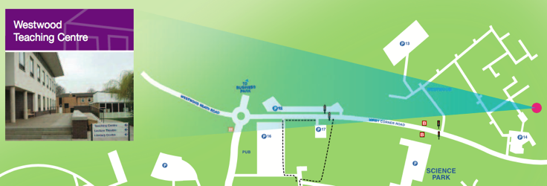
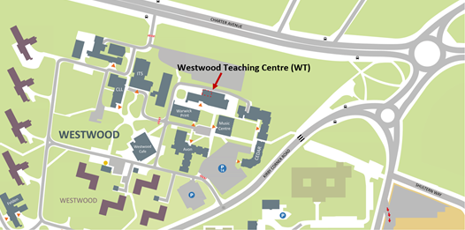

Rooms

The keynotes and paper sessions take place in rooms WLT (Westwood Lecture Theatre), WT0.02-0.05 on the ground floor, and WT 1.04 and 1.05 on the first floor, which can all be accessed from Westwood Teaching Centre (WT). The poster session as well as coffee breaks take place in the foyer in WT.

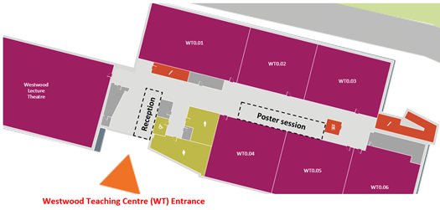

Parking options
There is a carpark at Westwood Teaching Centre. It costs £2 for 4 hours and £4 all day. If that one is full, Car Park 13 is also on Westwood campus and has the same charges. There are also carparks at the nearby Cannon Park Shopping Centre, Aldi and in other parts of the campus such as Car Park 15.
There is a small car park that is open to the public on the left as you turn in to the Westwood campus (the larger car park on the right is Staff Only). It is pay and display - £2 for 4 hours and £4 for a full day. If there are no places there, continue up Avon Road and turn left. Follow signs to Car Park 13 which should have some spaces and has the same charges. It is about a 6 minute walk back to the conference site.

Lunch options
Please note that we will provide neither lunch nor dinner. The nearest café is the Westwood café, which is open from 8am to 3pm and offer meal deals from £3.50 and jacket potatoes from £2.50. They also offer a range of burgers, baguettes and paninis which are priced from £2.50 to £3.95.
You can also get lunch in the Cannon Park Shopping Centre, the University House, the Warwick Arts Centre or Rootes supermarket in the central part of campus. Participants may form groups to go out for dinner in Kenilworth, Coventry, Leamington Spa (all three accessible by bus from campus) or Birmingham (accessible by train).
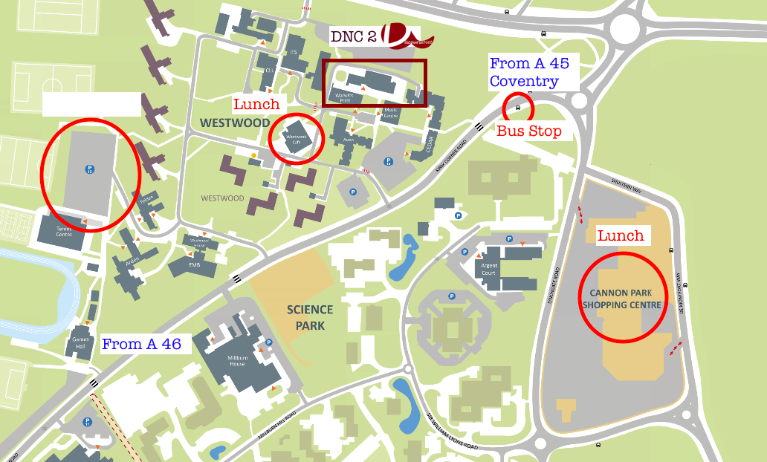

Sessions

Paper presentations must not exceed 15 minutes and there will be 10 minutes for discussion. Before your talk, the panel chairs will need some biographical information from you.

Poster presenters should bring posters no bigger than A1 (please get in touch with Kyoungmi,Kyoungmi.Kim@warwick.ac.uk) .

The rooms will be equipped with projectors. If you need special adapters (i.e. not VGA), you must bring your own ones.

We cannot print or copy anything on the conference site.

You will be given a receipt of your fee at the conference.

Internet Access and Social Media

There is access to the Eduroam network on campus.

The official hashtag of the conference is #DNC2, we encourage you to tweet about your observations and reflections from the sessions.

Inquiries and Emergencies

Do not hesitate to contact us if you have any questions. In case of urgency, you may call Ronny Scholz +44 7400 103914 or Tilly Harrison +44 7811 006391.

The Organizing Team

Johannes Angermuller, Johannes Beetz, Sixian Hah, Tilly Harrison, Eduardo Chávez Herrera, Kyoungmi Kim,
Michael Kranert, Stephanie Schnurr, Ronny Scholz, Veit Schwab, Sue Wharton, Marta Natalia Wróblewska,
Shafiq Hizwari Md Hashim, Norazrin Zamri, Christina Efthymiadou, Michael Kranert, Francoise Dufour.

