Assignment Question:
Carry out a trial run or ‘pilot’ of one of the research ‘instruments’ you will use during your research project (e.g survey, interview schedule, observation schedule). Explain the principles on which you designed this ‘instrument’ and the opportunities and problems you foresaw. How did your instrument work in practice and how would you amend it in the light of this experience. (Note we are expecting you to report on a trial run not an extensive pilot). The date for submission of this assignment is 31 August 2015.
Terminology:
PQMethod (analysis software), Q-sort (framework used for and the activity of sorting), Q set (set of opinion statements on the construct under study), P set (group of participants)
Introduction
My research interests are in emotions or stances taken by learners in their mathematics education journey in general but their viewpoints on their mathematical resilience in particular. Mathematical resilience, defined as a ‘positive adaptive stance to mathematics which allows students to continue learning despite adversity’ (Johnston-Wilder & Lee, 2010) is of particular interest to me as it is a relatively new construct that could contribute to improvement in mathematics performance and is receiving growing interest and research into, and my research will add to this body. Literature review reveals that, of the research carried out in this area of mathematical resilience so far, there is no research at the moment that used Q Methodology (subjective-internal standpoint of the individual) to explore this construct. Previous research has extensively used the R Methodology (objective-external standpoint of the researcher), e.g. Johnston-Wilder & Lee 2010. The pros and cons of each methodology will be discussed in greater detail in the thesis I will produce from this research. A search of journals on the use of Q Methodology has also revealed that this methodology ‘can be found across the social science spectrum’, McKeown and Thomas (1988 p11), even though it still retains this ‘new method’ status within the larger scientific community. Brown (1988 p5) supports the use of Q Methodology when he says ‘There are few methods and techniques employed in the social sciences which, as conventionally used, lend themselves to the study of operant subjectivity.’ I have therefore chosen to use the Q Methodology to explore the construct of mathematical resilience because it is the methodology best suited to explore and highlight some of the viewpoints of learners on affective factors attributed to and indicative of mathematical resilience (as proposed by previous objective research) in learners. This is also supported by Coogan and Herrington (2011) when they say ‘Therefore if you want to know what ‘points of view’ exist on a particular topic, then use Q methodology, as this allows for the subtle differences to be highlighted as well as the major differences to be seen.’ The overarching aim of my research is to investigate students’ viewpoints in relation to mathematical resilience. This pilot study will feed into and inform the rest of my research, my practice as a teacher as well as give other professionals an extra ‘tool’ in the box.
This pilot study will try out two ‘instruments’ that I will be using in my research, the q sorting technique, for data collection, as well as the PQMethod software, for data analysis. So, this pilot report will give a brief snippet of my research.
Instruments I will be using
- Q sorting technique (using Q Set and Q sort Frame)
As mentioned above, I chose to use a q set (appendix 1) and q sort frame (below) to carry out my data collection.
The q set is a term used within the Q methodology research technique to refer to the set of statements that are produced to describe different viewpoints of the phenomena under investigation. My q set, of 36 statements, describes opinions held by individuals that are associated with different affective factors on mathematical resilience. These factors include, but are not limited to Value, Struggle, Growth and Resilience (Kooken & Johnston-Wilder 2013). For the purposes of this ‘pilot’ and as a launching pad, my q set is made up of modified statements from the Mathematical Resilience Scale developed in 2013 by Kooken, referred to as a ‘ready-made’ q set (McKeown and Thomas 1988 p25).
The q sorting is a term used to describe the activity of ranking the statements and placing them accordingly into the q frame. For my pilot, to accommodate the 36 statements, I designed the frame below.
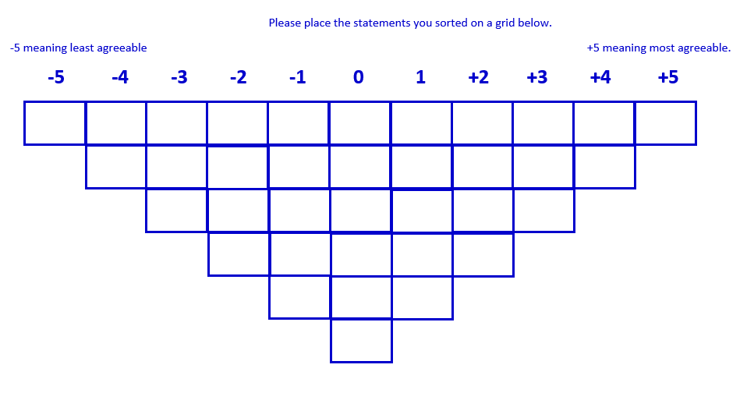
As well as the ready-made q set, I will provide space on my q sort template for participants to add any other opinions or comments they would like to express about mathematical resilience. These newly generated opinion statements will either be incorporated in a modified q set for my main research or used to develop a completely new q set.
- PQMethod
There is a wide range of software that Q researchers use to analyse their data. These include FlashQ, PCQ, QMethod (later version called PQMethod), Q-Assessor, QPress, HTMLQ and Ken-Q Mobile (online search). I chose to use the PQMethod because I found and joined a community website that offered the software for free, tutorials and as well as support. As this was a completely new software I felt I could use all the help I can get
The PQMethod software is a program specifically tailored to Q Methodology studies. It analysis and produces intercorrelations between q sorts then factor analyses these to produce an extensive output that includes a variety of tables on factor loading, factor scores, defining statements for each factor as well as statements across factors (as shown in the results section). This output is what I will then use to produce an analytic report on viewpoints held by respondents in relation to mathematical resilience. A more detailed discussion and unpacking of this output is provided later in the results and analysis section.
Principles on which I designed this ‘instrument’
There is a lot of tension in the research field as to what constitutes a q set. Different researchers hold different views on this. Drawing on wider research, McKeown and Thomas (1988 pg 25-27) give a good summary of these views. They point out that there are ‘naturalistic q-samples’, generated purely from communications from participants, ‘ready-made q-samples’, generated from sources like rating scales and ‘hybrid types’, generated from a combination of the two afore mentioned. I am yet to decide on which route to take but at the moment, for the purposes of trialling this data collection and new analysis method and software, I will use ready-made statements. Should I design my q set for my research, it will follow one of the above discussed principles.
My q-sort frame followed the general structure widely used by Q methodologist, an invented quasi-normal distribution (Rogers in Smith, Harr’e and Langenhove 1995). There are varying suggestions on which frame is suitable for which type of construct. Van Exel and de Graaf (2005 p6) point out that a highly contentious construct would benefit from a near flat (as shown below) q frame as people will be more opinionated either way with very little neutrality, while a mild construct would benefit from a deeper frame as people there is a greater chance of neutral opinions. It was after reading around this literature that I decided to structure my frame as shown above.
Opportunities that I foresaw
One of the opportunities that I foresaw was trialling an instrument that was new to me and my area of research, which had been used in similar research elsewhere but not in my area of interest, mathematical resilience. This research would be ground breaking in the body of research in this area. The study would also help me understand my students’ point of view on their mathematical learning journey better to better equip both me and my students to make this journey as profitable and manageable as possible. I also sought to administer and collect approximate MBTI data to look for any evidence of relevance/link between students’ viewpoints on their personality and their viewpoints on their mathematical resilience. Another opportunity that I foresaw was that I could use this exercise to collect a comment from each respondent to give them a voice (Johnston-Wilder & Lee 2010) to express their own opinion. This exercise will potentially provide me with new q set items that I could either incorporate into a modified q set (a hybrid set) for my research or use to produce a new q set (a naturalistic set).
Problems that I foresaw
Like any research, there are inherent problems. One of these for me was time. I was trialling a new instrument that was not familiar to me so I was not aware of how much time I needed to carry it out. Complications of the school timetable and school programme played a part in this issue as well. In my previous research I had used questionnaires and I had a good idea of how using questionnaires works, but q sorting was completely new to me. Tying in with time was the issue of logistics. As I had never administered q sort before, I did not know how I would set it up, how many I could have been ‘q sorting’ with at any one time. In the literature review I carried out, the researchers did the q sorting in a wide range of ways. Plummer (2012 p53) did a face-to-face q sort exercise, Stollerly (2013 p34) carried out a ‘small group’ q sorting exercise, ‘usually of two participants’, while Van Exel (2005 p7) refers to a study where q sorts were administered through mail. My choice of approach was greatly influenced by feasibility within the school timetable and school schedule.
The other problem I foresaw was that of what statements to use. As discussed above, different researchers have different opinions of what makes a q set. Going with the naturalistic approach would have meant a 2 stage exercise, statement collection and q sorting, which would exacerbate the time issue mentioned above. Furthermore, it would greatly squeeze on the ‘school time’ I could take out for this activity. Another, and probably potentially the biggest, problem I foresaw was the need to become familiar with the new software. As I mentioned before, Q Methodology (and my software of choice PQMethod) has not been used in my area of research. This raised the issue of support and/or collaboration in learning and understanding the new software as this would involve someone from a different research field. This brings with it issues of finding common available time, venue as well as factoring in travelling costs etc.
In Practice.
As discussed earlier, I have explained that I used a ready-made q set, designed an appropriate q sort frame following the general structure widely used by Q methodologists, but what I have not explained is how and why I chose my p set.
To those familiar with R methodology, the Q methodology approach to participants may seem perverse (Rogers in Smith, Harr’e and Langenhove 1995), as it seems, in a number of ways, the complete opposite of R methodology. Rogers points out one of these differences when he says ‘the participants in Q methodology are not sampled, they are chosen to facilitate the expectation of finite diversity. They are chosen particularly in a multiplex of person-locations or subject-positions, ones where the researchers expect, out of their own cultural knowledge, to hear varied stories, accounts or discourses.’ (p182) relevant to the construct under study.
With that in mind, my p set was made up of my current year 10 set 3 group from the girls’ school I currently work in. The class is made up of 21 students. I chose these students as I felt they were at that stage where they are starting to weigh up what is important (or not) to them and are quite opinionated about what is important to their future careers. I felt they will have a clearer understanding and viewpoint about their mathematics learning and their resilience, as they are not at the ‘start’ and neither are they quite at the ‘end’ of their learning journey. They would be at the ‘crucial’ decision-making stage about the value they place on mathematics.
As mentioned earlier, most of the Q methodologists whose research I reviewed carried out a wide range of q sorting approaches. I decided to do the 21-1 q sorting, primarily due to time and logistic constraints. The students sat in exam conditions. Each had an envelope containing the written information and consent page (app1), the q sort instructions (app 2), the q sort template (app 3), the MBTI instructions (app 4), the MBTI questionnaire (app 5) and the statement cards (app 6). I asked the students to read the instructions first and then all the statements so they get a general feel of what the statements are about. Once the students had read all the statements they then had to start sorting them, starting off by putting them into three roughly equal groups. At the start of this exercise I spoke to the group for about 5minutes, then I helped individuals. Individuals mostly asked questions related to grouping the statements. The q sorting and the MBTI questionnaire were all allocated an hour slot. The q sorting generally took longer than the MBTI questionnaire. Some students completed the two activities early and were advised to review their q sort and MBTI questionnaire cf exam conditions. The students were all fully compliant. Once both tasks were completed and reviewed (for some) they were placed back in the envelope, I collected them and the students left.
After collecting the envelopes, I then narrowed the number I was going to analyse to 13. The narrowing down exercise was done after I had received my 2015-2016 timetable and class lists. The reason for this was that while I still wanted to and was trialling this new technique, I also wanted it to have impact on my practice by focusing my in-depth understanding particularly on the students I was going to be working with in my year 11 class the following year. Due to set moves, even though I was still going to take the same set 3 into year 11, some of the students had either been moved up or down, and of the group I had in year 10 only 13 remained in that same set. These are the 13 I proceeded to analyse.
Results from the q sorting activity.
An example of a result from a q sorting activity
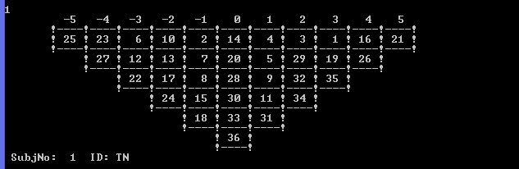

Outputs from the Q sorting analysis.
To begin the analysis, each participant’s rank-ordered statements needed transforming into an array of numerical data (as shown in the q-sorts above). This was achieved through entering the raw data into the PQMethod software. The ranking ranged from -5 (denoting the least agreeable statement) to +5 (denoting the most agreeable statement). These are the scores each statement received. Once this data was run through the software, each arrangement was then intercorrelated with the arrangements of other participants. This produced a matrix that showed which participants arranged the statements in a similar order. A factor analysis of this matrix produces arrangement clusters that are highly correlated, referred to as ‘factors’ or ‘opinion types’ (Valenta and Wigger 1997). Factor ladings show each participant’s association with each of the identified factors (see table below).
For this pilot study I chose to extract 3 factors. I made this decision following a guideline given by Watts and Stenner (2012 pg 197) where they suggest the ‘extraction of a factor for every six Q sorts in your study’.

- Factor Loading for each participant.
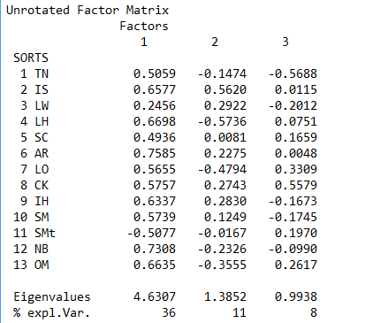

- Statement scores by factor
Factor 1:Top 10
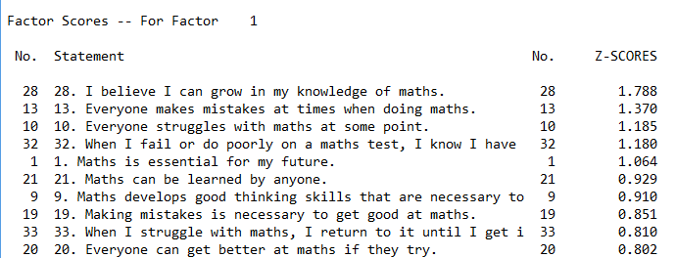
Bottom 10
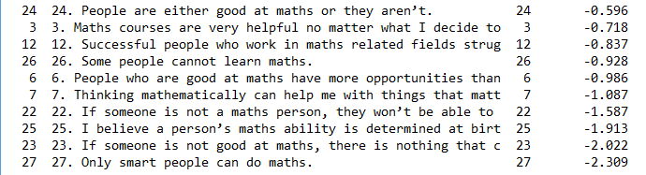

Factor 2:Top 10
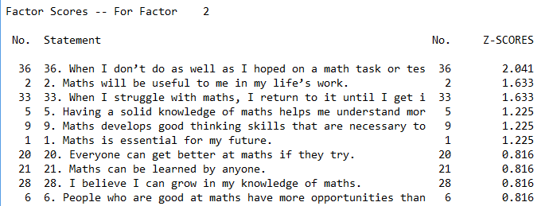
Bottom 10
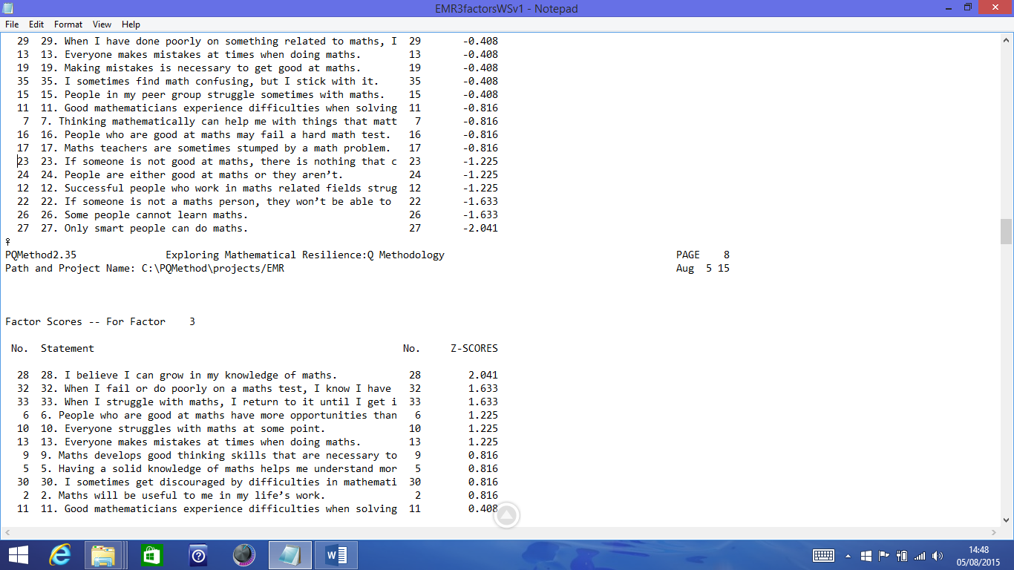

Factor 3:Top 10
Bottom 10
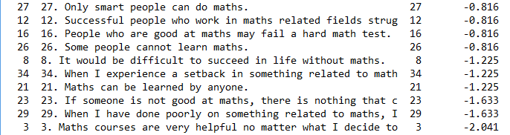

- Distinguishing Statements for each factor:
Factor 1
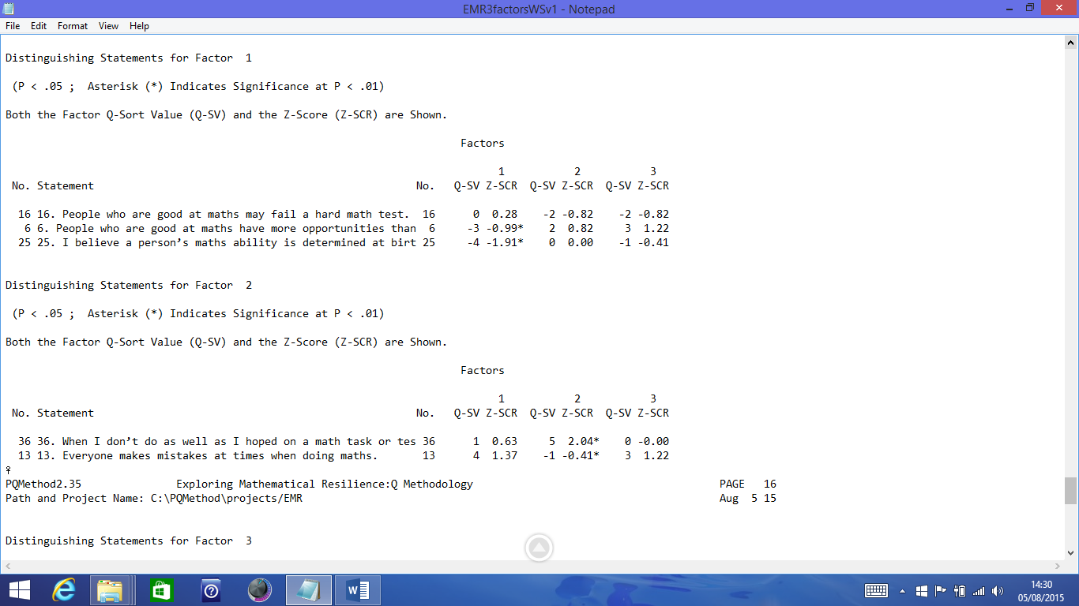
Who is the factor 1 student?
The distinguishing statements for factor 1 identifies the student who does not hold a growth mentality (Dweck 2000) and believe that even people who are good at maths can fail (once they reach their ability limit) but this student still appreciates the value of maths.
Factor 2

Who is the factor 2 student?
Distinguishing statements for factor 2 identifies that student who believes that anyone can make mistakes at maths and that there is value in keeping on trying.

Factor 3
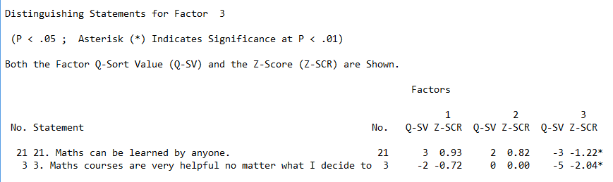
Who is the factor 3 student?
Distinguishing statements for factor 3 identifies that student who values maths and believe that anyone can learn maths.
Interpretation of the Q sorting analysis.
Factor loading
In order to identify significant sorts for each factor I needed to calculate the significant level for my data. The significant factor loading (SFL) for my data, at the p < 0.01 significance level, was 0.43. Any sort that loaded above 0.43 would be considered significant. Using this significant factor, I then sorted the factor loading results into 3 groups as shown below.

SFL on single factors (sorts that loaded significantly for each factor):
Factor 1: 1, 2, 4, 5, 6, 7, 8, 9, 10, 12, 13, 11(-ve)
Factor 2: 2, 4 (-ve), 7 (-ve)
Factor3: 8, 1 (-ve)
Significant factor loading on single factors showed all three factors as bipolar factors. These would make for some tricky but interesting interpretation. Also, Factor 2 has 3 significantly loading Q sorts while factor 3 has only 2 significantly loading Q sorts (relatively few). Watts and Stenner (2012 pg 199) would suggest improving these outcomes by extracting only the number of factors that have eigenvalues of more than 1(on the factor loading output). In my factor loading output only 2 factors have an eigenvalue of more than 1, suggesting I should extract 2 factors. I will leave ‘improvement’ outside of this project and include it in my amendments section for further exploration. There is quite a lot of further technical know-how associated with this methodology that I need to explore and this will form part of my further literature review.
Having sorted out those Q sorts for each category of SFL, I was able to flag (shown below) defining sorts that I would be exploring under the distinguishing statements for each factor.
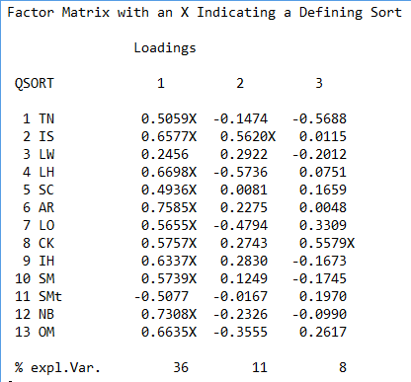
SFL Confounded (participants loading significantly on more than one factor)
1, 2, 4, 7, 8
These sorts significantly loaded for more than one factor and will make for further exploration, with the help of further literature review.
SFL Non-significant (participants who do not load significantly on any factor)
3
Sort number 3 did not significantly load for any of the factors extracted. What would be interesting is to explore further what effect extracting more or less factors would have on sort 3’s factor loading.

Brief Discussion
As can be seen from the above outputs, this makes for interesting findings. The above interpretation is just a snippet of what can be drawn out of these results. A more in-depth analysis will be dealt with in the thesis. It would have been noted from the introduction that this study is two pronged, it explores mathematical resilience as well as understanding their personalities. Because of limitations of space the links, if any, between viewpoints and personality will be explored in greater detail in the upgrade paper and the subsequent thesis. This study has presented a shortened form and not a completed research.
Amendments
Using the instruments in practice achieved reasonable success. Even though this worked much better in my head (and on paper), I felt it was not as 100% successful as I would have liked. Some of the reasons I would attribute to this are lack of experience in setting up the activity as well as time constraints. Because I had time constraints I decided to do the 21-1. I found that even though the students were all compliant, the 21-1 set up was not as manageable as I thought it would be. There is no telling what influence the fact that I needed to help one student not too far from another would have had on their outcomes. The MBTI was not as clear as I thought it was and because students were at different stages of these two tasks at any one given time any ‘explanatory help’ to one student would be overheard by another student opening the possibility of either a positive or negative impact. I will try and do another mini pilot involving a 1-1 and/or 2-1 q sorting this time, for comparison purposes as well as checking to see if either the 1-1, 2-1 or ‘21’-1 would be the preferred set up for the next stage of my research. Another amendment I will make, following further literature review, is that my q sorting frame will use ‘most agreeable to most disagreeable’ instead of ‘most agreeable to least agreeable’. This is because the latter (drawing on wider research) assumes that my participants agree to some extent with all the statements presented to them, there is no provision for them to disagree with any of the statements.
What have I gained from this exercise?
I have gained new skills in using new software (and the accompanying language), gained experience in using a new research technique (Q Methodology) and more importantly a better understanding of the PhD research process. I have also gained useful data for next year’s teaching as this data will enable me to better plan, facilitate and support students in my charge’s learning of mathematics and hopefully guide them to greater success.
Appendices
Appendix 1
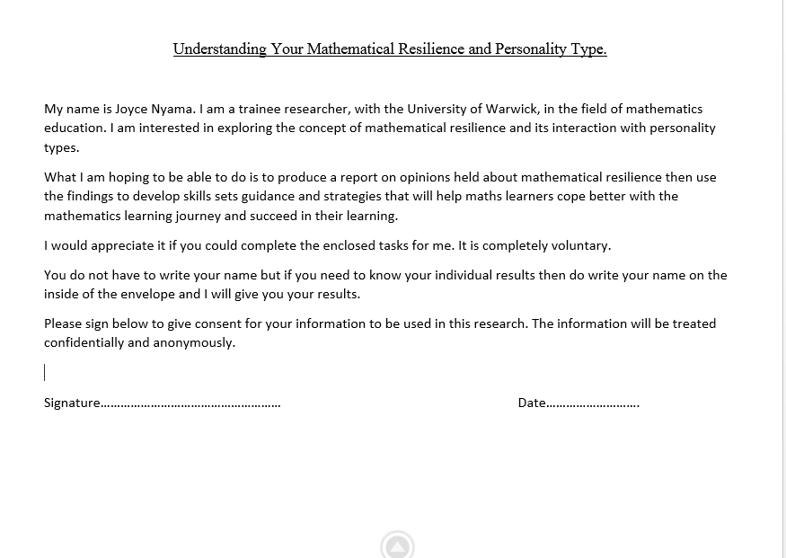
Appendix 2

Appendix 3
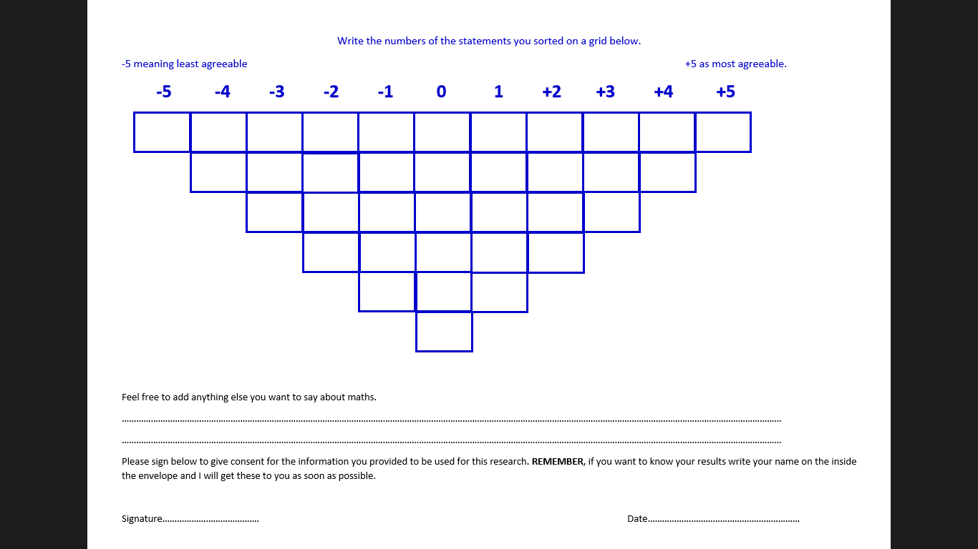
Appendix 4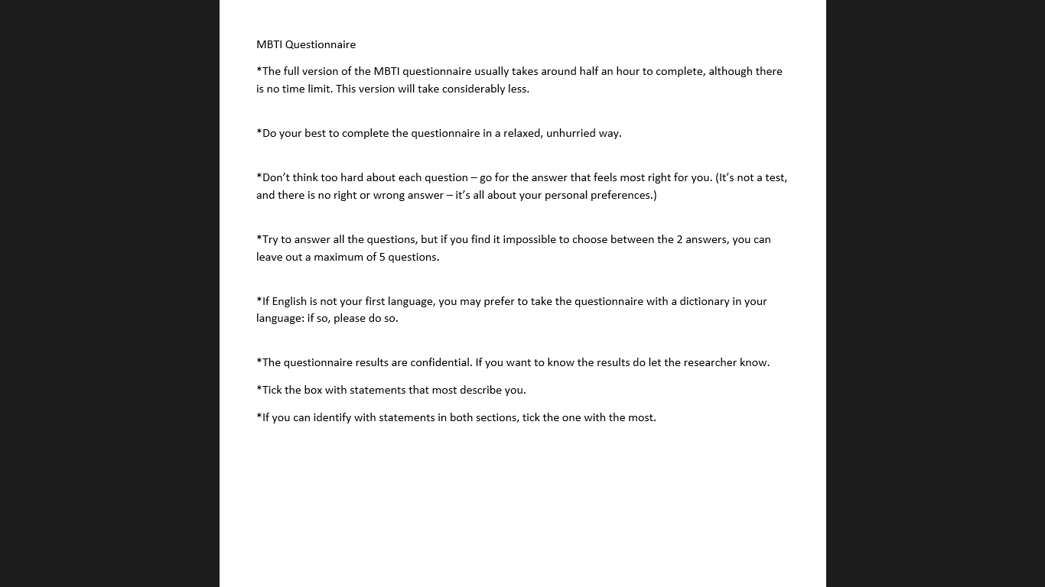

Appendix 5 (source Myres’ Introduction to Types)
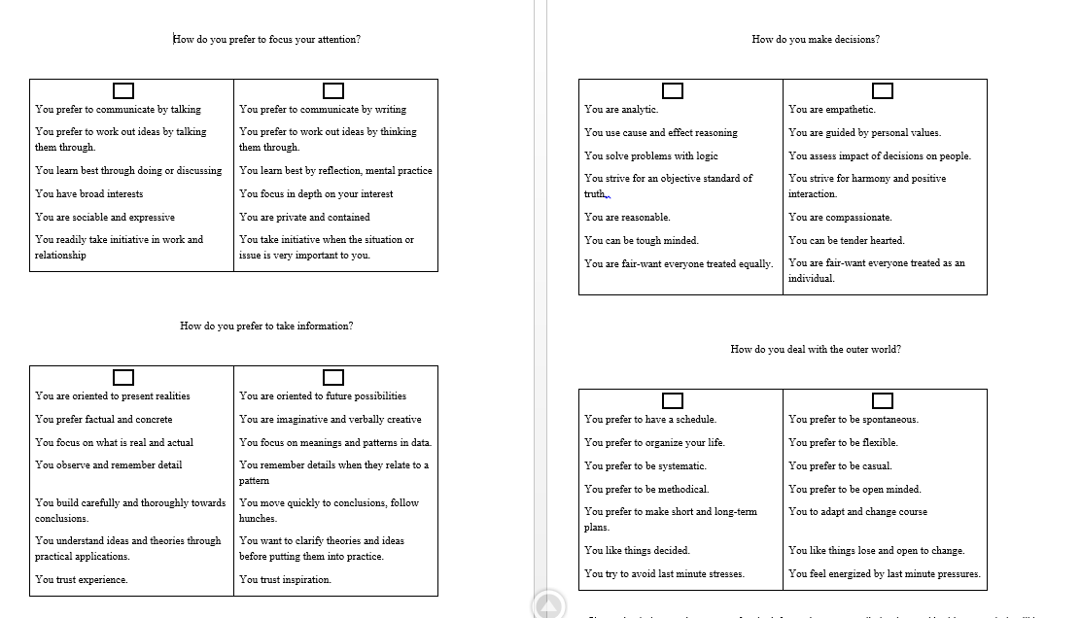
Appendix 6
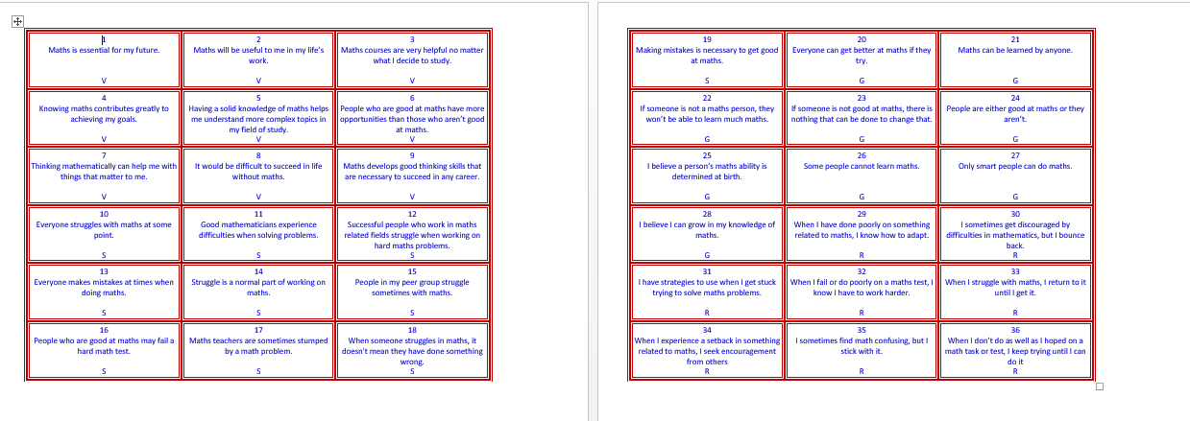

References
Brown, S. R. (1980). Political subjectivity. New Haven, CT: Yale University Press.

Coogan, J. and Herrington, N. (2011). Q Methodology: an overview. RESEARCH IN SECONDARY TEACHER EDUCATION Vol.1, No.2. October 2011 pp. 24–28.

Dweck, C. (2000). Self-theories: Their role in motivation, personality and development. Lillington NC: Psychology Press, Taylor & Francis.

Johnston-Wilder, S. (2013). Measuring mathematical resilience: an application of the construct of resilience to the study of mathematics, AERA 2013, San Francisco, California. WRAP Warwick.

Johnston-Wilder, S & Lee, C. (2010). Mathematical resilience. Mathematics Teaching.

McKeown, B. & Thomas, D. (1988). Q Methodology. Newbury Park: Sage Publications.

Myres, B. I. (1998). Introduction to Types: CPP Inc.

Plummer, C. (2012). Who Cares? An Exploration, using Q Methodology, of Young Carers’ and Professionals’ Viewpoints. The University of Sheffield.

Stollery, R. L. (2013). A Q Methodological Study of the Support Values by Students with English as an Additional Language. The University of Sheffield, 126 p.

Valenta, A. L. & Wigger, U. (1997). Q-methodology: Definition and application in health care informatics. Journal of the American Medical Informatics Association, 4, 501-510.

Van Exel, NJA. and Graaf. d. G. (2005). Q Methodology: A sneak preview. Rotterdam.

Watts, S. & Stenner, P. (2012). Doing Q Methodological Research: Theory, Method and Interpretation. London, Thousand Oaks CA, New Delhi, Singapore: Sage Publications.

Software source: http://schmolck.userweb.mwn.de/qmethod/#PQMethod (accessed 27th May 2015)

