Five Propositions: Why policy initiatives struggle to improve social mobility rates.(Accepted to appear in the spring edition of FORUM; not to be quoted without permission from the authors)

Bernard Barker (Emeritus Professor of Education, University of Leicester) and Kate Hoskins (Reader in Education, Roehampton University)

Coalition Government plans to increase social mobility in the UK place a strong emphasis on improving education to ensure more equal life chances for everyone. As Secretary of State for Education between 2010 and 2014, Michael Gove declared that he was ‘determined to do everything I can to help the poorest children in our country’ transcend their backgrounds and progress to leading positions in the land. This policy goal is consistent with the widespread perception that a better life depends on working hard at school to gain qualifications and entry to prestigious universities. Our paper argues, however, that the government’s proposed improvements in teaching, the curriculum and examinations are unlikely to achieve their desired goal. Five propositions are presented to illustrate the strength of the varied obstacles to social mobility.Deep structures, including poverty, class, gender and inequality shape the lives of families and individuals in ways that are not easily changed by educational intervention.

Introduction
Successive governments have declared their eagerness to improve life chances for individuals so that society becomes fairer and more meritocratic. Tony Blair promised to make greater social mobility the priority for his third term as Prime Minister (Wintour, 2004, unpaged), while Nick Clegg, as Deputy Prime Minister after 2010, said that ‘improving social mobility is the principal goal of the Coalition Government’ssocial policy’ (HMG, 2011, p. 3). New Labour and Coalition strategies for promoting mobility have been broadly similar, and emphasize the extent to which education can enable individuals to overcome family circumstances. The statistics and conclusions rehearsed inGetting On, Getting Ahead (Cabinet Office, 2008), and in Unleashing Aspirations (PFAP, 2009),closely resemble those that appearinOpening Doors, Breaking Barriers (HMG, 2011), and in The Importance of Teaching (DfE, 2010).

Our paper challenges thisestablished policy consensus. We presentand discuss five propositions drafted to encapsulatestrongevidence that education reformsare unlikely to improve rates of social mobility. We argue that Coalition policy is essentially flawed because it depends on overlooking the issues and data reviewed below and on discounting the influence of social and economic structures. The propositions are:

1. There has been no significant change in overall patterns of social mobility in the UK despite massive and continuing investment in education.

2. Elite formation, stratification and inequality are features of most human societies, and arise from a mixture of political conflict and economic organization rather than from weaknesses in the school system.

3. Relative family wealth is more strongly associated with educational outcomes than any other variable or combination of variables.

4. Class differences shape how people experience and respond to their circumstances and are instrumental in producing differential outcomes in education and the workplace.

5. Increased inequality since the 1970s is a powerful obstacle to improved rates of social fluidity and mobility.

Education and Social Mobility
The official version of social mobility disregards these possibilities in favour of a profoundly individualist model of social change and development. Each child is expected to work hard to achieve good examination results and improved career prospects, and so to become the author of his or her own life story(DfE, 2010). Policy-makers have encouraged, but have also been influenced by, the rise and spread of a culture of individualism and an economics of individualization (Ball et al., 2000; Savage, 2000). Their assumptions reflect a long-standing discourse that can be traced back to nineteenth century writers and reformers like Samuel Smiles, who became a celebrity with his book Self-Help (1860)and popularized the idea that an individual’s character and hard work arethe keys to social progress.

Smiles gave countless examples of famous men who sprang ‘from the ranks of the industrial classes’ to achieve distinction in various walks of life (1860: 24), including great inventors (like James Watt) who were ‘principally working men’ (1860: vii). Today, new examples (Bill Gates, Sir Alan Sugar, Sir Stuart Rose) seem to confirm the long-standing popular conviction that hardworking, determined individuals will achieve upward mobility, despite their family circumstances.

The belief that access to education can overcome an individual’s disadvantaged circumstances, transformhis or her life chances and improve social efficiency is also deeply rooted in British thinking and culture.Robert Owen (1969), an early nineteenth century reformer and one of the founders of the cooperative movement, was among the first to recognize the role that education could play in social improvement. He claimed that governments were able give any character to any community and that a proper system of education would lead to natural social harmony.

His passionate conviction was widely shared through the nineteenth and early twentieth centuries, with large numbers of ‘the rank and file of the working class world’ coming to believe education would enable them to transform themselves and the wider society (Tawney, 1924: 7). Since the 1960s, human capital theory,combined witha growing faith in the potential of all young people, has encouraged hope that a longer, better education can remove the effects of social disadvantage (Woodin et al., 2014).

As Education Secretary (2010 – 2014), Michael Gove adopted thisview,and complained that ‘we still do not do enough to extend the liberating power of a great education to the poorest’ (Gove, 2011a, unpaged). He blamed the poor quality of state education for perpetuating disadvantage, and claimed that it was his ‘moral purpose’ to remove barriers that stop poor children from climbing to prestigious positions (Gove, 2011a, unpaged). Gove was convinced that ‘access to a quality education is rationed for the poor, the vulnerable and those from minority communities’ (Gove, 2011a, unpaged) and pointed his finger at schools where ‘all too many children’leave without ‘basic accomplishments’ (Gove, 2013, unpaged).

The Coalition government embarked, therefore, on radical reforms of the curriculum and assessment regime,with the intention of reducingthe differences in attainment between rich and poor and so improvingopportunity for less advantaged children. In short, Coalition ministers are persuaded that education is a potentially transformative ingredient that empowers individual effort and mobility through better examination results and believes every dedicated, hardworking individual can move upwards, regardless of personal circumstances (DfE, 2010; HMG, 2011).

Self-evidently, competitive individualism works for individuals. Numerouscases confirm that some succeed against apparent odds,rising to wealth and position not imagined by their ancestors. But such success stories are exceptional and are frequentlytold in ways that mask the advantages that have made them possible (Gladwell, 2008). The seriously upwardly mobile seem to be divergent, unrepresentativeindividuals, often with less education than might be expected. Right from early childhood they have been‘at odds with their environment’ and are inclined to deviate from the ‘pervasive and powerful norms’ that form most people’s aspirations(Richardson, 1977, p. 187).

Such individual, unusual examples of upward mobility, based on the accumulation of small advantages within particular families, tend to show just how hard it is for most ordinary people to buck the trend and escape ‘pervasive and powerful norms’, especially if they come from disadvantaged, lower class backgrounds. Our propositions help explain why character and hard work do not necessarily lead to better examination results and improved social status, and suggest that education reform is most unlikely to lead to large-scale social mobility.

The Propositions

1.There has been no significant change in overall patterns of social mobility in the UK despite massive and continuing investment in education.

John Goldthorpe and his collaborators are convinced that very large improvements in educational quality and access have had little impact on upward or downward mobility rates and that there has been no significant reduction in class inequalities since the early years of the twentieth century (Goldthorpe and Jackson, 2007; Goldthorpe and Mills, 2008). They argue that apparent changes in mobilitystem from shifts in the size and distribution of social classes, rather than from increases or reductions in social fluidity over time (Goldthorpe and Mills, 2008). The exceptional demand for professional and managerial personnel since the Second World War, for example, created the conditions for increased absolute social mobility, with individuals from lower groups able to secure positions in the elite service class because there was ‘more room at the top’ (Goldthorpe, 1987; Goldthorpe and Jackson, 2007). But relative mobility rates are unaltered, with the proportion of individuals found in different class positions from those of their families of origin remarkably stable since the 1970s (Goldthorpe and Mills, 2008).

This emphasis on the essential stability of British society over an extended period is consistent with research in the 1990s indicating that the pattern of relative class mobility chances or the degree of equality of opportunity has remained the same through the years covered by the Oxford Mobility Study, the Essex Class Project and the British Social Justice Survey. The authors found class boundaries neither more nor less permeable than in the past. Sectoral shifts towards non-manual work had created more room at the top, but no greater opportunity to get there from less-advantaged social positions. Children of service-class parents were found to be five or six times more likely to obtain service class jobs than those from working-class origins (Marshall et al., 1997).

These conclusions are confirmed by a Department of Work and Pensions research report. The authors conclude that trends in social mobility are decidedly resistant to policy interventions, mainly because those in higher social classes seem to have taken greater advantage of the opportunities created by government action, and to have used additional resources to maintain their relative position (Nunn et al., 2007; HMG, 2011).

2. Elite formation, stratification and inequality are features of most human societies, and arise from a mixture of political conflict and economic organization rather than from weaknesses in the school system.

Michael Gove blamed state schools for social immobility and inequality but elite formation, stratification and inequality seem to be features of most human societies, and to arise from a mixture of political conflict and economic organization rather than from flaws in education. A recent survey of a vast number of archaeological and anthropological studies suggests that inequality developed during the transition from early hunter-gatherer groups to larger, settled communities. Achievement-based societies became common once agriculture was established. The ‘active manipulation of social logic by human agents’ seems to have driven the creation of hereditary inequality, although factors such as population growth, intensive agriculture and a benign environment seem to have played a role. People’s desires to be thought of and treated as superior have been another powerful motive in the formation of unequal social structures (Flannery and Marcus, 2012: 191). Today’s ‘rent-seekers’, who use their political power to secure a lucrative legislative and regulatory regime, provide a contemporary example of the ‘manipulation of social logic’ (Stiglitz, 2012).

Stratified, unequal societies, once established, have shown remarkable resilience even in times of turbulence and violent upheaval, often resisting the best efforts of social engineers and revolutionaries. In Hungary, for example, a rich qualitative survey of family histories has shown that overall patterns of social mobility have been broadly similar to those found in western capitalist countries. Life chances for the descendants of all social classes were determined by predictable structural and cultural factors, although the socialist regime favoured skilled industrial workers and farm labourers, and discriminated against professionals and kulaks. There seems to have been little significant change in relative positions within the social hierarchy (Andorka, 1997).

A study of fifty Russian families suggests that even the extreme conditions of the 1917 October Revolution failed to prevent many of the expropriated members of the governing class from reinserting themselves into the Soviet regime. Between 1914 and 1918, almost all the well-to-do and rich were made poor. The Tsarist social order vanished, removing the collective resources that had enabled the former elite to transmit social status.This trauma does not seem to have prevented significant numbers of children of the old guard from integrating themselves into post-revolutionary society through political activism. It seems that a ruling-class habitus, possibly internalized in childhood as a disposition to organize and direct others, may have contributed to the process (Bertaux, 1997: 250).

If unequal social structures and relative mobility rates have remained more or less stable through war and revolution, we should hardly be surprised at evidence of similar continuity in the UK, particularly when our domestic trends closely resemble those recorded in other Western European countries and the US (Breen, 1997). There has been no successful invasion of the country since 1066, and this has contributed to the stability of British society and institutions over many centuries. The distribution of status, wealth and income captured in government statistics has not emerged suddenly but reflects a long history of inequality that has produced privilege for some and serious disadvantage for others.

Current trends suggest that inequality has grown worse; other indicators, including youth unemployment and increased debt, as poor families struggle with lower incomes, seem to be loaded against upward mobility (Wilkinson and Pickett, 2010; Clifton, 2011). The recent increase in payday loans is a particularly worrying development, reminiscent of the debt servitude and debt slavery that anthropologists have identified as factors in the creation of inequality in earlier periods. Families who receive food and shelter in times of need are in ‘a poor position to deny … claims to luxury items and hereditary privileges’ (BBC News, 2013a; Flannery and Marcus, 2012: 79).

This evidence about the origins and durability of unequal social structures does not support the idea that education is the decisive influence on life chances. On the contrary, some scholars believe that educational processes are important in social reproduction, aid the transmission of class advantage, and contribute to social stability (Bourdieu and Passeron, 1977).It is hard to believe thathistoric patterns of unequal wealth and opportunity, compounded through many generations, have no impact on children’s prospects of success.Can it all be down to the schools?

3. Relative family wealth is more strongly associated with educational outcomes than any other variable or combination of variables.

Webber and Butler (2005) added the UK Mosaic Neighbourhood classification system to the records of the Pupil Level Annual School Census (PLASC) and found that the type of neighbourhood in which a pupil lives is a more reliable predictor of his or her General Certificate of Secondary Education (GCSE) performance than any other information held about them on the PLASC database.

National performance data also shows a strong correlation between GCSE results and relative wealth. The outcomes shown on Figure 1 trace the steady improvement in GCSE point scores from left to right as the relative wealth of neighbourhoods improves. The above-mean performance shown for advantaged neighbourhoods in the upper right quadrant of the figure is the mirror image of the below-mean performance shown for disadvantaged neighbourhoods in the bottom left quadrant. Figure 1 shows relative performance dispersed across the spectrum of inequality, rather than sharply polarized between disadvantaged Free School Meal (FSM)/Pupil Premium eligible students and everyone else. The gap that policy-makers are so keen to close may be a statistical illusion, produced by applying the FSM criterion to identify students in need of support. The closely graduated relationship between GCSE performance and relative wealth supports the hypothesis that social structure, however conceptualized, exerts a strong influence on student outcomes and limits what can be achieved by school-level interventions.

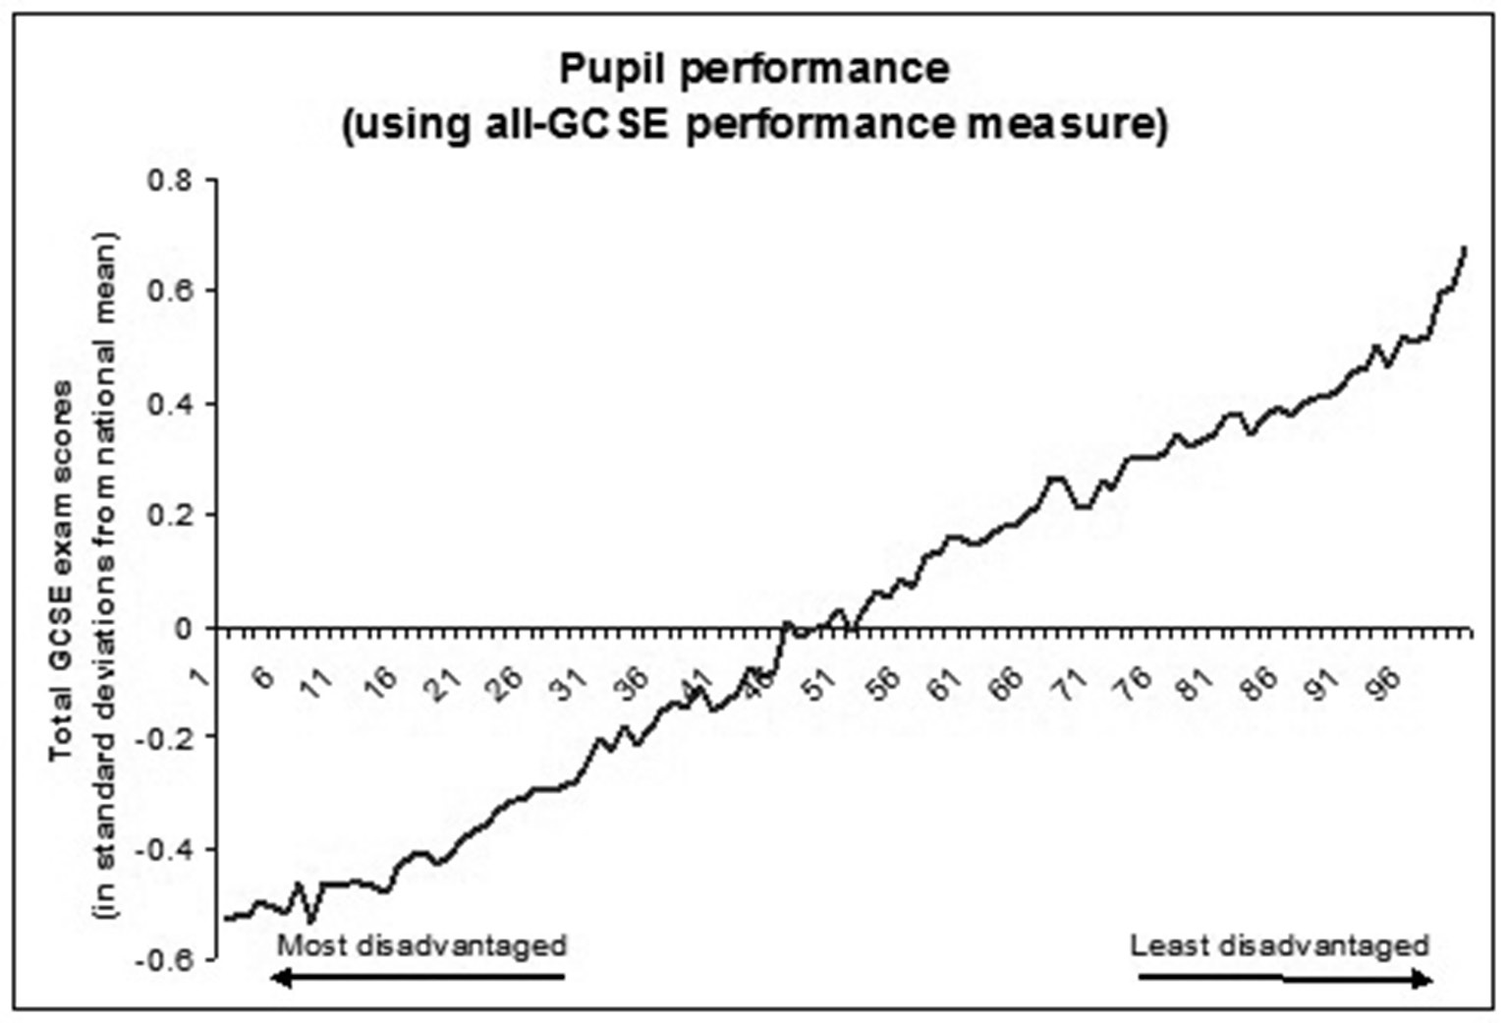

Figure 1: Standardized GCSE examination point scores at state schools in 2010, displayed by the relative wealth of neighbourhood (Cook, 2012)

The evidence that relative wealth is a better predictor of achievement than any school variable raises other questions. If education transforms lives, why have schools found it so difficult to close the attainment gap and improve mobility rates? If students are the designers of their own lives and careers, why do so many follow in the footsteps of parents, siblings and other relatives?

4. Class differences shape how people experience and respond to their circumstances and are instrumental in producing differential outcomes in education and the workplace.

Class differences continue to be experienced and felt. They exert a continuing influence on young people’s aspirations and goals. Between 1983 and 1991, for example, it was consistently found that two-thirds of the population regarded themselves as working class, suggesting that class remains a major anchor for social inequalities. Surveys show that people continue to identify themselves in ways that involve relational comparisons with members of other classes (Savage, 2000). Class categories continue to have a high degree of construct validity because they can be used to show differences across a range of life chances and choices along theoretically expected lines, for example in relation to security of employment and earnings prospects (Goldthorpe and Mills, 2008).

Persistent differences in the life chances experienced by dissimilar social groups confirm that the dream of a classless society is far from realization and that class processes continue to shape people’s outlooks and prospects. Diane Reay (2006: 303) argues that class remains ‘the hereditary curse of English education’, the ‘zombie’ still stalking our schools and classrooms even after more than twenty years of reform designed to improve their effectiveness. She points out that the attainment gap between the classes, like relative social mobility rates, is as great today as it was twenty or even fifty years ago. Working- and middle-class life patterns remain sharply different, with class ‘everywhere and nowhere, denied yet continually enacted’ (Reay, 2006: 290). Despite reduced levels of class awareness, class differences continue to be important and class itself is ‘ever present in people’s lived experience’ (Savage, 2000; Archer et al., 2010: 10).

Despite considerable overall social fluidity, class background is also closely associated with subsequent occupational destinations. Just 7 per cent of ‘high-ability’ sons of large business owners and managers were in manual employment by the age of 33, compared with 38 per cent of the ‘high-ability’ sons of unskilled manual fathers. By contrast, over half of the ‘low-ability’ sons from professional families join the middle class, compared with 10 per cent of the ‘low-ability’ sons of unskilled manual workers. Savage concludes that students from middle-class backgrounds are better able to convert their high ability into middle-class jobs than those from the working class, and he believes this superior conversion rate is probably related to the social, cultural and economic resources available to them (Savage, 2000). The absence of such resources could explain why the disadvantaged do less well and why education has failed to improve relative mobility rates (Devine, 2004).

5. Increased inequality since the 1970s isa powerful obstacle to improved rates of social fluidity and mobility.

There is new evidence that relative status, and the relative steepness of the social gradient to which we all belong, are profoundly important for children’s welfare and long-term life chances. Wilkinson and Pickett’s (2010) epidemiological study of inequality has three main elements. In the first, they compare the income spread in 21 advanced countries, using the Gini coefficient, with each country’s index rating on ten health and social problems. Figure 2 shows the results, with the least unequal countries experiencing significantly better outcomes than the more unequal countries.

The second element repeats this analysis with comparable data from the states that comprise the US. This study confirms the relationship between high inequality and greater health and social problems, with the least unequal states having better outcomes than more unequal states. Wilkinson and Pickett conclude that the gradient of income inequality in a state can be used to estimate accurately the incidence of health and other problems in that state. They show that ‘international educational scores are closely relatedto income inequality’ and that ‘more unequal states have worse educational attainment’ (2010. p. 105).

The final element draws together a large number of health studies that confirm the negative impact of social inequality. Increased inequality produces heightened anxiety, evaluative threats to the social self, reduced self-esteem, greater social insecurity and more status-related shame. Innumerable studies reveal that each of these has a marked impact on health, including life expectancy. The incidence of problems does not relate to average income levels or particular levels of disadvantage but to the spread of income across the social gradient. Everyone is better off in more equal societies. This is a troubling finding for the UK, where income inequality has increased dramatically since 1974 and is among the highest in the world.

Wilkinson and Pickett (2010) argue that inequality and the resulting disadvantage are not shaped by levels of material deprivation, or confined to a particular location or community, but are instead features of human society that condition everyone’s health and happiness. For them, education is just another area where inequality exerts a formative influence, not an agent that improves life chances or overcomes social problems. Schools may help a few fortunate individuals achieve upward mobility, but they cannot overcome disadvantage as a phenomenon, however efficient and effective they may become (Equality Trust, 2012; Wilkinson and Pickett, 2010). As Crawford et al. (2011) conclude in a review for the Department for Business, Innovation and Skills, it is very hard to increase social mobility without tackling inequality.

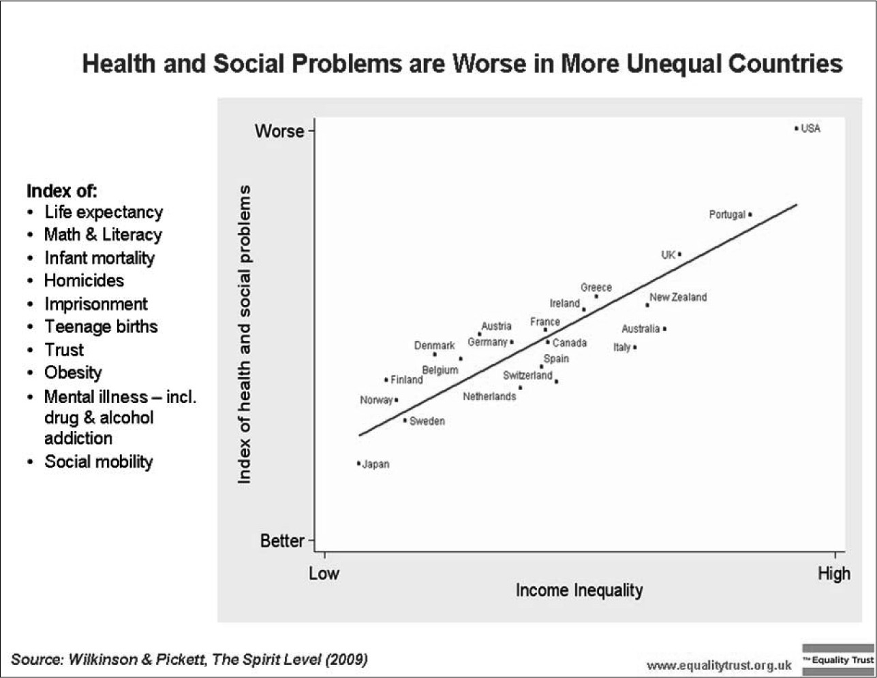
Figure 2: Income inequality compared with health and social problems
(Wilkinson and Pickett, 2010)

