How to reduce teachers’ marking workload? New evidence from an EEF evaluation
This week sees the publication of the EEF’s FLASH Marking evaluation. Lead Evaluators, Rebecca Morris and Stephen Gorard, and FLASH Marking developers, Sarah Cunliffe and Leon Walker, summarise the findings from the report.
Teachers and school leaders know about the importance of providing high-quality feedback to their students, and evidence has shown the value of feedback for promoting pupil progress. We know much less, however, about the impact of written marking and feedback.
Alongside this challenge, there has been growing awareness of teachers’ excessively high workloads and the contributions of marking and feedback approaches to these (see e.g. Allen et al., 2021). Research has also highlighted how workload is associated with problems for teacher retention and reduced feelings of wellbeing.
Findings from our recent evaluation of FLASH Marking suggest that there may be a practical way to reduce teachers’ marking workload while still providing high-quality feedback to students.
Why was FLASH Marking needed?
In response to the workload crisis in schools, the DfE and Ofsted have acknowledged the issue and have produced the School Workload Reduction toolkit and other guidance. These are welcome contributions from a policy perspective, although it is not yet clear what impact they have had for schools and teachers around the country.
More rigorous evidence is also needed on the effect of new or alternative marking and feedback practices in the classroom. Do these approaches lead to improved outcomes for students? Can they help to reduce teachers’ workloads?
These were questions which the FLASH Marking development team, Sarah Cunliffe and Leon Walker, sought to answer when they designed the approach. After seeing benefits in their own school, the approach was approved for an EEF-funded evaluation in 2017. The trial involved 103 schools from across the UK and included 18,500 pupils and 990 English teachers.
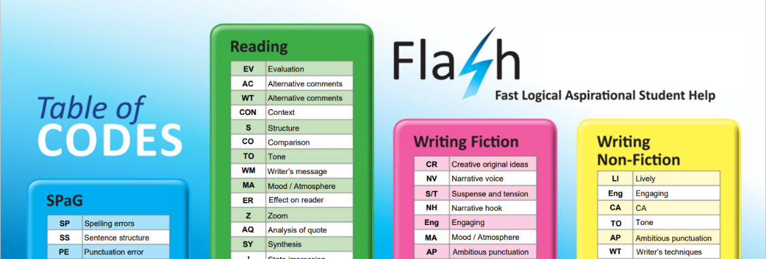
What is FLASH Marking?
The FLASH Marking approach involves using skills-based codes in Key Stage 4 English. The FLASH codes are aligned with language from the GCSE English Language and Literature grade descriptions and are presented to students to signal where there are areas for improvement and development in their work. An example of the codes can be seen in the image above, and further details about the intervention can be found in the evaluation report here.
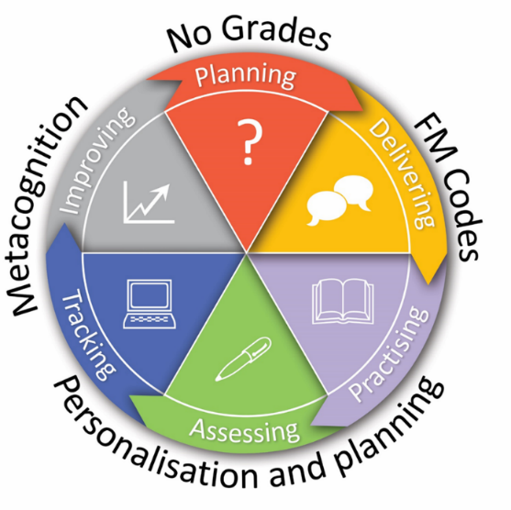
But FLASH Marking is also about much more than code-marking. Through professional development and a range of strategies and resources, the approach is designed to provide personalised and focused feedback while also developing students’ metacognitive skills, encouraging them to take a more proactive and independent role in their learning. FLASH also allows teachers to create meaningful assessments that inform future planning and contribute to a shared language in the classroom.
How does FLASH aim to reduce marking workload?
English teachers recognise that feedback plays an integral part in helping students to understand, develop and thrive in their subject. FLASH ensures that students receive feedback rapidly and regularly but that they aren’t always reliant on the teacher to provide it. Self-assessment and peer-assessment play a pivotal role in the approach, working in tandem with teacher planning, assessment and oversight.

Did FLASH Marking reduce teachers’ workload?

Due to the impact of Covid-19, it was not possible for the measure of impact on English Language and Literature attainment via GCSE exams to take place as planned: key conclusions are based on analysis of the teacher workload survey, along with in-depth data from the implementation and process evaluation.
Findings from the trial indicate that teachers receiving FLASH Marking reported a greater reduction in both total hours spent working and hours spent marking compared to teachers who did not receive the intervention.
The process evaluation also found that teachers were positive about engaging with FLASH and recognised its potential benefits for students and staff alike. When asked to share how it had influenced their workload, the comments below are indicative of the kind of feedback we received.
‘There is no doubting that it has reduced teacher workload when it comes to feedback and assessment, allowing us to spend more time on important things like planning.’ (Head of Department, London)
‘We can all agree that our workload has definitely reduced. Marking a set of books is no longer such a daunting process and the students’ responses to feedback is now of a much higher standard as they are taking more ownership and pride in their reflection time.’ (English teacher, North West)
What’s next?
The outcomes of this evaluation are valuable, and potentially helpful for informing decisions around marking and feedback at school level. Due to the pandemic and the lack of externally assessed, standardised GCSE outcomes, it was not possible to complete these attainment analyses. Rigorously assessing the impact of FLASH (and other approaches to marking/feedback) on student academic outcomes is a vital next step.
FLASH Marking required senior leaders and teachers to commit to a two-year investment into professional development, allocating dedicated time to ensure that the principles of the programme were embedded and well-implemented. As with most school improvement strategies, the approach required investments in time, money and teachers’ energy. Our findings suggest that while FLASH appeared to support the development of assessment practice in many schools, these investments also have the potential to influence and improve other areas, such as curriculum planning and implementation.
So should teachers consider adopting new approaches to feedback and marking?
Yes….But there are no quick fixes. Implementing any new approach requires school leaders and teachers to carefully consider the core active ingredients and principles, and how these will fit with the needs of their context and students.
There is still so much more that we need to know about the impact of marking and feedback in the classroom. Reports such as this one on FLASH Marking add to our knowledge and hopefully support teachers to make evidence-informed decisions about implementing new approaches in their ‘real world’ school settings. We are optimistic that future research can continue to build this picture and enhance our understanding of the most effective strategies.
After a number of years working collaboratively on this project, one thing is certain. The success of the FLASH Marking evaluation could not have happened without the contributions made by the many schools, teachers and pupils who participated. We are grateful for their hard work and commitment and wish them all the very best for the future.

