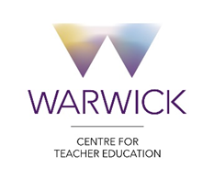

WaSP Agenda

Thursday 5th December 2019 (2.15 - 4.00pm)

- Welcome and introductions
- Apologies
- Minutes of last meeting and matters arising
- Updates:
  - Admissions (Cara Pearson – 10 mins)
  - ITT core content (document 1 attached)
  - Ofsted update (KI/DH – 5 mins)
  - Primary Programme Change (document 2 attached)
  - MA developments (document 3 attached)

- Discussion questions:
30 mins + 20 mins feedback and questions

- In the first term of Instructional Coaching (IC), what have you noticed?
- Good practice
- Impact on trainees
- Areas for consideration
- What do you need next to make your School/Alliance practice in IC and support of trainees stronger?

- What can we do as a partnership to make our provision more coherent, cohesive and effective?
Ref: Document 4 – Moderation Visit form

- Updates from partners
- AOB

Next meeting Thurs 19th March 2020

