ITE Policy Document – November 2018

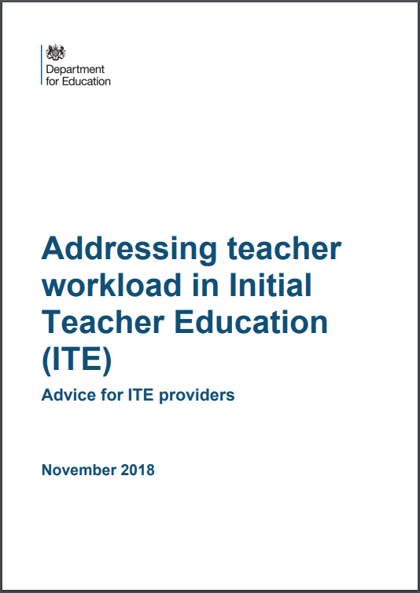

Aims:
- Reduce workload of trainees
- Establish good habits
- Encourage and foster culture change within schools
CTE’s commitment:
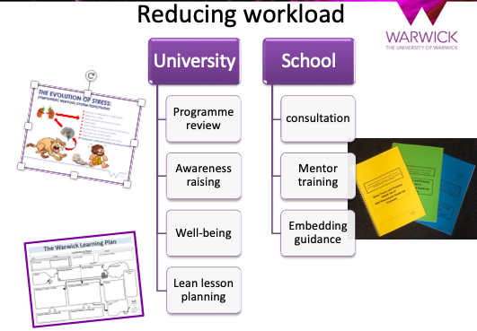

Future developments/opportunities:

- NQT transition conference
- On-going NQT support
- Partnership contracts
- Supporting lesson planning
- Mentor development
- Teaching expectations for placements

