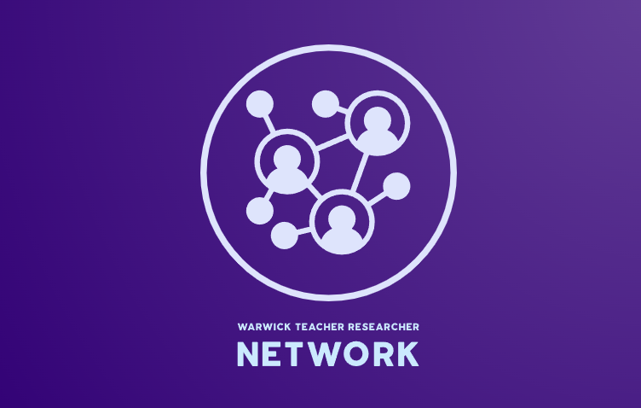
WARWICK TEACHER RESEARCHER NETWORK NEWS
ISSUE 5: 20th June 2022

Welcome to the Warwick Teacher Researcher Network
The WTRN is aimed at colleagues who are interested in close-to-practice research in schools, drawing together both university and school-based colleagues to support and enhance research culture. We are delighted to have secured funding from Research England’s Enhancing Research Culture fund to support the Research and Development People and Culture Strategy. The funding will support our drive to engage more people in research and provide access to research to our school partners. Burnaford, Fischer, and Hobson (2001) neatly summarise the essence of teacher-research, describing a personal as well as a professional quest, "a journey towards making sense of and finding satisfaction in one's teaching”, emphasising the importance of seeing teaching and research as a joint enterprise.

Our aims:
- Improve access to and participation in research.
- Improve research leadership skills across all career stages.
- Create routes for collaboration and exchange with third sector organisations.
- Deliver new approaches to public dialogue and community led research. The end of project report to be submitted in July 2022 would focus on whether engagement with his project contributed to these areas.

Proudly introducing the 2022/23 Teacher Researchers, their Research Development Liaisons (in brackets), and Projects:
Iain Green (Kate Mawson) - ‘Impact on culture of the development of a professional development strategy’.
Grace Laszlo (Andy Hind) - ‘What wellbeing strategies do ECTs learn across the two years of their course, and how do these help them manage workload and mental wellbeing effectively?’.
Alison Marsh (Rebecca Friesen) - ‘Cross-curricular teachers as experts in teaching reading: improving classroom approaches for teaching of reading to close the Covid gap’.
Helen Ward (Jen Rowan-Lancaster) - ‘Boys Achievement Action Research Group’.
Martyn Colliver (Will Haywood) - ‘Linking Stem education to real-world industry for project-based learning – a case study around an energy from waste (eFw) plant’.
Matt Hornsey (Kirsty Weeks) - ‘Building solid foundations for Disadvantaged Pupils’.
Katie Collins (Rachel Cooper) - ‘Efficacy of school-based interventions to support the development of self-esteem in secondary school children to reduce suspension rates and negative behaviours’.
Helen Cooke (Kate Mawson) - ‘Instructional coaching using the Teaching WalkThrus’.
James Luton (Alison Morgan) - ‘Equality and Diversity’.

Learn more about the rest of the 2022/23 WTRN and their projects via the community tab on the WTRN webpage: www.warwick.ac.uk/fac/soc/cte/professionaldevelopment/trn/community/

Promoting Research Culture in schools
“By engaging in research these teachers focussed on evidence they had collected, moving them from congenial (sharing) conversations to collegial or dialogic ones.” - Val Poultney (University of Derby)
“Research is becoming central to what schools strive to do: an increasing number are appointing research leads in senior roles, training teachers to become researchers and building centres to foster research initiatives.” - Iro Konstantinou (Tony Little Centre for Innovation & Research in Learning, Eton College)
“Placing the use of research practices and evidence at the heart of a school improvement journey enriches day-today decision-making, and enables the development of strong professional capital and a framework for self-extending transformation.” - Megan Dixon (Aspire Educational Trust)
On our WTRN webpage, you can find various helpful guidance resources on promoting and nurturing an inclusive and supportive research culture within schools, including:
- A link to issue 5 of the BERA Bites series (‘Research used or produced in schools: Which informs practitioners most?’) which presents selected articles from the BERA blog on key topics in education including:
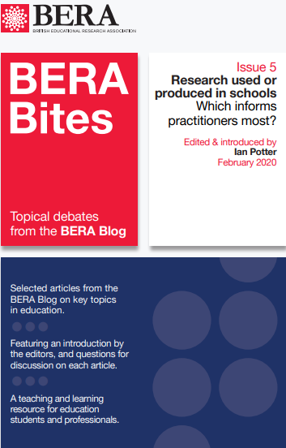
- Educational research as continuing professional development, and ‘self-improvement’, for teachers.
- The challenges of encouraging teachers and schools to become ‘research literate’.
- The importance of fostering a culture of research and research-use, particularly for school leaders.
- How schools can work with the university sector and other schools to create ‘collaborative spaces’ between research and practice.
- Ethical issues and ‘risk-taking’ in research-active schools.
- Professional doctorates and the power of insider research.

- A call-for-research partnership page to promote yourself and your research to attract and establish future research partnerships and opportunities within schools. Both Georgios Pazaitis and Charlie Atkins, for example, are undergraduate research students from the University of Warwick’s Education Studies course:

"'When in the blaze, build windmills' - Headteacher Practice, the Role of Pragmatism, and the Issue of System Change in UK Education"

With the support of Warwick's Undergraduate Research Support Scheme, I am conducting research into the praxis of headteachers in the UK. Working closely with practitioners, I aim to understand the discourses and practices successful headteachers draw upon to run excellent schools, while at the same time interrogating the potential of the headteacher role in effecting change beyond the school level, with a specific focus on marketisation and academisation. For this project, I am hoping to shadow the work of a headteacher for a certain time period to gain insights into their tasks and the issues they face. The exact timeframe and scope of the project would be collaboratively developed with the school. For inquiries, please contact me at Georgios.Pazaitis@warwick.ac.uk

The Factors Affecting Social Capital Among Students
Through the Undergraduate Research Support Scheme (URSS), Warwick has granted me funding to complete research focusing on Years 10 to 13 (KS4/5). I hope that the study will identify ways we can support students' access to social capital and meaningful networks. The study involves a 10-minute online student questionnaire and small focus groups (non-essential). I am keen to collaborate with the schools to share findings and recommendations on completing the study. This study has received ethical approval from the Department of Education Studies at the University of Warwick, and the data collected is anonymous. For more information, please visit: www.inspireyourfuture.co.uk/factorsaffectingsocialcapital
Contact:
Charlie Atkins (Researcher): charlie.atkins@warwick.ac.uk
Dr Rebecca Morris (Supervisor): rebecca.e.morris@warwick.ac.uk

To advertise a call for research partners or contributors, please send us an email: warwicktrn@warwick.ac.uk.

Upcoming events:

BERA SIG - Live, Virtual Journal Club Meeting: Charlotte Bagnal's ‘Talking about School Transition (TaST): an emotional-centred intervention to support children over primary-secondary school transition. Pastoral Care in Education’.
23rd June 2022|17:30-19:00|Dr. Claire Tyson and Emma Taylor
Register here: www.bera.ac.uk/event/a-virtual-journal-club-meeting


BERA SIG FORUM MEETING – Practioner Research SIG
13th October 2022
Join the Practioner Research SIG annual meeting to network with colleagues, learn about the activities of the SIG over the last year and plans for 2022. This meeting will be hosted on Zoom, where you will have the opportunity to network and speak to other SIG members.
Register here: www.bera.ac.uk/event/sig-forum-meeting-practitioner-research-sig

Queries, eager to contribute, looking to advertise, or keen to recommend others to us?

Email: warwicktrn@warwick.ac.uk

LinkedIn: warwick-teacher-researcher-network

Twitter: @WarwickTRN

