Maths and English Skills Check at Interview (Primary and Early Years)

The purpose of this task is to help identify areas of development in your fundamental skills in Maths and English (reading and writing). It should take you approximately 45 minutes.

Please complete without the aid of technology

Maths Task (approximately 20 minutes)

This graph shows the number of pieces of homework completed by Year 4 at Camberwick Green Primary over a fortnight period.

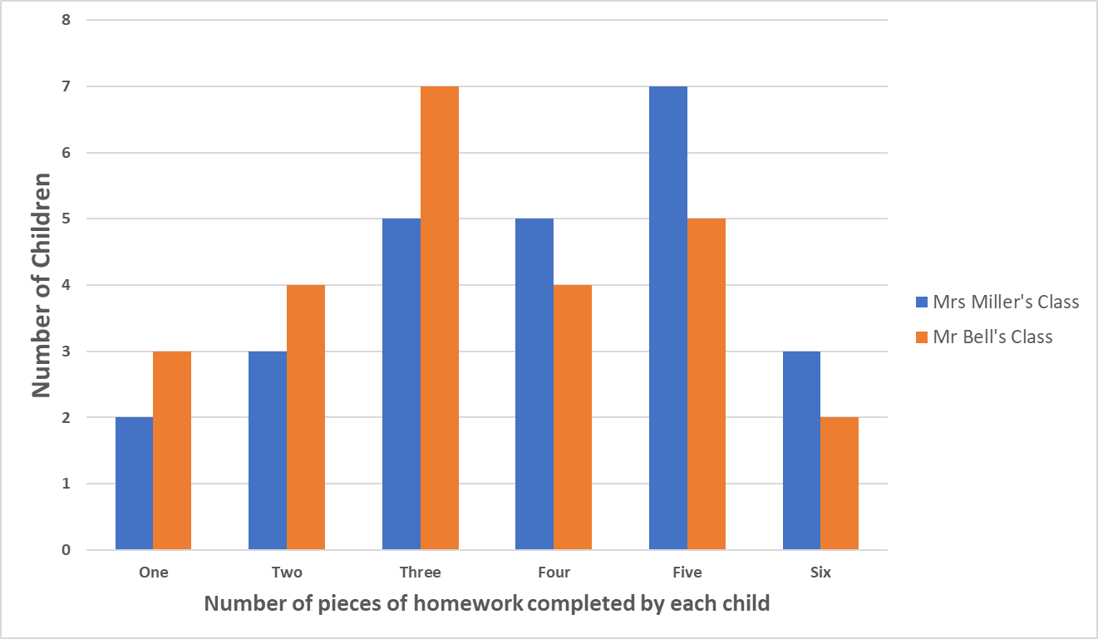
Please show your working out
- How many children in Year 4 completed less than 4 pieces of homework?

Answer:
- How many pieces of homework does Mr Bell have to mark in total?

Answer:
- Which teacher has more pieces of homework to mark in total?

Answer:
- If Mrs Miller has marked ¾ of her homework, how many pieces does she have left to mark?

Answer:
- What percentage of children in Mrs Miller’s class completed five or more pieces of homework?

Answer:
- In a parental survey at Camberwick Green
2/5 felt there was too little homework
1/10 felt there was too much homework
What fraction of the parents felt there was the right amount of homework?

Answer:
- If 90 parents completed the survey, how many felt there was too little homework?

Answer:
- Camberwick Green children use Times Tables Rockstars for homework. Over a three-week period, the following number of children practised at least once:
Week one: 345
Week two: 287
Week three: 323
Over the three weeks, how many times did children engage with Times Tables Rockstars in total?

Answer:

English Task (approximately 25 minutes)

Your response to the task should:
- Outline some of the advantages and disadvantages that you perceive of setting homework for primary aged children
- Consider what a school could do to mitigate some of the disadvantages
- Use clear, accurate, legible and coherent English
- Use correct spelling and punctuation
- Use paragraphs appropriately
- Use Harvard referencing to the best of your current ability

Teachers and educators have considered homework as one of the main mechanisms to continue pupils' learning when they are not at school. Authors like Corno and Xu (2004) defined homework as the “job of childhood” insofar as it develops pupils' responsibility and attitude, preparing them for their future profession. However, it has become one of the main sources of disagreement between schools and parents (Cooper, 2001) because of the sometimes excessive amount of homework given at an early age.

Authors who suggest that homework has a positive significant influence include Cooper, Robinson, and Patall (2006). Carrying out a meta-analysis of studies conducted between 1987 and 2003 in the US, they found a positive correlation (of approximately 0.60 standard deviations) on children's achievement. This evidence was, however, specific to the US, with the studies included in the meta-analysis varying in terms of size and quality. Outside the US, Baş, Şentürk, and Ciğerci (2017) also carried out a meta-analysis, finding a smaller but still significant average effect of around 0.20. This is consistent with the few cross-national analyses conducted to date…..Similar results had been found by Hattie (2009) who performed a meta-analysis on the influence of homework on academic achievement.

Yet Trautwein and Köller (2003) concluded that the empirical evidence with respect to its benefits was rather weak. This is supported by a recent analysis by the Education Endowment Foundation in the UK which, based upon the international literature, noted how “A number of reviews and meta-analyses have explored this issue. There is stronger evidence that it [homework] is helpful at secondary level, but there is much less evidence of benefit at primary level” (Education Endowment Foundation, 2017, p. 1). This is supported by Kohn (2006) who highlighted a range of issues with existing studies on the effects of primary school homework.

Taken from: Jerrim J, Lopez-Agudo LA, Marcenaro-Gutierrez OD (2020). The association between homework and primary school children's academic achievement. International evidence from PIRLS and TIMSS. European Journal of Education. Vol55 Issue 2 p248–260. Available from: https://doi.org/10.1111/ejed.12374

[input your response here]

