
Teacher Selection Day: Data Task
Introduction
Teachers must be able to read critically in order to remain up to date with new sources of policy and understand how to adapt their practice accordingly. They must also be comfortable working with data in order to monitor pupil performance and provide accurate feedback on children’s work. As such, the Department for Education states that all teachers are expected to be competent in fundamental English and mathematics and, by their end of their training, must be able to demonstrate competence across a wide range of literacy and numeracy skills.
This task is designed to gauge your abilities of comprehension and written communication, as well as your ability to interpret data and draw suitable conclusions. These elements are critical to successful completion of the Secondary PGCE and achievement of the Teachers’ Standards. This task is formative, meaning it will only be used to determine your support needs in respect of the fundamental English and mathematics skills. As such, it does not form part of the formal selection process, however you will need to complete the task and return this to us as explained below.
This should be your own work and the use of Artificial Intelligence (AI) to complete the task is not permitted. You will be asked to confirm you have not used AI at the point you submit this task.

Instructions
- This task is formative. Please complete it before your interview day and email your completed task to cte.admissions@warwick.ac.uk.
- As a guideline we recommend that you spend around an hour on it.
  - Approximately 15 minutes reading the information provided.
  - Then approximately 45 minutes formulating your response.
- Your response should not exceed two pages of A4 paper.
- You may use your phone or any other internet-enabled device if you wish
(though there is no requirement to do so).
Please read the information provided on the following three pages, which includes:
- Recent sources of policy from the Department for Education, for context.
- Commentary from the Education Policy Institute, for context.
- School data from three schools (A, B and C) within a Multi-Academy Trust.
The Task
Please write a written response to this information:
- Explain in general terms what the school data means in the context of the policy information with which you have been provided. You may wish to consider:
- The schools’ respective track-records over time for pupil progress.
- Each school’s performance compared to local and national averages.
- The relative performance of different groups of pupils within each school.

- Additionally, imagine you are the Chief Executive Officer of the Multi-Academy Trust:
- What recommendations would you make to the Head Teachers of each of the schools?
- In what areas is each school doing well and where might they seek to improve?
- What strategies might you suggest in order to improve outcomes across the Trust?
You may wish to refer to the source material from the Department for Education and Education Policy Institute in your response.
Progress 8
Progress 8 was introduced in 2016. It aims to capture the progress a pupil makes from the end of primary school to the end of secondary school. It is a type of value-added measure, which means that pupils’ results are compared to the actual achievements of other pupils with similar prior attainment. This new performance indicator measures performance across eight subjects. Every increase in every grade a pupil achieves will attract additional points in the performance tables.
Progress 8 scores are calculated for each pupil as follows. Firstly, all pupils nationally are grouped according to their prior attainment based on their key stage 2 results in maths and English, resulting in groups of pupils with similar starting points to each other. Secondly, each pupil’s Attainment 8 score is calculated, which is based on their GCSE grades in each of eight subjects. English and maths scores are double weighted to signify their importance. This scored is then compared to the national average Attainment 8 score for pupils in the same prior attainment group. A pupil’s Progress 8 score is the difference between their actual Attainment 8 result and the average result of those in their prior attainment group – a positive number therefore represents better than average progress.
A school’s Progress 8 score is the mean average Progress 8 score of its individual pupils. Progress 8 scores will be centred around 0, with most schools within the range of -1 to +1. A score of 0 means pupils in this school do about as well, on average, at Key Stage 4 as those with similar prior attainment nationally. A positive score means pupils make more progress, on average, than those with similar prior attainment nationally. A negative score does not mean that pupils did not make any progress; rather it means they made less progress than other pupils nationally with similar prior attainment. For example, if a school has a Progress 8 score of -0.25 this would mean that, on average, pupils in this school achieved a quarter of a grade less than other pupils nationally with similar starting points.
Adapted from: Department for Education, 2016. Progress 8 – How Progress 8 and Attainment 8 measures are calculated. London: Department for Education.

Pupil Premium
The pupil premium grant is additional funding for publicly funded schools in England. It is a school-level grant that gives schools extra resources to help them meet challenges, including those arising from deprivation. It is allocated for schools to:
- Improve the academic outcomes of disadvantaged pupils of all abilities
- Close the attainment gap between disadvantaged pupils and their peers across the country
School leaders are best placed to decide how to use the pupil premium to improve disadvantaged pupils’ academic attainment. There is a growing body of evidence on how schools can best help disadvantaged pupils make progress. The needs of all pupils should be assessed, and the grant used to make maximum impact in the school. Pupil needs will differ and will cost differing amounts to address. Schools are held accountable for the effectiveness of their pupil premium use by publishing a pupil premium statement online, as well as through published performance tables and data gathered during school inspections.
Adapted from: Department for Education, 2019. Pupil premium: funding and accountability for schools. London: Department for Education (online).

Commentary from the Education Policy Institute
The attainment gap for disadvantaged children emerges over the course of childhood but does not grow at a consistent rate. The gap widens most quickly before age five and between ages 11 and 16. We see a substantially slower widening of the gap during the latter years of primary school. Over the last fifty years, school funding policy has been reformed in two distinct ways. By seeking to ensure that funds intended for schools are spent on schools and, secondly, that funding levels match the greater needs of disadvantaged pupils. The pupil premium sits at the intersection of these two strands: it is allocated to schools on the basis of how many disadvantaged pupils they teach, and to be spent as schools see fit on the condition that they will be held to account for the outcomes of these pupils.
Our findings demonstrate that there is considerable variability between schools with differing pupil intake characteristics when it comes to trends in the progress gap, which measures how far disadvantaged pupils fall further behind their peers during school. Our analysis has uncovered divergent pathways followed by schools with different contexts. The progress gap is closing fastest in schools with the highest concentration of disadvantaged pupils. In contrast, schools with the lowest proportions of disadvantaged pupils have seen the progress gap widen, particularly at key stages 2 and 4. This growth has levelled off since 2012, but nonetheless paints a worrying picture of the prioritisation and focus that disadvantaged children are given when they are in the extreme minority.
Adapted from: Hutchinson, Dunford and Treadaway, 2016. Divergent pathways: the disadvantage gap, accountability and the pupil premium. London: Education Policy Institute (online).
School Data
School A
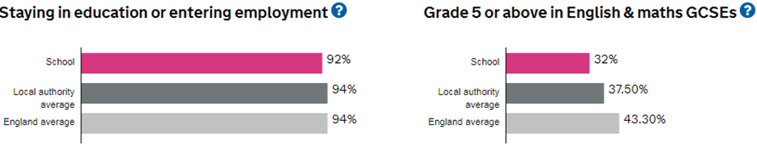
School B
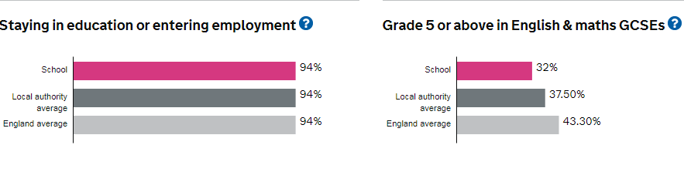
School C
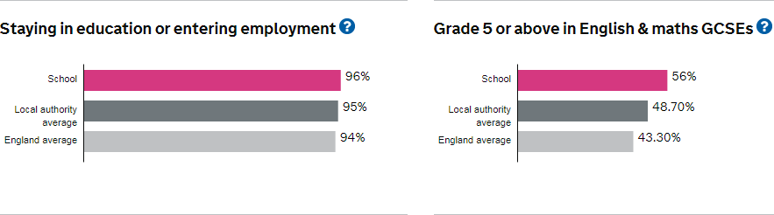

 | School A | School B | School C | Local Authority Area Avg. | National
Total number of Pupils | 662 | 1307 | 1792 |  | 3343780
Pupils with Special Educational Needs support | 13.6% | 13.7% | 13.9% |  | 10.4%
Pupils whose first language is not English | 52.6% | 81% | 7.1% |  | 16.5%
Pupils eligible for free school meals | 39.1% | 49.6% | 11.5% |  | 28.6%
Overall absence | 7.5% | 5.2% | 2% |  | 5.5%
All Pupils
Progress 8: Year 1 | -0.2 | 0.6 | 0.61 | -0.05 | -0.03
Progress 8: Year 2 | -0.49 | 0.24 | 0.45 | -0.12 | -0.03
Progress 8: Year 3 | 0.14 | 0.12 | 0.19 | -0.08 | -0.02
Disadvantaged Pupils
Progress 8: Year 1 | -0.44 | 0.48 | 0.21
Progress 8: Year 2 | -0.81 | 0.21 | -0.07
Progress 8: Year 3 | -0.25 | -0.08 | -0.62
Non-Disadvantaged Pupils
Progress 8: Year 1 |  |  |  | 0.08 | 0.1
Progress 8: Year 2 |  |  |  | 0.02 | 0.11
Progress 8: Year 3 |  |  |  | 0.12 | 0.13
Pupils whose first language is not English
Progress 8: Year 3 | 0.63 | 0.22 | 0.19
Non-mobile Pupils (those who were at the school throughout Years 10 and 11)
Progress 8: Year 3 | 0.2 | 0.12 | 0.21

