2023
Centre for Teacher Education Induction Handbook
STP
University of Warwick | Centre for Teacher Education


Dear Colleague

The Centre for Teacher Education (CTE) exists to provide high quality Initial Teacher Education (ITE) and Professional Development for teachers and school leaders. We are passionate about the importance of developing the very best teachers who gain employment in our partner schools and beyond and who make a difference to children and young peoples’ lives.
We pride ourselves on making a difference to our students. We place high-quality teaching and student support at the heart of what we do and recognise that our success is built on the strength of our partnership with our students and schools. Teaching is our top priority and our commitment to our students is paramount.
Our professional and support staff play a vital role in supporting students. Our team are friendly, committed and enthusiastic and our warm and welcoming culture ensures that we work with you as an individual as you develop and are encouraged to fulfil your potential.
I extend a very warm welcome to you as you join the Centre for Teacher Education and hope that your professional life at Warwick is both rewarding and fulfilling.
I look forward to meeting you very soon.
Best wishes,
Andy
Dr Andy Hind
Head of the Centre for Teacher Education, University of Warwick

About Us

CTE is the main department of the university responsible for initial teacher education in schools. All our courses are post graduate taught (PGT) except for the Introduction to Teaching undergraduate (UG) modules.

Strategic Vision and Intent

In 2021 the department engaged in a strategic renewal process where the following strategic vision and intent were agreed for the next 5 years:
To be the first choice for teacher education, contributing to the supply and retention of intellectually curious teachers, with an outstanding national and international reputation for research informed academic practice, thought leadership and professional excellence.
To continue the long history of teacher education at Warwick where generations of teachers change the lives of the children and the young people they teach.
Underpinning all that we do are our Warwick Teacher Values. We aspire to foster the following values in all teachers who engage with learning at The University of Warwick.
Social justice: to be ethical in their approach to young people’s learning, inclusive of all young people in their work and fostering of social justice through education.
Intellectual curiosity: Where students are curious to learn about learning, passionate about mastery of teaching expertise and critical thinking in examining evidence to inform their practice.
Creativity: Receptive and resilient to challenge and change, open to imaginative ways of working and resourceful in acquiring new skills.
These 3 Warwick Teacher Values are underpinned by the core values of approaching our work through an international dimension and through a commitment to sustainability.
The courses we currently offer are:
- Primary (5-11) PGCE (Core & School Direct)
- Primary (2 -7) PGCE (Core)
- Secondary PGCE (Core & School Direct)
- Assessment Only route to QTS
- MA in Professional Education
- PCGE International - PGCEi
- Introduction to Education Programme (Undergraduate Optional Modules)
The website offers lots of detailed information on the Centre and all the courses we offer and is a good place to start to get an understanding of CTE.
Link to CTE Organisational (Teams) Chart CTE CTE Organisational Chart

IT Services

The following information provides useful IT links and instructions.

For all IT Services information click on link - IT
Staff email account
Register account click on link - How to register for an ITS Account - University of Warwick
Once registered and your IT account is activated, this will generate a Warwick staff email and a username that you will be required to use to access Warwick staff pages.
Help Desk IT - helpdesk@warwick.ac.uk
Need Help -Call the helpdesk on 024 76573737 Available 9:00 to 17:00 Monday to Friday.
Use the online Help Desk at any time to ask a question or track your requests.
Link for work from home information using managed or unmanaged devices. IT-covid-19

Link to access Workspace instructions

Once registered for an ITS account, this will generate a Warwick staff email and a username that you will be required to use to access Warwick pages, including the STP website for the submission of timesheets.
All Sessional Tutors can get their staff card (which is required to access certain buildings and Library use) from Senate House on Main Campus.
CTE Website
Can be found at: - Centre for Teacher Education (warwick.ac.uk)

Staff ID Card
Once your IT account is activated you can attend Senate House or University House on Main Campus to collect a photographic ID card which will provide you with access to most university buildings.
For information re opening times and site location see information at University ID Card Printing (warwick.ac.uk)
CTE Resource inboxes
CTE has various resource inboxes listed below, please use these where possible.
Ctefinance@warwick.ac.uk – Finance and business / local HR administration for the Centre.
CTECurrentStudents@warwick.ac.uk – for current student related emails managed by the Student Experience Team.
CTEAdmissions@warwick.ac.uk – for course enquiries, managed by Admissions and Enrolment Team.
Studentreferences@warwick.ac.uk – inbox used for employers to request references for trainees.
Parnership@warwick.ac.uk – inbox used for communication with partnership schools.

Timesheets
Link to claim Sessional Teaching Payroll (warwick.ac.uk)
A timesheet is the method of recording your hours on a weekly basis, providing a reflection of the hours worked during that week. All sessional teachers are required to submit a weekly timesheet to claim for their hours. You should submit your hours online at the end of each week. Your administrative departmental contact is asked to authorise these hours before they are processed for payment.
There is a range of how to guides in this link STP How to guides please view the following 2 videos:
- How to complete a Detailed Timesheet (CTE require detailed timesheet for all STP contract)
- How to claim Holiday pay
If you cannot access the video’s, please find below a step by step guide also available via this Link
Below is a step-by-step guide on how to submit your detailed timesheets:
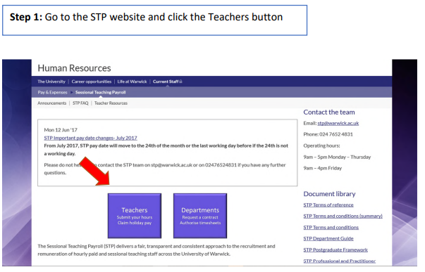
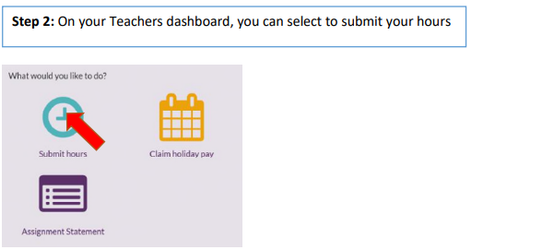

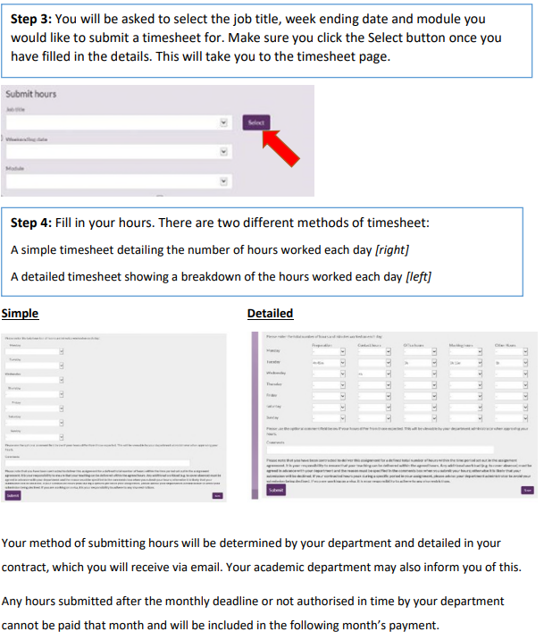
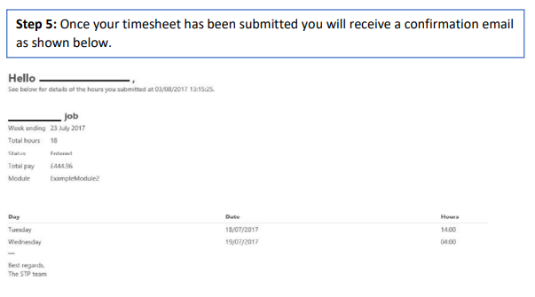
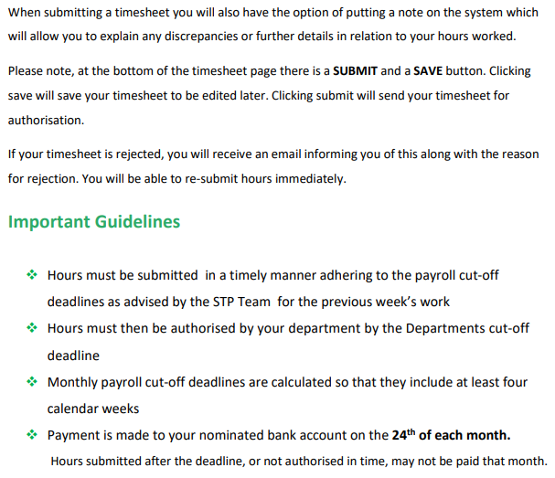
Holiday pay
Holiday pay is an additional amount to your standard wage and accrues for each hour worked. You can claim holiday pay online in the Tutor area ‐ please refer to the guidance document online via Link which illustrates how to claim holiday pay. We cannot automatically process holiday pay without a claim as this would constitute rolled up holiday pay which is against EU legislation. You will be required to claim all holiday pay during the contract year in which it accrues. Although the STP team will send out reminders before the end of the holiday year, it is the sessional teacher’s responsibility to make sure that all their holiday pay has been claimed before 31st August.
• Holiday pay is accrued with every hour that you work. • Holiday pay is available to claim after your hours have been approved by your department. • Claims for holiday pay must be submitted before the main payroll deadline. • Requests made after a payroll deadline will be processed for the next available payroll run. • Please be aware that you are unable to submit partial claims.
Please email ctefinance@warwick.ac.uk if you have any queries.
Success factors
Success Factors is the UOW online HR tool. We use Success Factors to complete HR-related tasks, please use the links below to access information for staff and managers about the system. There is also the information required to access your profile and other self-service tools currently available to you in Success factors.
If you do not have an ITS-managed PC or laptop, first ensure that you have logged into the University intranet and then click on the following link Success Factors
You will see that the system enables you to utilise the self-service online applications to make changes such as updating your personal information, changing address and bank details. Update details
During your first 2 weeks please familiarise yourself with the system, check that the information already contained in your profile is correct and make any amendments /additions as necessary If you are experiencing any difficulties, please contact CTEfinance@warwick.ac.uk

Expenses
Type of contract | Non-Taxable Expenses | Taxable Expenses | Expenses not applicable
Secondary PGCE Professional Practice Tutor (PPT) | Home to school mileage | Home to University for face-to-face Meetings
Secondary PGCE Personal Academic Tutor (PAT) |  | Home to University for face-to-face meetings
Secondary PGCE Sessional Tutor Subject |  |  | Expenses cannot be claimed for these contracts
Secondary PGCE Marking contracts |  |  | Expenses cannot be claimed for these contracts
Primary PGCE Moderation Tutor | Home to school mileage | Home to University for face-to-face Meetings
Primary PGCE Personal Tutor |  | Home to University for face-to-face Meetings
Primary PGCE Sessional Tutor |  |  | Expenses cannot be claimed for these contracts
Primary PGCE Marking contracts |  |  | Expenses cannot be claimed for these contracts

Expenses forms- please refer to table above to check which form you should complete

FP16a Non-taxable expenses form (Excel) - Non-taxable expenses are expenses incurred as part of carrying out the work and they may include travelling to a place that is not your standard place of work, interview expenses, and subsistence expenses. Non-taxable expenses will need to be claimed on form Fp16a, available above. The Fp16a form will need to be filled alongside evidence (tickets, receipts if no receipt is available, we would need whatever evidence you can provide, such as redacted bank statements or text messages confirming payment) and returned to ctefinance@warwick.ac.uk
STP exp Form-Taxable expenses - The University does not normally reimburse expenses related to commuting to Warwick/ your place of work. HMRC views this as “ordinary commuting”. Exceptions have been agreed in certain circumstances please see taxable expenses in table above. The STP taxable expenses form available above will need to be completed and sent to ctefinance@warwick.ac.uk
General rules
Always:
- sign and date (you should be able to copy your signature from a word document) and email ctefinance@warwick.ac.uk
- This form has a front and back-page tab to be completed by claimant
- provide postcode to postcode for mileage claims ensuring you indicate if a return journey and calculate the full return mileage (home to school)
- Always attach receipt evidence (ticket) for parking etc. (receipts if no receipt is available, we would need whatever evidence you can provide, such as redacted bank statements or text messages confirming payment)
- Send to ctefinance@warwick.ac.uk for budget holder approval and processing (not direct to expenses or STP payroll)
If you are experiencing any difficulties, please contact ctefinance@warwick.ac.uk
Essential links for STPs
STP Team - Sessional Teaching Payroll (warwick.ac.uk)

Other useful Links: -

IT support - https://warwick.ac.uk/services/its
IT set up - https://warwick.ac.uk/services/its/servicessupport/accounts/register/
HR - https://warwick.ac.uk/services/humanresources
Security Training Record - https://trainingessentials.warwick.ac.uk/

Training
New starters are required to read essential information and complete online training in this section within two weeks of joining Warwick. Completion is monitored online.
Health, Safety & Fire and Safety is the responsibility of everybody in the University. It is essential that ALL must follow health and safety procedures and take care of ourselves and others. All new colleagues and students MUST follow the link below and complete the mandatory Health & Safety Induction course.
Security and Information Management This includes completing the online Information Security Essentials Training Course. GDPR This e-learning module will help all staff to understand how to deal with (collect, hold, and manage) personal data.
New starters are required to read essential information and complete online training in this section within four weeks of joining Warwick. Completion is monitored online.
E D & I This e-learning module is designed to assist colleagues in carrying out their roles within the university and in understanding the relevant legislation in this field. It may be of relevance to front line or customer-facing colleagues and ALL who have a leadership or management role.
Unconscious Bias Unconscious bias looks at the nature of bias and how it impacts on the workplace. The course provides insight into how our own behaviour might be affected by prejudice and looks at what we can do to reduce or eliminate its influence in the decisions that we make.
Once you have completed the above, please see the link below for the additional training CTE requires you to undertake, this lists the UOW mandatory in blue & CTE mandatory training in black these courses should be completed within your first month and before the end of the probationary period. STP Training 2022
It is important that you send completed training certificates (or if the course does not provide a certificate an email confirming name of course and date completed) to ctefinance@warwick.ac.uk
DBS
University of Warwick will undertake DBS for all STP Tutor roles – note this is regardless of whether you have a current DBS with another employer
You will receive the application link from GBG Online Disclosures System <noreply@onlinedisclosures.co.uk along with instructions for completing and submitting your application.
Once completed and submitted please inform Warwick DBS and arrange for your ID documentation to be verified. You will need to contact DBS@warwick.ac.uk to arrange a visit to verify your documents. (Note UOW is currently not using the Post office service).
Please note that from submitting your application you have a maximum of 6 weeks to get the ID documents verified. Unfortunately, if you fail to get the documents verified within this period the application is cancelled and we need to request that the application link is reactivated
Please confirm via CTEfinance@warwick.ac.uk when you have received your copy of your UOW initiated DBS. This is in order that we can update CTE register which we maintain for Ofsted compliance

The Avon Building

For those STP colleagues undertaking roles that require them to come to the University
CTE office accommodation is in the Avon building. This building is accessible 24 hours a day. Before 8am and after 6pm a student card or staff card is needed to access the building.
Most of the building is occupied by CTE staff, but a small number of offices are used by other departments. There are also centrally timetabled teaching rooms and a student hub which are accessible by whole university student community.
The student hub
The seating area in the large ground floor central area is the Student Hub and study area. This facility can be accessed by students and staff from across the university and should be treated as a quiet area.
Visitors should be asked to wait in here and be collected by those staff organising meetings.
The kitchen
There are two kitchens for staff use only. On the ground floor the kitchen is off the student hub and first floor off the landing seating area. The code for entry to either is 7070.
In each kitchen there is a fridge, microwave, and toaster available for use. Please do ensure you clean up any spillages and dispose of any food that goes out of date. There is also a water-boiler on the wall for hot drinks and a plumbed in water cooler.
Toilets
Main female and male toilets are located by the entrance opposite Westwood Café. There is also a disabled and gender-neutral toilet available on the ground floor just off the Student Hub. On the first-floor landing area there is a further disabled toilet and a shower.
CTE Staff location Information
The Admissions and Enrolment Team WA0.19. cte.admissions@warwick.ac.uk
The Admissions and Enrolment Team are responsible for processing applications and offers across the Primary and Secondary phases of PGCE (university led) and across all other courses offered within the Centre for Teacher Education (Assessment Only, PQCEi, iQTS and MA).
They also support the lead schools within our school direct partnerships with their recruitment & process offers on their behalf.
The team are responsible for arranging and supporting interview days for university-led applicants and for tracking and chasing all conditions of offer (across all routes and courses) to ensure that applicants make it through the selection process, onto the courses, and are able to enrol.
If you would like to meet with the Admissions and Enrolment Team as part of your induction, so we can tell you a bit more about what the team does please feel free to arrange this through your line manager.
The Student Experience Team WA0.09 ctecurrentstudents@warwick.ac.uk
The Student Experience office provide support for all student and course administrative matters for programmes offered within the Centre for Teacher Education.
(Please note for admissions and enrolment queries please contact the Admissions and Enrolment team)
The team can provide you with advice and guidance regarding a wide range of policies and procedures including (but not limited to) mitigating circumstances, suspected plagiarism, and student withdrawals. They are also responsible for administering student references for PGCE trainees seeking their first jobs.
The team can help with ensuring you have the appropriate access to IT systems/software.
Please arrange to meet with the Student Services Manager as part of your induction so the team can provide you with overview of key information that will support you in your role.
Partnership Team WA0.01 partnership@warwick.ac.uk
The Partnership team gathers relevant information from students in order to effectively arrange their professional placements.
Partnership resource, organise and administer finances for university-led PGCE placements.
The team maintains partnership-facing intranet resources and distributes newsletters to partner schools.
They also play a significant role in contractual arrangements with schools, and in the vetting check (DBS (Disclosure and Barring Service)) process.
The team also provides secretariat for WaSP meetings, Steering Group, and the Suitability Panel.
Business & Finance WA0.20 ctefinance@warwick.ac.uk
The Business and Finance team are the first point of call for any issues concerning IT, Recruitment, Annual Leave, Training and Procurement please contact us with any queries you may have.

Primary Team hub located downstairs in WA0.05c
Secondary Team hub is located upstairs in WA1.05d.
Kate Ireland’s office WA1.05b (Director of the Centre) is also located upstairs
Lisa Ramsden PA to Director and SLT in WA1.05a.

Staff room lists can be found here and Information on who occupies which office is labelled on the floor plans by both entrances to Avon Building.
Avon staff room locations first floor
Avon Staff room locations ground floor
Floorplans of CTE in the Avon building can be found here:
Avon ground floor plan
Avon First floor plan
See this page on the website for CTE staff details and pictures:
Staff Profiles
You can also locate people in the University using People Search the link is
People Search

Useful phone numbers for other departments at the University:
Postgraduate Admissions (general) | x24585
Postgraduate Admissions (Lesley) | x22064
Postgraduate Admissions | x75121
IT Services | x73737
Centre for Lifelong Learning | x24627
Centre for Education Studies | x23800
International Office | x23706

Emergency Procedures, Exits and Where to Meet
Your nearest emergency exit is on the corridor where your office is located.
On your first day you will be shown around the building and fire exits pointed out.
Each area of the building has a designated Fire Warden. The lead Fire Warden for CTE is Leigh Capener (WA0.01). A list and location of fire wardens is displayed around the building
The meeting point for the Avon Building is the hatched area by the car park barrier for Car Park 14.
There is a fire alarm test every Wednesday morning. The alarm sounds for no more than 2 minutes and evacuation is not required. If the alarm was to sound longer normal evacuation procedures apply.
First Aid
For minor first aid please contact our first aiders listed below
First aider’s Jenni Smith (WA0.09), Mandy Bingham (WA0.20) or Darren Storey (WT), Alex Walker (WA0.01)
For major incidents please contact Security on 22222 or 024 7652 2222 (fire, police, ambulance)
All incidents should be reported via this link A & I reporting
Car Parking
There are various pay by phone car parks on campus please see the web page for more information Carparks Note in certain circumstances cark park fee can be claimed via expenses see Expenses section Parking– if no receipt is available, we would need whatever evidence you can provide, such as redacted bank statements or text messages confirming payment.
Printers
Location of Printers
The main printer and paper supplies for CTE staff printing, photocopying, scanning etc. is in the photocopier room WA0.08. The code for entry is 7070
For staff who need to undertake large prints you will need to obtain a quote and obtain line manager approval this is most economically provided for by Warwick Print please follow instructions at Warwick print
The printer in WA0.08 is called Kyocera and should be automatically set up on a managed device.
Print set up for an unmanaged device - Link
Athena Swan
The Athena SWAN Charter is a framework, established in 2005 which is used across the globe to support and transform gender equality within higher education and research. The University of Warwick holds an Institutional Silver Athena SWAN Award. Information regarding this initiative can be found at Athena Swan

