Emoji Self-Assessment

Use your green pen to complete this activity. Choose an emoji image from below to represent how you feel about your learning in today’s lesson. Draw a circle around it :

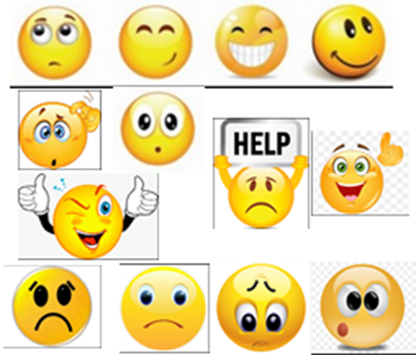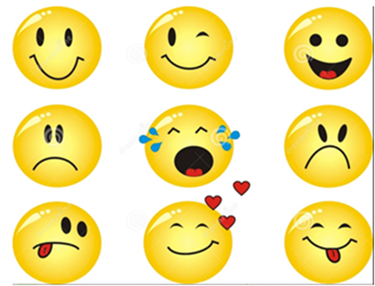

2 Stars (WWW):
 ___________________________________________________________
_________________________________________________________________
___________________________________________________________
_________________________________________________________________

A Wish (EBI):
_________________________________________________________
_________________________________________________________________
_________________________________________________________________

Starter
Write a Facebook status about what you already know about this topic:


Mid Lesson
Write a tweet about what you have found out so far this lesson:


Plenary
Draw an Instagram picture with a caption summing up what you have learned today

