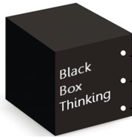



SPaG
Black Box Thinking:

Successes to celebrate:

Polaroid moments:
Missing/incomplete work:
Class: 10 Focus of Work: Date:
English Department Feedback Crib Sheet

