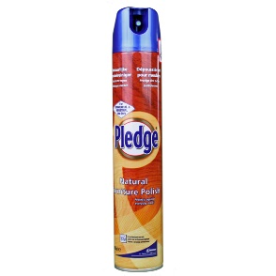
Folder and note polishing!
The ‘polishing’ of your folders and notes should be carried out weekly to ensure that all notes and tasks are up-to-date and complete.
This process adds to your self/peer assessment activities when you act upon the feedback that so that you can make further progress.
Reviewing and folder polishing are key elements leading to success.
Follow the flow chart below to help you:

