Cross-border banking and monetary independence: difficult partners

Marcus Miller

1. Introduction

For Milton Friedman, money was a potent national symbol - a creation of the nation state with a key economic role to play. Misgoverned, money may cause crisis – witness the Great Depression. But properly managed, it can promote the welfare of the people. This, it seems, is what inspires his monumental Monetary History of the United States, co-written with Anna Schwartz (Friedman and Schwartz, 1963); and accounts for his lifelong fascination with monetary policy. Some countries may choose to sacrifice their monetary independence - by joining the Gold Standard, like the US until 1934; or by pegging to an external currency, as many did after World War Two. But for Friedman a floating exchange rate and well-managed money was a recipe for stability and enterprise: honi soit qui mal y pense!

In reality, of course, money is not the sole creation of the state; for most businesses and households the money - and near-money - they use is to be found on the balance sheets of private corporations, licensed and regulated by the state, may be, though increasingly protected by limited liability. These corporations have their own interests to pursue, both at home and, if the cap fits, outside national boundaries by cross-border banking.

In these circumstances, Friedman’s perspective may prove misleading. Does it not rest on the Assumption of Triple Coincidence, to use the terminology of Avdjiev et al. (2016a,b), where this involves assuming that the currency area, the GDP boundary and the realm of decision-making all coincide? “No doubt,” they say, “this is an elegant simplification for analytical purposes. However, the assumption of the triple coincidence can mislead in a world of multinational firms and international currencies in which financial flows are important in their own right.” Avdjiev et al. (2016b). For, with national monetary systems increasingly ‘joined at the hip’ by financial integration, a floating exchange rate with capital mobility is no longer a guarantee of monetary independence - a point persuasively pursued in recent papers by Helene Rey (2013, 2016) and with co-authors, e.g. Passari and Rey (2015); with the application of these ideas to emerging markets analysed in Aoki et al. (2015).

While Helene Rey focuses on the existence of a global financial cycle which affects countries independently of the exchange rate regime, in this paper we examine the transmission of financial crisis, in particular. The focus is on international linkage via the ‘risk-taking channel’, using the US subprime crisis as a case in point. The effects of the US ‘shadow banking’ crisis reverberated around the financial world; but freely floating exchange rates provided scant protection for trans-Atlantic neighbours in the UK and the EU.

What about the regulation of banks in the home country – and hopefully elsewhere? Will that not offer the necessary insulation? As it happened, the Basel Committee on Banking Supervision ( BCBS) first established in 1975, had come to see its mission as devising bank regulations - to be applied country by country - so as to ensure financial stability in the economies of the West. Concern that there might be a regulatory ‘race to the bottom’ had led to the Basel Accord of 1998 with an 8% Capital Adequacy Requirement to be applied to Risk Weighted Assets.

There is no doubt that this marked a significant step in coordinating financial regulation among independent sovereign states. In the eyes of one observer, “Through the Basel Accord, nations effectively pooled their sovereignty to win back from markets some of the control that was slipping away from each individually. ... [it] promoted capitalist stability and the long-term transposition of liberal national democratic ideals to the changed world economy driven by stateless capital.” Solomon (1995, p.447). His concluding assessment was, it should be said, much less optimistic: “As competent as central bankers have been, I find it frightful the extent to which we are relying for the prosperity of the free world economy – and ultimately the stability of democratic society – on the judgement of a handful of expert technocrats who, to tell the truth, are often caught by surprise like the rest of us about the transformations occurring in the economy and the financial system.” Solomon (1995, p.508).

How justified these doubts were, the financial crisis that started in August 2007 was later to prove. So, as Charles Goodhart (2011, p.581) puts it bluntly in concluding his comprehensive study of the BCSB over the years 1974-97, ‘the key question is: why the apparatus of financial regulation failed to prevent a systemic failure’. The answer, he notes with regret, is in large part because those involved in devising the regulations had ‘insufficient appreciation of financial economics’! For, as he points out, academics such as Kiyotaki and Moore (1997) had been stressing the ‘dynamic effects of amplifying forces within the financial system’ as a driver of cycles of financial booms and busts. Concern with such dynamics was evidently at odds with the view of national bank regulators and the BCBS that their duty lay in ‘improving the risk management practices of individual banks’. Nonetheless, where there are self-reinforcing dynamics at work, Goodhart (2011, p. 578) argues, ‘their duty is to strengthen the stability of the financial system as a whole.’

The early Basel perspective suffered, one could say, from the Fallacy of Composition - the fallacy that ensuring each institution behaves well will ensure the system as a whole is safe and sound. This perspective remained in place as Basel I was upgraded to Basel II. That it put unwarranted trust in Credit Rating Agencies and ignored the role of externalities was forcefully pointed out in Danielsson et al (2001), an ‘Academic Response to Basel II’ from economists at LSE - including Charles Goodhart - which warned that Basel II would promote rather than check systemic crisis. Sadly, the warning was ignored.

The same happened when, at the Jackson Hole jamboree in honour of Mr Greenspan, Rajan (2005) famously warned the assembled central bankers that financial innovation was making the world riskier - and Hyun Shin (2005) used the swaying of the Millenium Bridge on its opening day to illustrate the idea of dangerous internal dynamics. They were ignored; as was the dramatic warning given at the conference on Cycles Contagion and Crises at LSE in June 2007, when Adrian and Shin used evidence from US investment banking to show that there was an asset boom in progress which could at any moment turn to bust. “In the subprime mortgage market in the U.S., when the balance sheets are expanded fast enough, even borrowers that do not have means to repay are granted credit…the seeds of the subsequent downturn in the credit cycle are thus sown.” Adrian and Shin (2008, p. 36)

Since the financial crisis, perceptions have greatly changed - not least because of the revisionist writings of Hyun Shin and Helene Rey. In Shin (2010, chapter 10), for instance, there is an outline of macro-prudential policies needed to limit externalities. These include regulatory intervention (with leverage caps and liquidity ratios), forward-looking provisioning charges on new loans, with structural reform to shorten the intermediary chain. Likewise, Helene Rey (2013) adopts a potentially radical approach in considering what regulatory protection will be needed to secure monetary independence. Noting that ‘ at the heart of the transmission mechanism is the ability of financial intermediaries, whether banks or shadow banks to leverage up quickly to very high levels when financing conditions are favourable’, she concludes that ‘macro-prudential policies are necessary to restore monetary policy independence for the non-central countries. They can substitute for capital controls, although if they are not sufficient, capital controls must also be considered.’

The idea of this short paper is to take the subprime crisis as an illustration of the two themes discussed above. First that, with cross-border banking, financial crisis can spread internationally irrespective of the exchange rate regime; and second that the regulations needed to check such undesirable ‘exports’ must take account of externalities, particularly those operating through asset prices.

2. Joined at the hip
Mr Greenspan was proud of the way the US economy weathered the collapse of the dotcom bubble: so he was sanguine about the subsequent boom in mortgage credit and house prices in the U.S.A. A key reason why the subprime crisis was so different - and so dangerous - was that most of the assets in question were, on this occasion, held by highly leveraged institutions. Indeed, almost two thirds of subprime assets were on the balance sheets of leveraged institutions (i.e. Investment Banks, Commercial Banks, Hedge Funds and US GSEs), as indicated in Table 1.

Table 1: Subprime exposure by type of institution
 | Percent of exposure | Approx value
Total of Subprime assets | 100% | $1.4
Non Leveraged institutions | 35%
Total leveraged institutions | 65% | $0.91 tr
Of which : US | 50% | $0.70 tr
Non US | 15% | $ 0.21 tr = $210b
Source Shin (2010 p. 153, Table 9.1)

For a total of assets worth approx. $1.4 tr, this gives an exposure of not far short of one trillion US dollars for leveraged institutions. A sizable fraction of these assets were held by non-US banks, however; their exposure comes to approx. $0.21 tr. or $210 billion.
How were these holdings financed? An indication is given by the graph in Avdjiev et al. (2016b), shown as Figure 1 below, where the thickness of the arrows indicates the size of the outstanding stock of claims. As between 2002 and 2007, Europe evidently borrowed an extra $1.1 tr in the US, and invested this back again. (This will include the exposure discussed above.) So, as the authors put it, ‘the dollars raised by borrowing from US money market funds flowed back to the United States through purchases of securities built on subprime mortgages’.

Figure 1 US dollar-denominated cross-border claims (billions of US dollars)
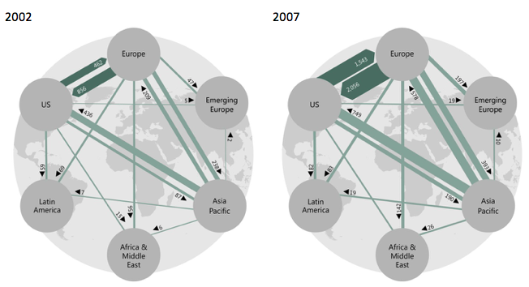
Note: arrows directed from region A to region B indicate lending from banks located in region A to borrowers located in region B.
Source: Avdjiev et al. (2016b)

The effects of the ensuing financial crisis on US banking institutions were simply catastrophic. ‘Each of the former Big Five investment banks failed, was sold, or was converted into a bank holding company. Two mortgage giants and the world’s largest insurer were placed under government control. And in early October, with the stroke of the president’s pen, the Treasury – and by extension, American taxpayers – became part-owners in what were once the nation’s proudest financial institutions.’ Sorkin (2009, p.529).
Does the fact that the gross exposure of foreign banks was hedged on a currency basis (by short-term $ borrowing) mean that non-US banks were not exposed? Not at all: it suggests rather that non-US banks had joined the party and were behaving just like the US investment banks! So when the value of MBS collapsed, they too would take a hit on their balance sheets. What that would mean in terms of Euro or sterling would depend on movements in exchange rates; but floating rates would not deflect the blow. If a European bank is behaving like a US bank, then it will win or lose like a US bank. The currency exposure of European banks holding subprime assets may have been hedged, but they were exposed to serious capital losses nonetheless.

3. Danger: Pecuniary Externalities at Work
Ordinarily foreign participation in US banking might not have been a matter of much importance –just like opening commercial banking branches in the US, for example, with profits and losses appearing on parent’s balance sheet. But for investment banking in 2002-7, these were no ordinary times. It is true that considerable efforts were being made by the BCBS to ensure that individual banks were adequately capitalised; and to ensure that there was a level playing field internationally. But, as argued above, the regulatory analysis was deeply flawed in that it ignored market failures and pecuniary externalities.
Hence, as Adrian and Shin (2008, 2010) pointed out, the stage was set for a major boom and bust in investment banking - a roller-coaster ride that foreign banks were free to join, with the floating exchange rate offering no path for escape.

Investment banking: the Shin Diagram
How to demonstrate that investment banks may be exposed to insolvency by ‘pecuniary externalities’ involving asset prices? What better device than the two-sector model spelt out in Shin (2010) – and the diagrammatic representation that goes along with it (shown in Figure 2)? That is the purpose of this section. The figure shows how the demand by ‘active’ or levered investors together with that of ‘passive’ investors determines the price of risky assets. The amount of risky assets is taken to be fixed in supply, with returns having a uniform distribution, with mean return q, and downside risk of z.
The demand by passive investors, measured from the right-hand axis, lies below the mean $q$ with a slope reflecting their degree of risk aversion, parameterised as τ. The demand curve for active investors is measured from the left-hand axis, where the kink reflects the level of their initial equity $e$; and the downward slope thereafter indicates, not risk aversion, but the effect of adhering to the VaR rule. A fall in price allows for more assets to be held as there is less risk per asset (specifically $p-\left( q-z\right)$) to be covered by this equity. Given the parameter values indicated, market-clearing equilibrium is at A, where the schedules intersect.
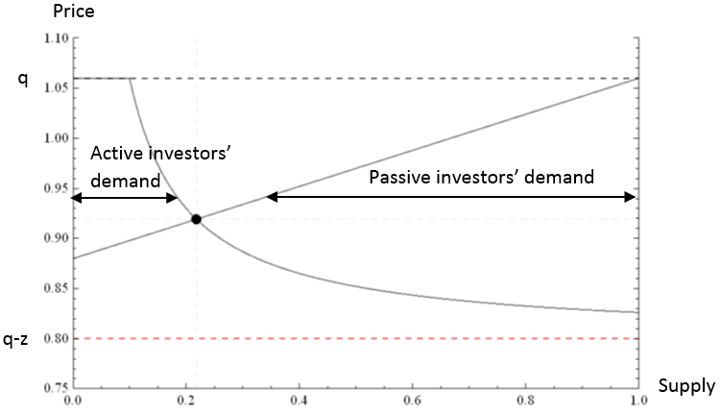
Figure 2. Market-clearing price of risky assets (q=1.06; z=0.26; τ=0.125; e=0.026)

Note that the equilibrium price lies ‘within the band’ between $q$ and $q-z$ where initial equity covers the maximum expected risk exposure on the balance sheet of the leveraged investors. So investment banks are dutifully following Basel Rules.

Pecuniary externalities
How will this equilibrium respond to unanticipated improvements in asset quality – in the expected pay-off $q$, for example, or in the maximum downside risk z? Each bank will respond to the parametric shift, taking the price of risky assets as given: but the concerted response will change asset prices and, assuming marking-to-market, the equity base of the banks themselves. If banks then proceed to expand their balance sheets as much as the VaR rules permit, the effect of such ‘macro’ shocks (i.e. those which affect every bank) will be amplified by ‘pecuniary externalities’. It is the system-wide response to these price changes that give the amplification.

How price changes amplify common shocks: effect of a quality upgrade
The case of a perceived improvement in the mean of the distribution neatly indicates how the marking-to-market of asset prices together with VaR rules can generate ‘pecuniary externalities’ in the form of booms and busts. So, as in Shin (2010, p.33), let the mean of the risky asset payoff increase from q to q’ without any change to the downside risk of the uniform distribution, which remains at z. Without marking to market, this will lead to an upward shift in the demand for both active and passive and investors as illustrated by the vertical shift from A to B in Fig 3. The price of risky assets will rise in response to the good news on quality, but the holdings of active investors will be unchanged.
Things do not end there if asset prices on the books of the leveraged institutions are marked-to-market and risk-taking is governed by VaR rules. For the rise in the equity of active investors will allow them to expand their holdings; and - assuming they fully exploit this profit opportunity - the effect will be a shift to the right of the demand by the investment banks. Allowing for the pecuniary externality, therefore, equilibrium shifts from A to C, with risky asset holdings by the active investors expanding by $y_{A}^{'}-y_{A}$ . As risk C lies closer to the mean return than A, the risk premium will have fallen, which is why risk averse investors move out.

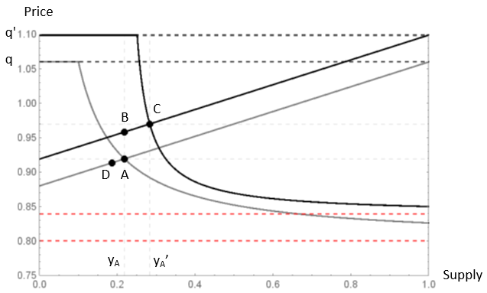

Figure 3. Increased market share of active investors with ‘good news’ on mean return

What if the quality upgrade was a mistake?
It is widely argued that Rating Agencies were prone to assign higher ratings to subprime assets than were warranted, Akerlof and Shiller (2014). This may not have been too evident when house prices were rising; but when they started to fall it became clear that much of the lending to subprime borrowers would have to be written down. This was foreseen by Angelo Mozilo, the co-founder of Countrywide, a key player in marketing subprime mortgages: in an email to other Countrywide bank executives, dated August 1, 2005, he wrote: ‘when the loan resets in five years there will be enormous payment shock and the borrower is not sufficiently sophisticated to truly understand the consequences, then the bank will be dealing with foreclosure in potentially a deflated real-estate market. This would be both a financial and reputational catastrophe.’ Chatterjee (2014)

Given the allegations of unprofessional behaviour made by Akerlof and Shiller – and repeated here - it is worth recording the outcome of subsequent legal action taken by the U.S. Department of Justice. Faced with the charge that they had handed out excessively rosy ratings for residential MBSs and CDOs to try to win more business from 2004 to2007, Standard and Poor’s settled in 2015 by paying fines amounting to $1.4b. Would such a substantial sum have been paid on a charge that was unfounded? (For good measure, the Department of Justice is planning to sue Moody’s for the same reason.)
One way of looking at the boom/bust cycle in terms of this model is to think of the boom as driven by the (unjustifiably) ‘good news’ initially supplied by the Ratings Agencies; and the bust is what happens when these ratings are later reversed (when house prices have peaked, for example). The outcome is shown in Figure 3, where the reversal of the good news does not, however, lead to a return to A; rather to a point like D where investment banks have had to contract their holdings. Why the ‘asymmetric’ response to a symmetrical news shocks? It arises because the capital gains on marking-to-market when the good news arrives are calculated on the basis of initial holdings at A; but the capital losses when the bad news arrives are calculated on the basis of the expanded holdings at C. With less equity on balance, they end up with less assets.
Could this asymmetry be sufficient in and of itself to trigger widespread insolvency? Not for the case shown in Figure 3, where the ‘bad news’ leads to a fall in the holdings of the leveraged sector, but the price fall (from C to D) lies well within the band of tolerable downside risk established in good times.

Catastrophic outcomes
If the news shocks were larger, however, this could trigger generalized insolvency, however. This would occur, obviously, if the upward shift was big enough so that the initial point A lies below the band of sustainable outcomes in the ‘good news’ equilibrium. For if $q'-z$ exceeds the initial price at A, then a news reversal that takes equilibrium prices any lower will by definition wipe out the equity base of the investment banks.
Such a big shock will be sufficient for mass insolvency, but it is not strictly necessary. Take the ‘intermediate’ case sketched in Figure 4 where a symmetric return to the initial equilibrium at A would be just manageable despite mark-to-market capital losses: but the asymmetry leads to unsustainable losses for the investment banks (as selling assets leads to insolvency). Since any outcome below the ‘band of sustainable outcomes’ established in the good times implies negative equity of investments banks, the only possible equilibrium is at D where investment banks are forced to withdraw from the market, and passive holders determine the asset price.

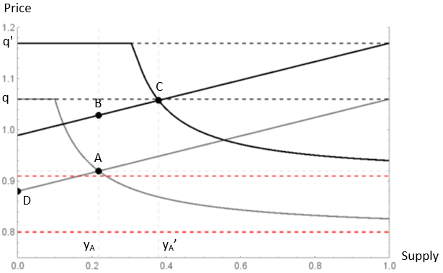
Figure 4 Simple reversal of ‘good news’ leads to insolvency

Note that, in either the ‘big shock’ or ‘intermediate’ cases, the financial system exhibits what mathematicians such as Zeeman (1974) and Arnold (1984) refer to as ‘catastrophic’ behaviour – highly asymmetric responses to symmetric movements in exogenous forces. Good news, when rescinded, wipes out the entire equity base of investment banks!
For a careful dynamic analysis of a model much like that of Shin (2010), the reader is referred to simulations carried out by Aymanns et al. (2016, in press ). For what they call the Basel leverage cycle, it is reported that:
A simple calibration based on reasonable values of the parameters yields a period of oscillation of roughly 10–15 years. This suggests that VaR as mandated by Basel II was sufficient to cause the Great Financial Moderation and the subsequent crash, and the collapse of the housing bubble might have just been one of several possible triggers for the crisis.
While this supports the view that Basel II system was inherently unstable, we should point out that, for these authors, boom-bust behaviour is driven by cyclically varying leverage targets rather than the activities of Rating Agencies.
So much for the technicalities. What is the broader issue that this formal analysis is designed to illustrate? It is the fragility of equilibrium in a context where profit-hungry, highly-leveraged intermediaries are subject to a VaR mandate and mark-to-market accounting and rules but free of any macro-prudential oversight; and where regulatory oversight of subprime lending has been let slip for political reasons, with credit standards left for Rating Agencies to set. If they rate a bundle of mortgages as triple A, they must be OK.

But what if, as Akerlof and Shiller (2014, Chapter 2) argue, the Rating Agencies themselves had distorted incentives? What if they were acting outside their area of proven competence – namely in rating corporate bonds – but were incentivised to give high ratings to complex products by generous fees paid by investment banks eager to expand their balance sheets? Then the stage is set for an unsustainable credit boom which will help pump up house prices, with the endogenous shifts in the lending capacity of the investment banks, induced by mark-to-market accounting, helping to accentuate the boom. Ultimately, however, as Mr Mozilo had foreseen, the end is financial disaster when house prices peak. And, willy-nilly, this will involve those hapless non-US banks who used ‘the dollars raised by borrowing from US money market funds ... to finance purchases of securities built on subprime mortgages’, Avdjiev et al. (2016b).

On the vexed question of why the Basel regulatory regime, designed to ensure financial stability in Western banking, should have failed so spectacularly to do so, Charles Goodhart (2011,p. 564), in his history of the Basel Committee on Bank Supervision, offers the following fascinating observation:

“From the mid-1990s there was an interesting variant of the ‘capture’ hypothesis, wherein the regulators come to adopt the self-interested positions of the regulated. In this variant the regulators are intellectually captured by the belief that the best versions of the models designed by banks for their own purposes should also be applied by the regulators.
But such an alignment is not necessarily desirable. Regulators should have different objectives from banks; the purpose of regulation – to deal with externalities and market failures in the financial system – is quite different from the purpose of banks – the maximisation of the current value of future discounted income flows of individual banks.”

Conclusion
With the subprime crisis as the focus of attention, our observations closely match what Helene Rey has argued on the basis of studying what she has dubbed the ‘global financial cycle’; namely that, with cross-border banking in operation, the exchange rate regime cannot ensure monetary independence; and that macro-prudential regulation is a more relevant policy option.
This look-back at recent history prompts a final reflection. Recall the famous episode in 2009 when Queen Elizabeth, on a visit to the LSE, asked why economists there had not seen the crisis coming: the answer given by Tim Besley and Peter Hennessy (2009) was that the lack of foresight on the part of their colleagues had many causes, but it was principally ‘a failure of imagination’. What our account suggests is a better answer would have been: since 2001 some of our colleagues have been warning the world repeatedly that the Basel Rules were crisis-prone - but no-one was listening!

References
Adrian, T. and H. S. Shin (2008) “Liquidity and Leverage”. Paper presented at LSE conference, June 2007, Chapter 1 of Cycles, Contagion and Crises, Special Paper Series No. 183, FMG, LSE (November), pp. 5-45.
Adrian, T. and H. S. Shin (2010). “Liquidity and Leverage”, Paper presented at BIS Annual Conference, June 2007. Journal of Financial Intermediation, 19(3), pp. 418-37.
Akerlof, G.A. and R.J. Shiller (2014), Phishing for Phools: The Economics of Manipulation and Deception, Princeton University Press.
Aoki, K., G. Benigno and N. Kiyotaki (2016), “Monetary and Financial Policies in Emerging Markets” Unpublished working paper.

Arnold, V. I. (1984) Catastrophe Theory. Berlin: Springer-Verlag

Avdjiev, S., R. McCauley and H. S. Shin (2016a), “Breaking free of the triple coincidence”, Economic Policy 31: 409-45

Avdjiev S., R. McCauley, H. S. Shin (2016b) “Conceptual challenges in international finance”. voxEU, 28 September
Aymanns, C., F.Caccioli, J.D. Farmer, V.W.L. Tan (2016). “Taming the Basel leverage cycle”. Journal of Financial Stability, forthcoming. http://dx.doi.org/10.1016/j.jfs.2016.02.004
Besley, T. and P. Hennessy (2009) The Global Financial Crisis—Why Didn’t Anybody Notice: Letter to the Queen, London: British Academy.
Calomiris, C. W and S.H. Haber, (2014) Fragile by Design: the political origins of banking crises and scarce credit. Princeton, NJ: Princeton University Press.
Chatterjee, P. (2014) “Bank of America to Pay $16.65 Billion to Settle Mortgage Fraud Charges” Corpwatch Blog, Aug.21, www.corpwatch.org
Danielsson, J., P. Embrechts, C. Goodhart, F. Muennich, O. Keating, C. Renault and H.S. Shin, (2001) “An academic response to Basel II”, Financial Markets Group, Special Paper 130, LSE.
Foley, D. K. (2006) Adam’s Fallacy. Cambridge, MA: Harvard University Press
Friedman, M. and Schwartz, A.J. (1963), A Monetary History of the United States, 1867-1960. Princeton: Princeton University Press.
Goodhart, C. (2011) The Basel Committee on Banking Supervision: a history of the early years 1974-1997. Cambridge: Cambridge University Press
Greenwald, B.C. and J. E. Stiglitz (1986) “Externalities in Economies with Imperfect Information and Incomplete Markets”, The Quarterly Journal of Economics, Vol. 101, No. 2, pp. 229-264
Kiyotaki, N. and J. Moore (1997) ‘Credit cycles’, Journal of Political Economy, 105(2):211-48
McGuire, P. and G. von Peter (2012), “The US dollar shortage in global banking and the international policy response”, International Finance 15: 155–78
Miller, M. and L. Zhang (2015). "The Hedgehog and the Fox: from DSGE to Macro Pru", Manchester School, vol. 483, No. S3, pp. 31-55
Miller, M., L. Zhang and S. Rastapana (2016) “A comedy of errors: misguided policy, mis-sold mortgages, and more”, CEPR DP 11533.
Passari E. and H. Rey (2015) “Financial Flows and the International Monetary System”. Economic Journal, vol. 125(584), 675-698.
Rajan, R. (2005) “Has financial development made the world riskier?” Economic Policy Symposium Proceedings: The Greenspan Era, pp. 313-369. Kansas City, MO: Federal Reserve Bank of Kansas City.

Rey, H. (2013) ”Dilemma, Not Trilemma: the Global Financial Cycle and Monetary Policy Independence," Economic Policy Symposium Proceedings: Global Dimensions of Unconventional Monetary Policy, pp. 285-333. Kansas City, MO: Federal Reserve Bank of Kansas City.

Rey, H. (2016) “International Channels of Transmission of Monetary Policy and the Mundellian Trilemma,” IMF Economic Review, Palgrave Macmillan, vol. 64(1), pp 6-35, May.
Shin, H. (2005) “Commentary: Has financial development made the world riskier?” Economic Policy Symposium Proceedings: The Greenspan Era, pp. 381-386. Kansas City, MO: Federal Reserve Bank of Kansas City.

Shin, H.S (2010) Risk and Liquidity, Oxford: Oxford University Press
Solomon, S. (1995) The Confidence Game. NY, NY: Simon and Schuster
Sorkin, A. R. (2009) Too big to fail. NY, NY: Viking Penguin
Zeeman, E. C. (1974) “On the Unstable Behaviour of Stock Exchanges”. Journal of Mathematical Economics, Vol.1, Issue 1, March, 39-49

Annex Pecuniary externalities: macro effects from VaR constraints
That ‘externalities’ may include price increases induced by ‘micro-prudential’ rules may be unfamiliar; but the example of a Rating Agencies upgrade of mean returns on risky assets helps to illustrate. Market-wide expectations of higher returns will, not surprisingly, lead to an increase in the market-clearing price: this is straightforward enough. But the fact that some agents, specifically highly-levered Investment Banks, are subject to prudential regulation in the form of a VaR rule can lead to a subsequent series of price (and quantity) adjustments on their part - an amplification that may be referred to as a pecuniary externality. For, if the initial asset price increases are marked to market, then the banks can - in line with VaR - purchase more risky assets: and, if this applies to all Investment Banks, their combined and synchronised purchases will push the price up further. But this will trigger a new round of marking to market, more lending, etc. As this goes on for many rounds, some prefer to call the process a ‘dynamic feedback’ effect.
To convey the idea of such externalities to delegates at Jackson Hole, Hyun Shin (2010, p.3) chose to draw an analogy with the dynamic effects following from a gust of wind hitting the Millenium Bridge, as on the day it was formally opened – and closed for restructuring:
“The wobbling of the bridge is an example of a shock that is generated and amplified within the system. The wobble of the bridge feeds on itself. When the bridge wobbles everyone adjusts their stance, which makes the wobble even worse. So the wobble will continue and get stronger even though the initial shock (say, a small gust of wind) has long passed. The pedestrians on the bridge are rather like modern banks that react to price changes, and the movements of the bridge itself are rather like [price] changes in the market.“
The logic is reminiscent of the Keynesian notion that, when some firms and households are ‘liquidity constrained’ and there is insufficient aggregate demand, individual spending decisions can have a positive externality for the system as a whole. If one thinks of these liquidity constraints as the equivalent for firms and households of the VaR constraint for banks, the externality in this case is the increase in other’s spending power achieved despite these financial constraints. As Duncan Foley (2006, p.186) expresses it:
“The spender has the private advantage of purchasing the commodity she wants, but she also increases the money balances of another agent, which permits that agent to make a desired purchase that was previously impossible because of financial constraints. Because individual spenders do not take into account the external impact of their decisions, the volume of spending may be too small to employ all the resources of the economy, and there is a case for government intervention to subsidize spending (or to spend itself) to make up the difference.”
Under a boom scenario, however, where Investment Bank balance sheets are over-expanding and leading to a house-price bubble, the appropriate intervention would be to reduce the expansion of lending - by imposing leverage caps; or imposing a provisioning charge when new loans are made; or perhaps by an explicit Pigovian tax on bank equity (which could be put in a resolution fund), (Shin, 2010, p.163).

Discussion with Gianluca Benigno and technical assistance of Songklod Rastapana are gratefully acknowledged.
In chapter 16: ‘The BCBS and the social sciences’
Further discussion, with examples, is available in Miller and Zhang (2014).
The externalities referred to here (sometimes called ‘pecuniary externalities’) are the side-effects of asset price changes due to the balance sheet rules imposed in the financial sector to check moral hazard. While these balance sheet rules work well for idiosyncratic shocks to the agents concerned, they can generate significant side effects – in the form of fire-sales, for example - when shocks are correlated. See Annex for further discussion - and the analogy of income externalities in Keynesian economics.
The paper was also presented at the BIS Annual Conference in June 2007. In both cases, actual publication of the conference proceedings came much later, as Adrian and Shin (2008) and Adrian and Shin (2010) respectively. Crises pay scant respect to publisher’s timetables!
The Treasury bailout of RBS in the UK (for £45bn (or $70bn), now worth only about £14bn) was closely linked to its exposure to subprime assets (due in large part to hurried acquisition of a Dutch bank).
Sometimes referred to as ‘dynamic feedback effects’.
More details available in Miller et al.(2016)
See Annex for discussion of these externalities with references.
Because, for example, getting low income households onto the housing ladder is seen as a way of compensating for income inequality - as Calomiris and Haber (2014) suggest was the case in the US.
Technically, the value of equity relevant to the demand for risky assets by any individual bank will depend on the market price of risky assets in its portfolio; but, as this reflects market demand, it will be an externality for the individual bank, see Greenwald and Stiglitz (1986).

