Careers Toolkit for xxxxx Teachers
Currently there is a national campaign to help young people better understand the advantages of studying science, technology, engineering and maths to higher levels, and to consider following a related career. As a subject teacher you can be asked careers related questions, or want to promote progression in their subject, but may need support to do so. This resource is designed as a starting point, bringing together relevant sources that you can integrate into teaching, display in classrooms, or recommended to students. Further help or advice can be sought from your Careers Co-ordinator or Careers Adviser.
Hand Out: See STEM Choices Pack pgs 60-62..
Careers Websites: add any others
www.futuremorph.org
www.Prospects.ac.uk - aimed at undergraduates but provides much useful info for younger students. This link http://prospects.ac.uk/options_with_your_subject.htm takes you to (choose) Options with xxxx , it show job roles for which xxxx is essential, or useful, explains what people with xxxxx degrees do, has case studies and info about further study .
Useful career profiles and films on www.icould.com Browse these: http://icould.com/watch-career-videos/by-job-type/ (choose type).
National STEM Centre elibrary contains careers resources related to xxxxx, as well as a huge range of teaching resources. If you haven’t already, register to download some materials including videos. Remember to rate and comment on materials at the bottom of the page.
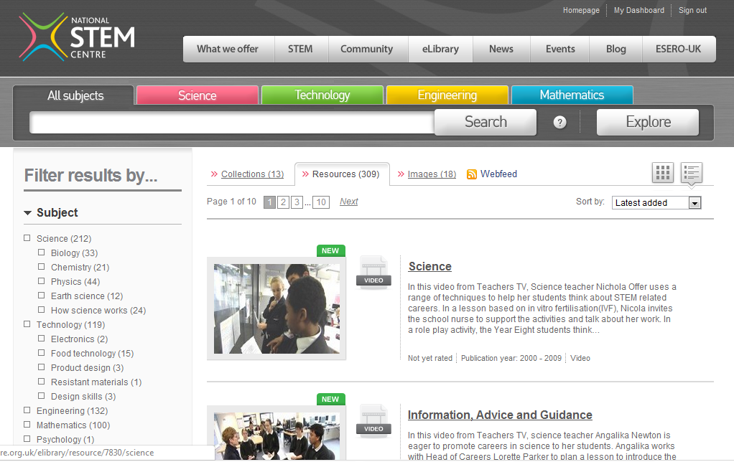

Where we are….(add any local information or contacts relevant to your area or school/college)

