Wragge Lawrence Graham and Co – Vacation Scheme Report
I was able to benefit from the MSP vacation scheme funding this summer after brokering an internship with one of the MSP’s major sponsors. The work experience gave me a chance to improve as a global citizen. I was based in Wragge Lawrence Graham and Co’s Guangzhou representative office for two weeks, immersed in a completely unique culture and work style. The experience working within intellectual property law truly surpassed my expectations and has given me a clearer idea of the types of legal work I want to pursue after graduating. My degree course is challenging, as it requires different learning techniques when merging legal analysis alongside more practical business theory. It was great to have the opportunity to put some of these skills gained to practice. I never imagined my first trip to Asia would be to a law firm office in the world’s most populous country! I was able to gain high levels of cultural enrichment as my trip coincided with the mid-autumn harvest festival, a richly celebrated public holiday in China.

Working in china was amazing, I was able to take a few mandarin lessons while I was there but was quite surprised at how little English was spoken in and around the city of Guangzhou where I was based. Intellectual property law was particularly exciting; I worked very closely with senior lawyers working on major cases and helped to draft case summaries of recent IP litigation. I also assisted in researching for partner presentations and upcoming legal alerts. The work culture in Guangzhou can only be described as unique. I did weekly yoga sessions with the team (in the office) to unwind and relax after a long week of work. Everyone is efficient but yet so laid back! I took part in a lot of business development work, attended meetings and networking events to help drum awareness of the firm and its services in China. One thing that struck me about China was the level of entrepreneurial flair everyone had. People are genuinely industrious and ambitious and it was refreshing to see.

High lights of the trip definitely include the access to cheap and delicious Chinese food and the efficiency of all the cheap taxis! Living in China can be difficult without some basic conversational mandarin or at least friends that speak and understand. The people I worked with were very supportive; they made sure to make me feel welcome by taking me to as many different places as possible! I gained so much from the experience and I would like to thank Multicultural Scholars Programme for funding my flights, and enabling me to take part in such an amazing experience. As a result of my time in Guangzhou, I am convinced I want to embark on my legal career in a firm that has an international focus. I’ve developed in more ways than I can recount and I would really encourage current MSP students to take advantage of all the opportunities offered by the programme and I look forward to supporting the programme in years to come.

Images:
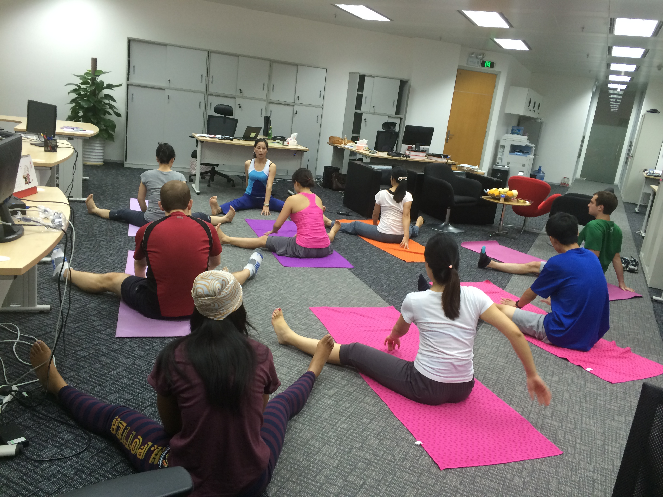
Weekly yoga sessions with the team
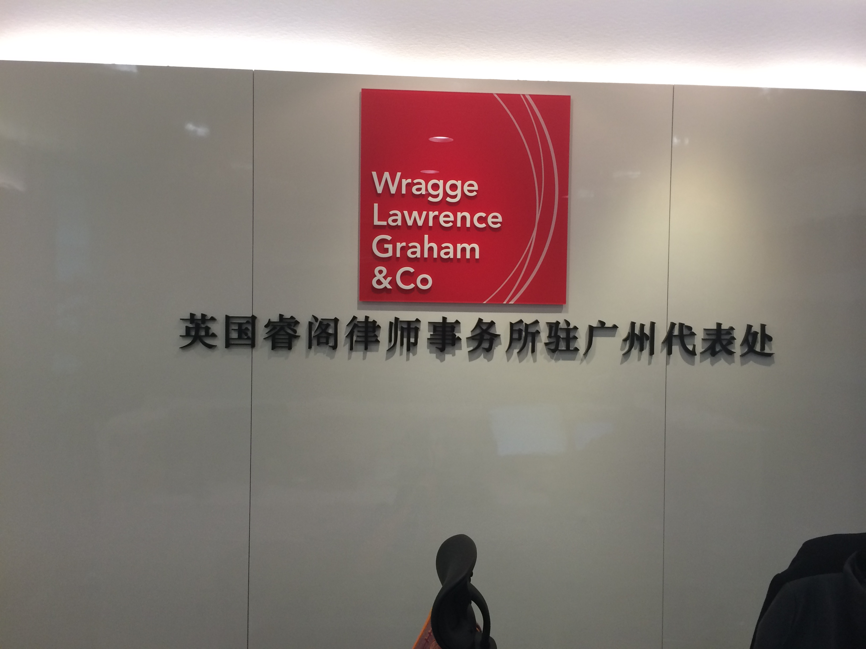
The Guangzhou office

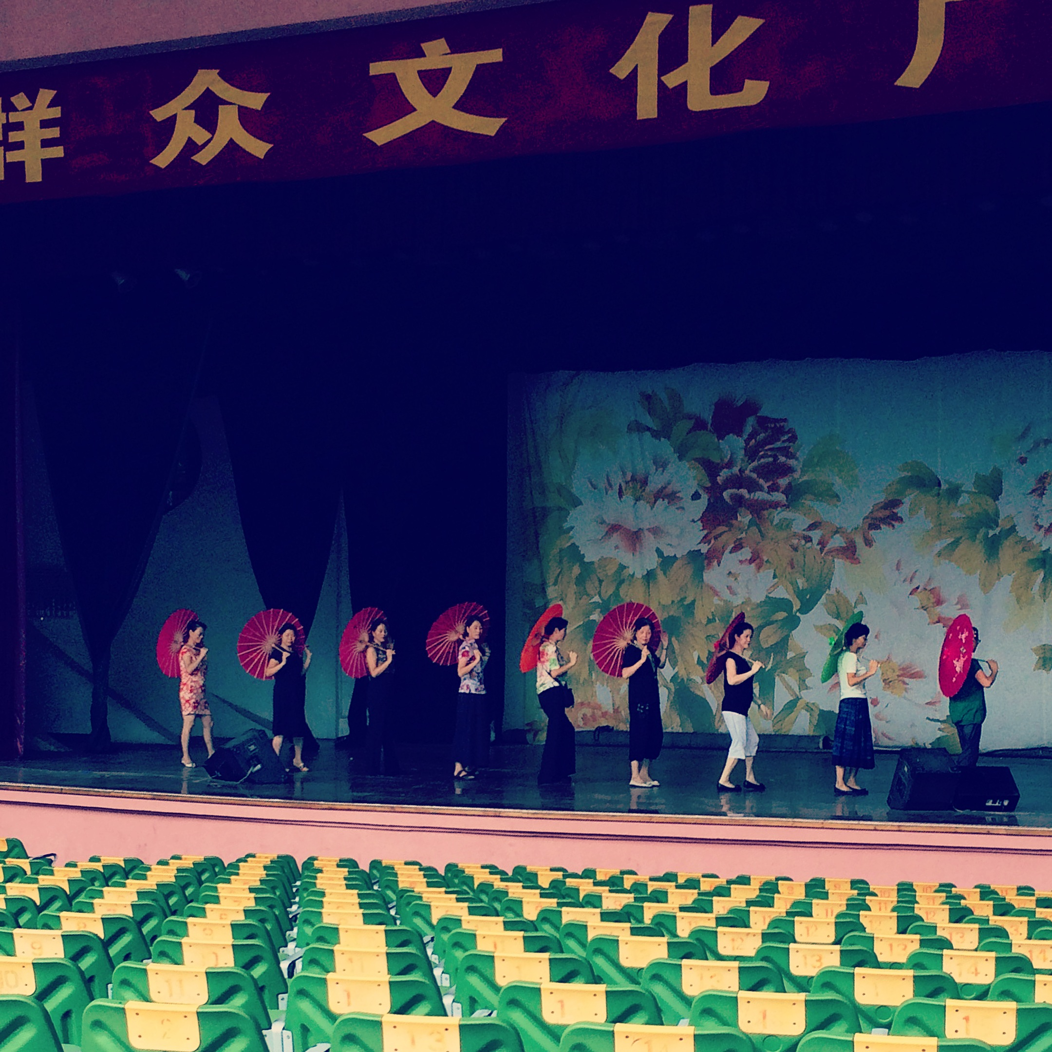
Performers practicing during mid-autumn festival
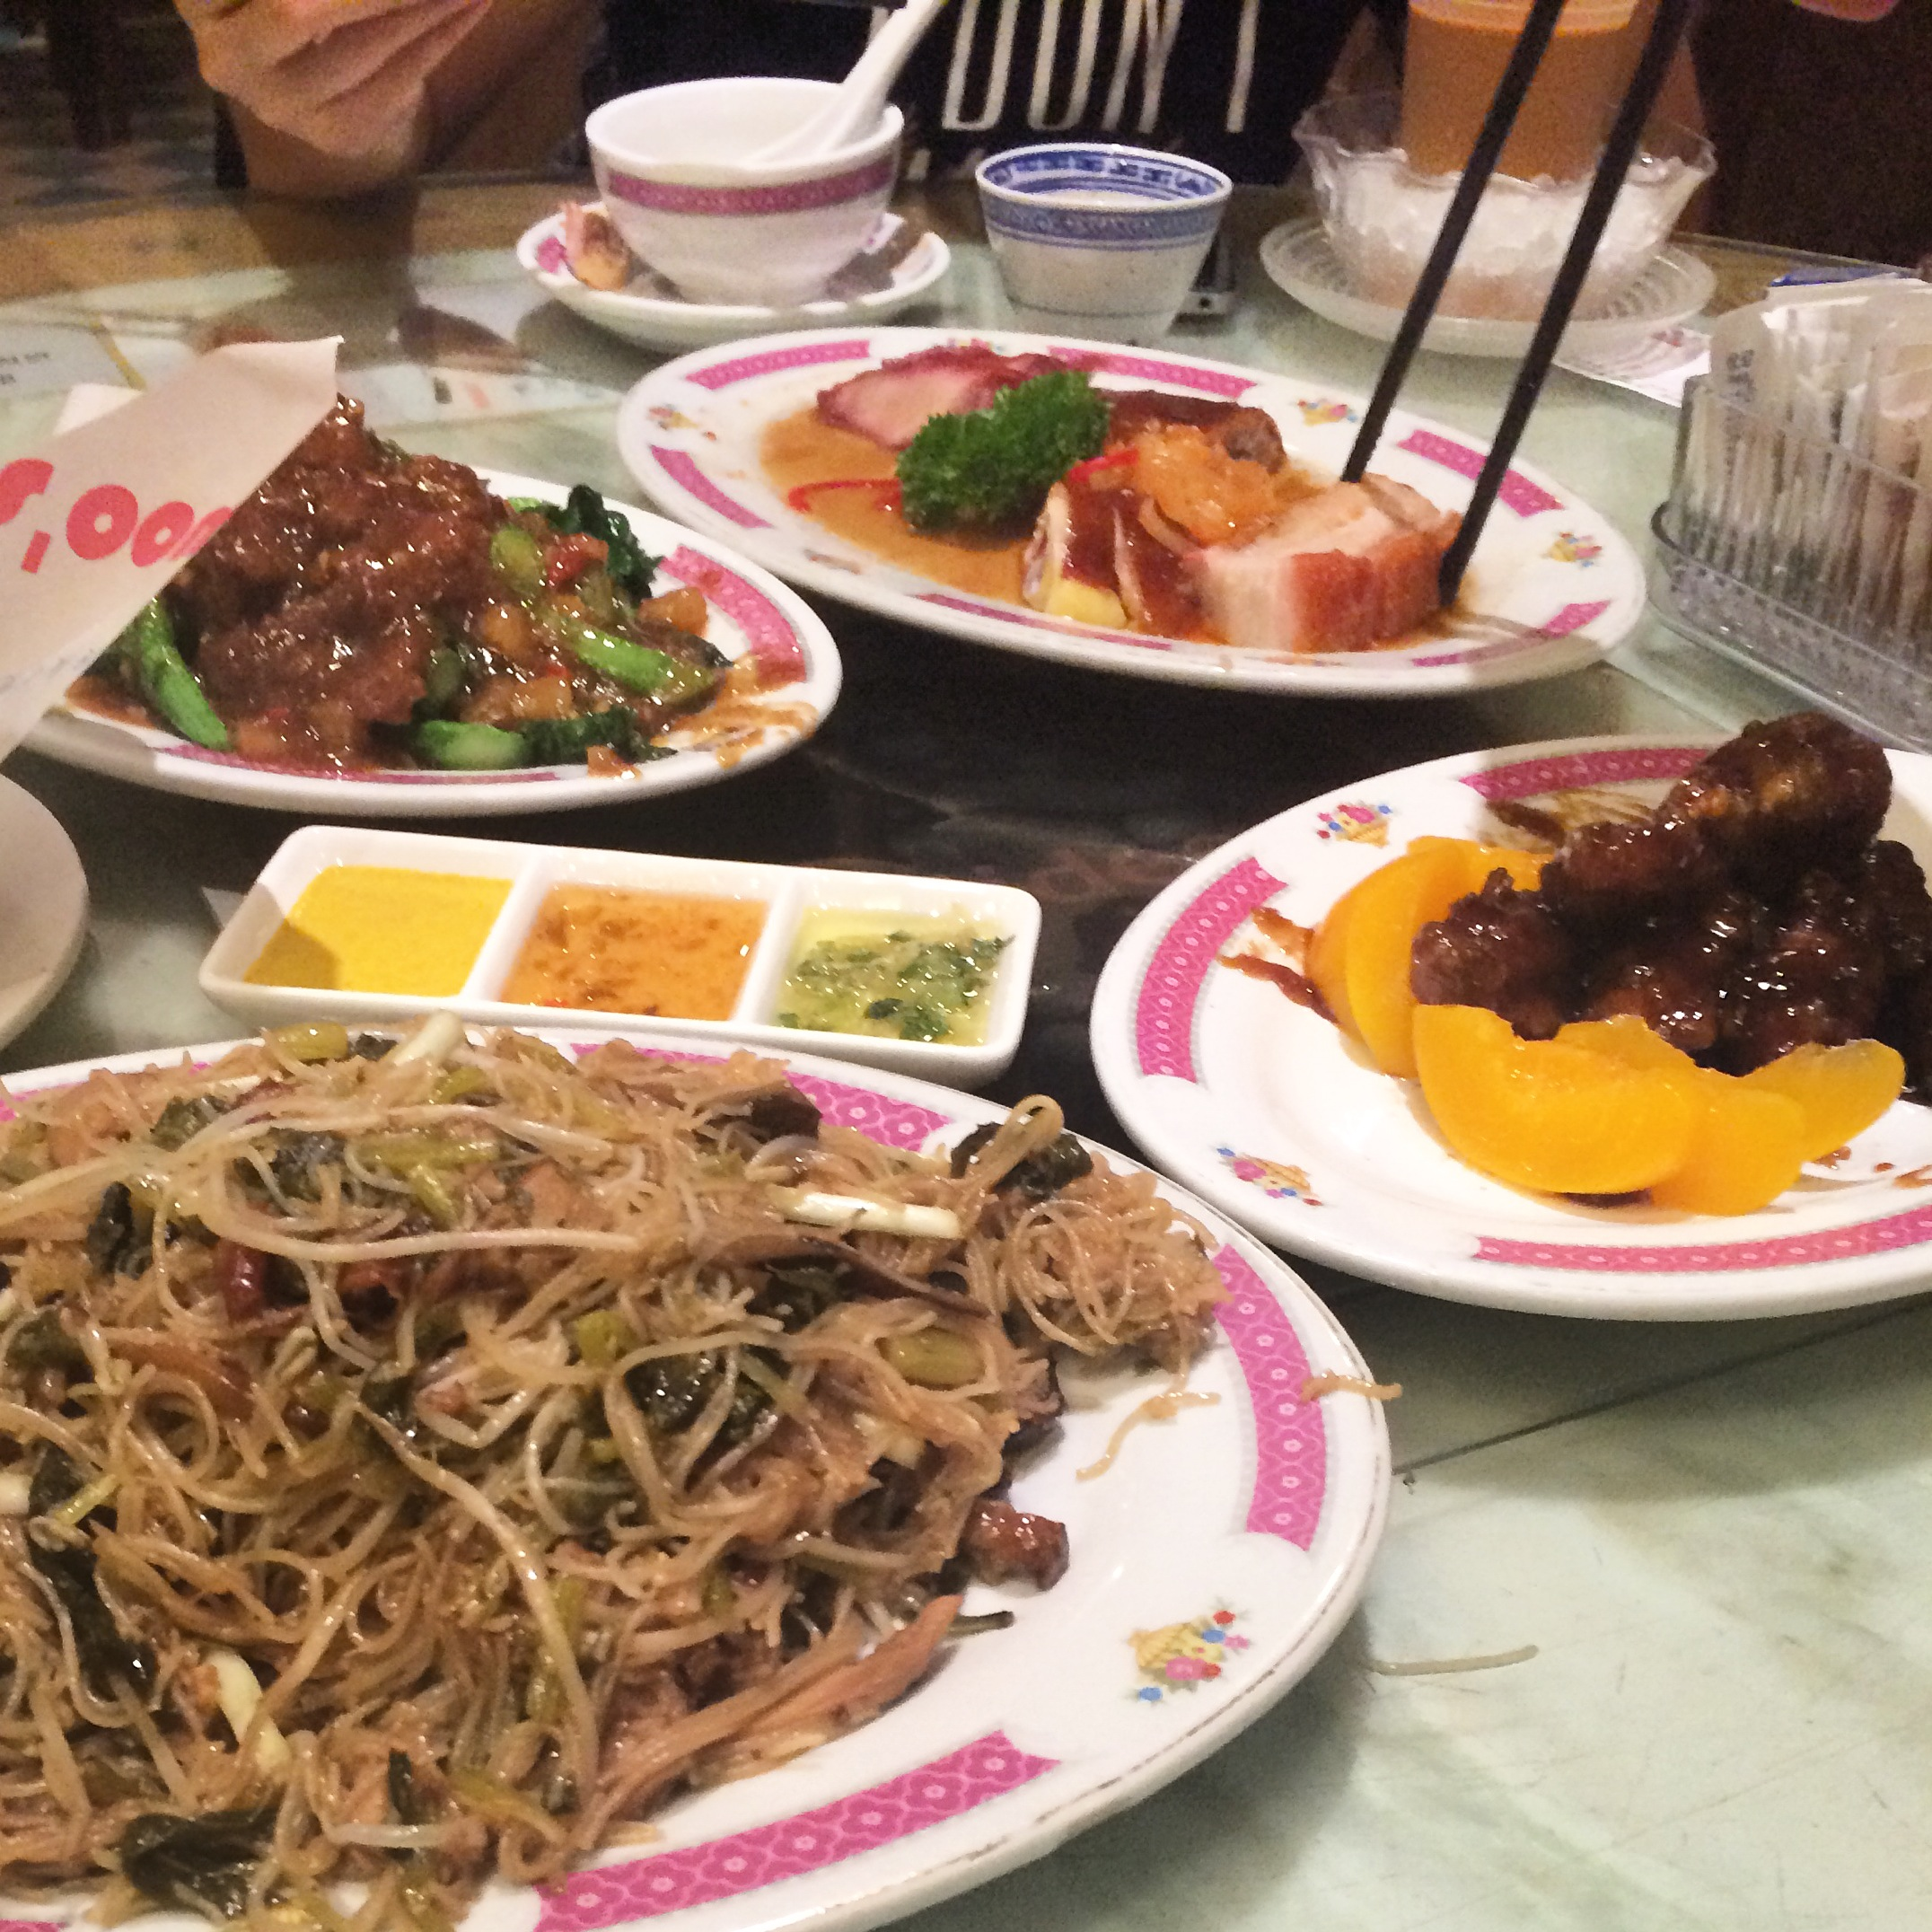
Snippets of the delicious food

British Chamber of Commerce – Guangzhou networking drinks
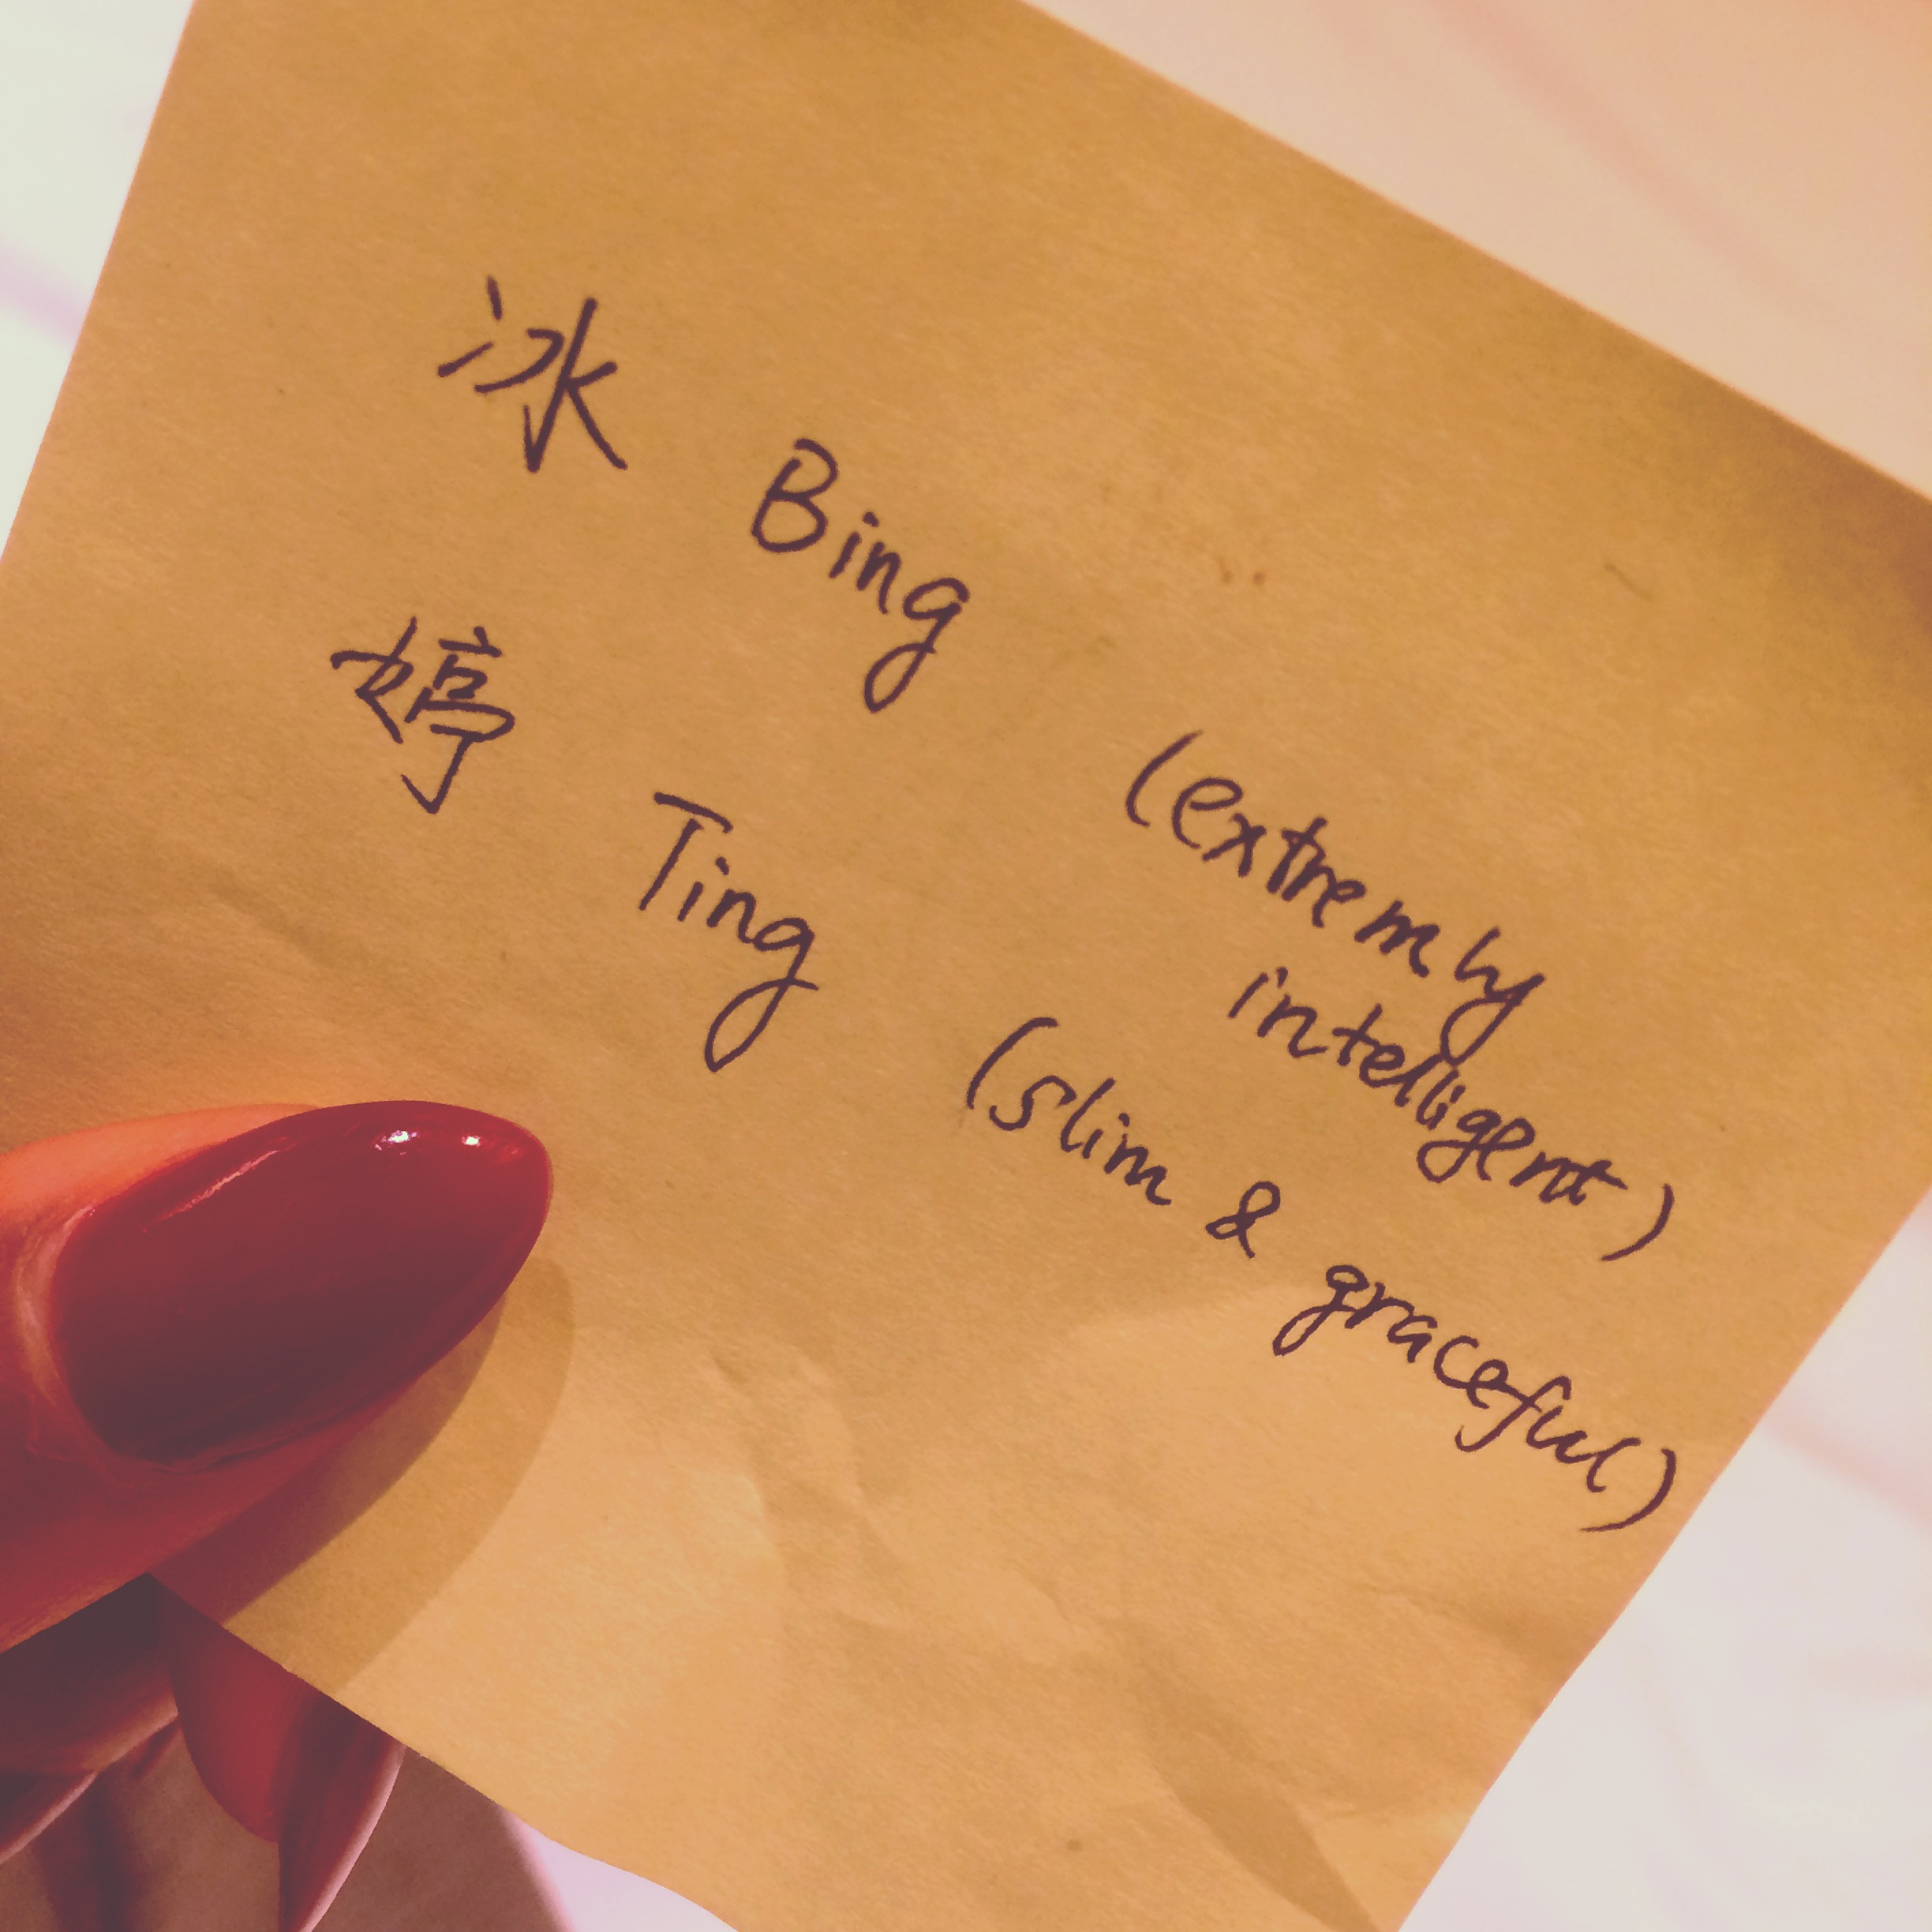
My very own Chinese name given to me by lovely colleagues!

