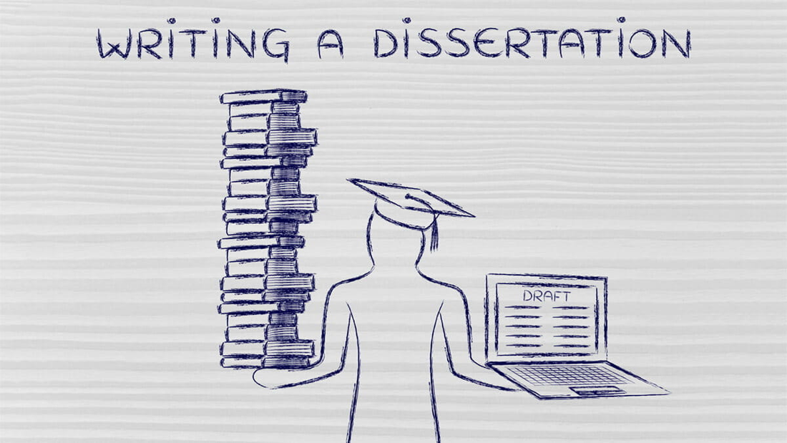

UG PROJECT PROPOSAL TIMELINE:
ALTERNATIVE JUDGMENTS

IN THIS Document, you will find:
- A timeline for completing a proposal and the steps you will need to take
- Exercises that will help you complete those steps

TIMELINE FOR ALTERNATIVE JUDGMENTS
  Key timing |   I should attend | 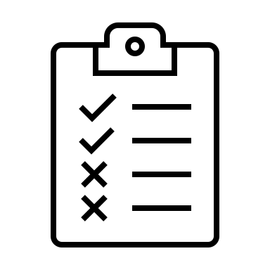  By the end of the week, I should have...
Week 2 of Term 2 | One of the project information sessions | Completed Exercise 1 and read about different project options to decide on a stream
Week 3 of Term 2 |  | Read blurbs of all available judgments and begun exploring options  Decided on the stream I want to do my research in
Week 5 of Term 2 | A stream specific session on developing proposal
Week 6 of Term 2 |  | Completed Exercise 2 and in particular, start considering the chosen judgment in more detail and explore what kind of perspectives and ideas you want to explore in your rewriting.
Week 7 of Term 2 | If I have any questions, attend one of the drop-in sessions | Read further into the readings identified
Week 10 of Term 2 | If I have any questions, attend one of the drop-in sessions
Term 3  Monday 29th April 2pm | Submit my proposal 

Exercise 1: exploring judgments
Consider all the judgments that are available to rewrite. Choose 1-3 judgments you are interested in, and begin to explore what aspects you want to rewrite, and how. Start by listing all of the perspectives and ideas for rewriting them you can think of in about 10 minutes. Then, list as many pros and cons as you can think of for each item. After all pros and cons have been identified, rank each item based on the perspective, the pros, and the cons.

Perspective /angle for re-rewriting | Pros | Cons | Rank

Notes to self

EXERCISE 2: NARROWING DOWN THE focus
Answer the following questions in 1-2 sentences per topic you are contemplating.
WHY SHOULD THIS JUDGMENT BE REWRITTEN?

What DO I HOPE TO LEARN FROM THE PROCESS OF REWRITING A JUDGMENT?

What DO I WANt the REWRITTEN JUDGMENt to SHOW to readers?

Do I want to challenge the outcome or the reasoning? DO I want to reach the same conclusion or a different conclusion from the original?

Are there ways of interpreting legal principles that I wish to challenge?

Are there contexts or experiences that I want to feature more prominently?

Are there changes to the language or tone of the judgment I'd prefer to use in my judgment?

WHAT KIND OF RESEARCH WOULD HELP ME to rewrite A judgment? What kind of materials wilL I need to read?

USinG the ONLINE LIBRARY SEARCH FUNCTION, identify and write down 5 potential sources:
These can include sources on the topic as well as on alternative judgements

Which one(s) of these sources is the most helpful and why? Just read the abstracts for now, and save the most helpful ones to later to read in full.

