

PROJECT PROPOSAL TIMELINE

IN THIS Document, you will find:
- A timeline for completing a proposal and the steps you will need to take
- Exercises that will help you complete those steps

TIMELINE
  Timing |   I should attend |   By the end of the week, I should have...
Week 2 of Term 2 | One of the project information sessions | Completed Exercise 1 and read about different project options to decide on a stream
Week 3 of Term 2 |  | Have outlined an area of law or a broad topic I want to explore further  Done preliminary research on the topic
Week 5 of Term 2 | A stream specific session on developing proposal | Decided on the stream I want to do my research in
 |  | Completed Exercise 2 and in particular, narrowed down from a broad topic to a more specific issue and identified five sources relevant to my research and considered why they are important.
Week 7 of Term 2 | If I have any questions, attend one of the drop-in sessions | Read further into the readings identified
Week 10 of Term 2 | If I have any questions, attend one of the drop-in sessions | Completed Exercise 3.
March 20th | Submit my proposal 

Exercise 1: exploring topics
Start by listing all of the ideas you can think of in about 10 minutes. You can reflect on your past study experiences, news, and personal interests to do this. Then, list as many pros and cons as you can think of for each item. After all pros and cons have been identified, rank each item based on the idea, the pros, and the cons.

Topic | Pros | Cons | Rank

Notes to self

EXERCISE 2: NARROWING DOWN THE focus
Answer the following questions in 1-2 sentences per topic you are contemplating.
What am I actually INTERESTED IN FINDING OUt?

WHY IS MY CHOSEN STREAM THE BEST route to CONDUCT this RESEARCH?

What DO I HOPE TO LEARN by CHOOSING THIS STREAM AND this topic?

WHAT KIND OF RESEARCH AND DATA WOULD HELP ME to ANSWER my questions?

USinG the ONLINE LIBRARY SEARCH FUNCTION, identify and write down 5 potential sources:

Which one(s) of these sources is the most helpful and why? Just read the abstracts for now, and save the most helpful ones to later to read in full.

Exercise 3: Finding your research topic and designing your research questions
Reflect on all the questions in the infograph – when you can answer all the questions, you are ready to submit your proposal.
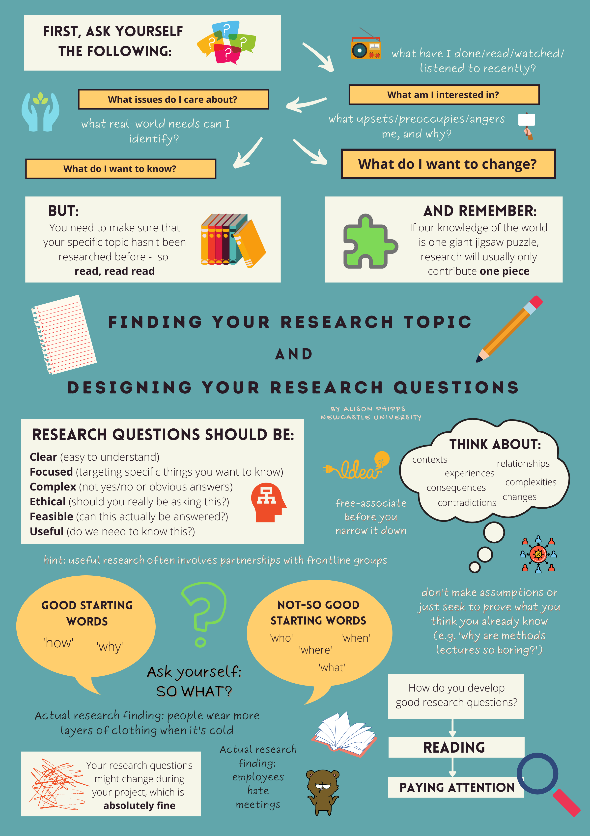
This infograph is made by Alison Phipps and it is freely available on her website: https://phipps.space/resources-for-researchers/
You can find other research resources there too.

