Concerts

Introduction

The concert is not just the arena where global fans can communicate with their favourite artists, but also the main means of making a profit for the music industry. Concerts have been planted to the global music fans’ everyday lives. According to Live Nation, the entertainment giant that owns Ticketmaster, after the end of the COVID-19 pandemic, concert attendance in 2023 will boom globally with more than 145 million fans and 620 million sold tickets at Ticketmaster.
In 2019, Coldplay, one of the top rock bands in the world, announced to pause their tour until their concert became ‘environmentally beneficial.’ This sparked a conversation about ‘eco-friendly’ concerts among many artists and led to immense attention to the impact of concerts on the environment.
However, the environmental impact of concerts has drawn less attention from academia and politicians compared to other industries’ environmental impact. Moreover, the fans are willing to pay for concerts for their favourite artists, and for ‘once-in-a-lifetime' experiences. A special edition of the journal Cultural Trends in 2018 noted “Culture and the environment are usually regarded as being distinct”.
In this context, our team attempts to ask significant questions: Do we appropriately appreciate the impact of concerts on our environment? Can we change the concert more sustainable and more eco-friendly? In this article, we will examine the environmental impact of concerts and the political economy that is deeply connected to it behind.

The Environmental Impacts of Concerts

Despite the growing attention to the environmental impact of concerts, the specific data on the impact of concerts on climate change is limited. In addition, it is difficult to specify the clear data because the methods and inclusion of measurement are different for each study and researcher. How do you measure carbon emissions or ecological impact? Who produces the pollution, artists, fans, or the music industries?
Despite its challenges and ambiguity, to gain a clearer picture of the environmental impacts of concerts, we divide the environmental impact of concerts into two categories depending on when and who produces the ecological impacts: (1) direct impact; and (2) indirect impact.
Firstly, the direct impact implies all kinds of pollution created by the participants during the concert performance. For example, we can easily think of plastic and food waste in a concert or music festival produced by fans. According to one study, concert-goers in the US produce 116 million pounds of waste and 400,000 tons of carbon emissions each year. One organiser of the Glastonbury, the biggest music festival in the UK, said “With more than one million plastic bottles sold [in] 2017.” On top of this, there are still tons of other toxic waste that is not reusable such as luminous bracelets, fans’ signs, stage setup waste, etc. For music festivals that hold a series of performances, food waste and camping waste are also produced.
The setups built by the artists also have negative impacts. South Korean singer Psy, famous for ‘Gangnam style’ and his ‘Soaked Show’, was fiercely criticised for wasting 300 tons of water at each concert amid the South Korean drought in 2022. Recently, there have been growing opinions to take noise pollution and light pollution into account. The noise pollution can affect the animals relying on sound to find food and communicate, thereby leaving their habitats.
Secondly, indirect impact encompasses the pollution created by participants and non-participants before and after the performances. A study by Julie’s Bicycle into the UK music industry found that the annual greenhouse gas emissions from artists touring in the UK and British acts touring overseas was approximately 85,000 tons of CO2 in 2010. Besides the artists’ private jets, the fans’ transportation also causes a huge amount of emissions. For example, in February 2024, the Melbourne airport faced the busiest day since pre-pandemic before Taylor Swift’s concerts, with surging plane tickets. The airline companies had to add extra flights for interstate fans.
The merchandise, including T-shirts, lightning sticks, accessories, album vinyl, etc., is consumed massively by the fans. These products cause more carbon emissions in the course of production and disposal. For example, CD packaging and booklet production accounts for more than a third (53,000 tonnes of CO2e) of the emissions within the music recording and publishing sector, estimated approximately one-tenth of the total emissions for the UK music market (540,000 tonnes of CO2e) (Bottrill et al, 2010). Other concert merchandise producers contribute to climate change through indirect emissions primarily via energy-intensive manufacturing processes and transportation. Manufacturing involves emissions from machinery, high-temperature treatments, and raw material extraction, while transportation emits greenhouse gases like CO2 and NOx. Based on National Oceanic and Atmospheric Administration (NOAA), the year 2023 has set the highest global climate record since 1850 and it was 2.12 degrees F (1.18 degrees C) above the 20th century (NOAA, 2024).

The Structural Reason for The Persisting Environmental Impacts of Concerts

Countries engage in fierce competition to host high-profile concerts, viewing them as economic stimuli for tourism and local businesses. As a prime example, we can look into Taylor Swift’s concert that happened recently in Singapore, which is estimated to have added around 300-400 million Singaporean dollars to the economy, equalling to 0.2% points of GDP. Not only that the concerts benefit the travel-related sector involving the flights of fans from other countries to Singapore, but they also boost related businesses such as accommodation, retail, food and beverage. Taylor Swift was given economic incentives so that Singapore is the only country in Southeast Asia to host her in this particular Eras concert tour, causing neighbouring countries to aim for hosting higher profiting events in the future. The theory of competition state can explain this phenomenon.
From the 1970s onward, a novel state form emerged, supplanting the previously dominant Keynesian Welfare National State. This shift marked a move away from the post-WWII emphasis on welfare expansion. While a Keynesian state emphasises on the state's ability to intervene in moderating and supporting economic activities to make sure there is price stability and full employment, a competition state adjusts its society to make it “fit for competition” (Leibfried et al., 2014), which includes neglecting long-term strategy to resolve climate change from the agenda of the state as it is seen as a competitive disadvantage. As the environment can be seen as an extension to what ensures the welfare of the society, it is only expected that it is receiving less prioritisation in being maintained. Another relevant example would be the fact that Sandiaga Uno, the Indonesian Tourism Minister, stated the government needed “what Singapore and Australia managed to pull off, which is to bring Taylor Swift. We need Swiftonomics in Indonesia”. He also spoke about a $127 million fund that is being launched to boost music, sports and cultural events (Singh, 2024).
A correlating reason would also lie in the music industry itself. Concerts and therefore the adverse impacts coming out of it are seen as externalities, which undermines the music industry as one of the many culprits of climate change. As the growth of production and consumption of goods are continuously pushed forward, the environment suffers as a result. While fans can try their best to minimise negative impacts to the environment from their side such as using more sustainable ways to reach the concert venue and reusing bottles for water, ultimately the music industry holds the most influence. A tragic case is when Ana Clara Benevides, a fan who attended Swift’s concert in Rio de Janeiro, died because of heat exhaustion (Jeantet, 2023; Petski, 2023). It was reported that water bottles were being prohibited to be brought in the show despite the extreme temperatures. Not only the unsustainable practice of concerts affects the environment negatively, but we can see that it has come full circle of actually harming the people living in the environment itself.

Conclusion

Are concerts absolutely bad for the environment, therefore stopped immediately? To make a change, the music industry has already put great efforts globally. As mentioned above, the British rock band Coldplay came back on tour with their ‘eco-friendly’ model of concerts, which uses Sustainable Aviation Fuel (SAF) for their plane, offers discounts for fans who use public transportation (tested by apps), and recyclable concert merchandise.
An American pop star Billie Eilish announced the release of an eco-friendly album, made with all recycled materials. There are many other institutions to mitigate climate change with a unified voice. For example, The Music Climate Pact put a vision to harness the power of the music industry towards inspiring transformational action on the climate crisis. Many international music conglomerates have signed in including Universal Music Group, Warner Music Group, Sony Music Group, etc.. The music industry, now, must reduce its dependence on unsustainable touring and concerts, and find a way to make the concert more sustainable and diversify its profit structure.
However, more importantly, the structural issue remains under the surface. Neo-liberalisation of concerts and tourism that reduce the costs of concerts to maximise the
profit must be adjusted at the level of an international or regional agreement. Without the government’s pro-active regulation, the concerts and music industry will be more
liberalised and commercialised which could lead to slowing down the eco-friendly
innovation. Governments must expand their spending on building sustainable concert
infrastructures rather than reducing their costs. With both governments’ and music
industries’ efforts, the concerts can be more sustainable and beautiful ‘once-in-a-lifetime’
Events.

[Video suggestion]

CNA - How has Taylor Swift's "Eras Tour" benefitted Singapore's economy? (5:20)
https://www.youtube.com/watch?v=TKP8YiRZnT0

[Photograph by our writing team]
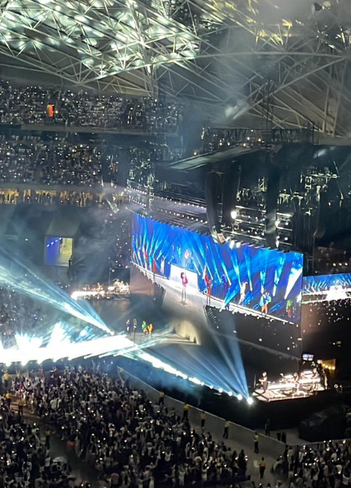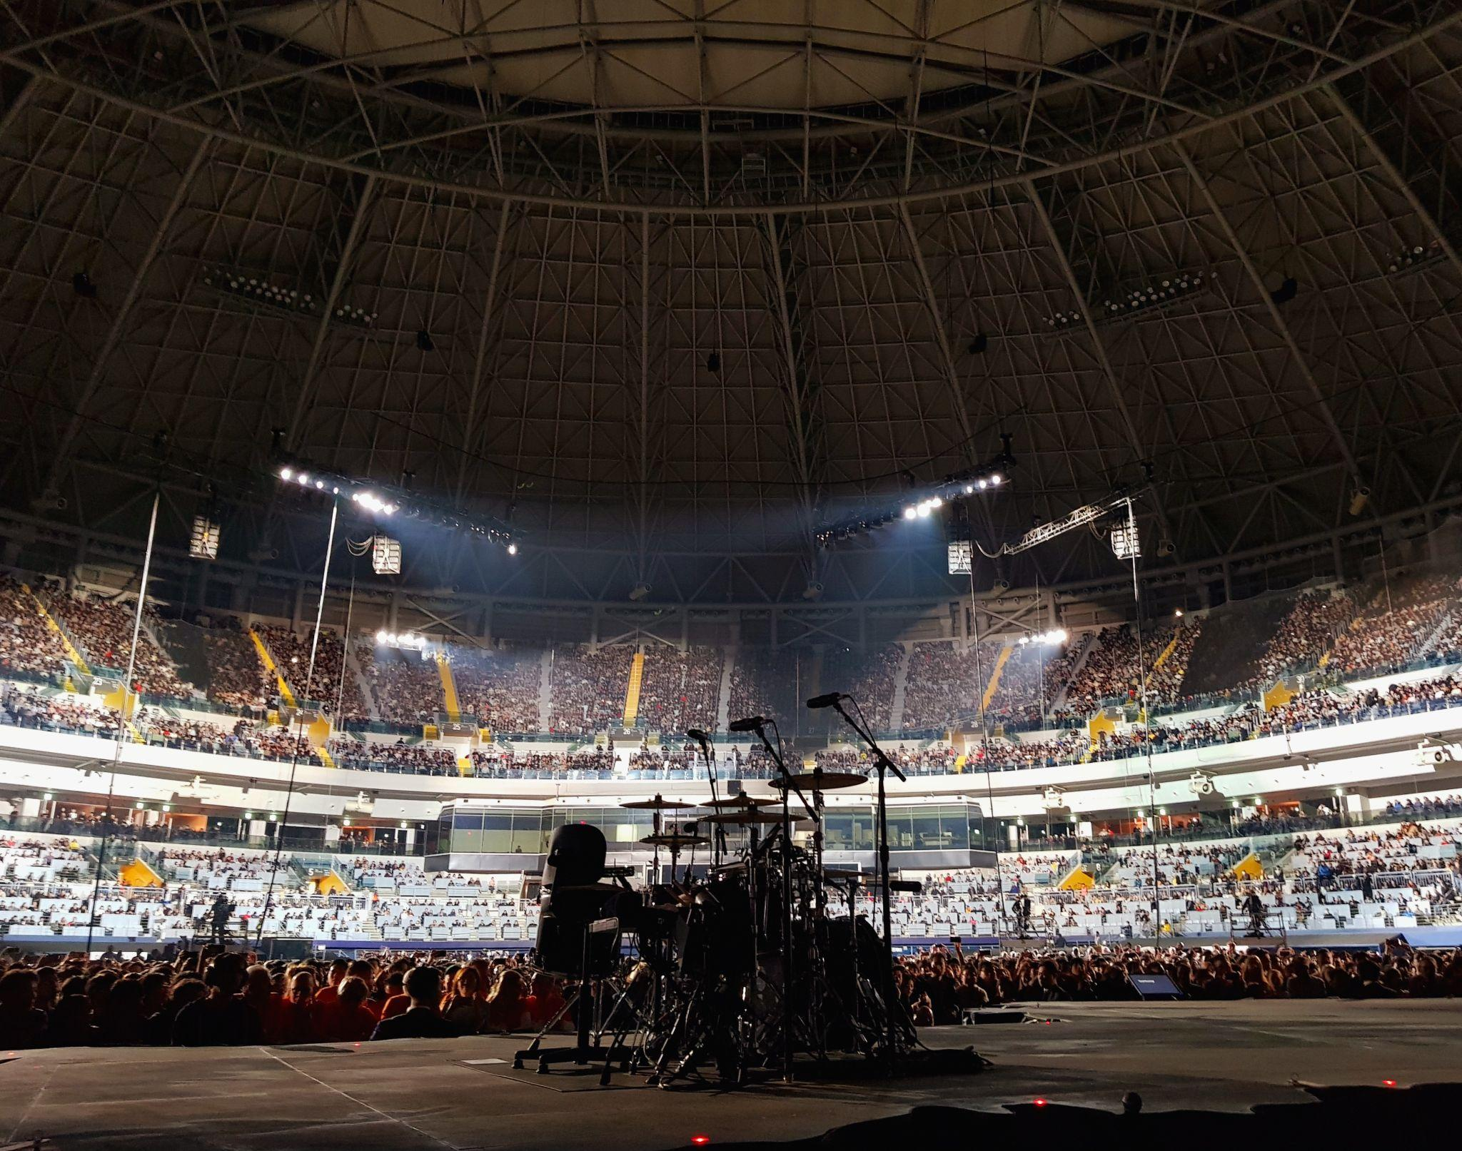

References
Bottrill, C., Liverman, D., & Boykoff, M. (2010). Carbon soundings: greenhouse gas emissions of the UK music industry. Environmental Research Letters, 5(1), 014019. https://doi.org/10.1088/1748-9326/5/1/014019

Gerretsen, I. (2019, June 25). How not to trash the planet at a music festival. CNN. https://edition.cnn.com/2019/06/25/world/plastic-waste-emissions-music-festivals-intl/index.html#:~:text=In%20the%20United%20States%2C%20festival%2Dgoers%20produce%2053%2C000%20tons%20of

Horton, A. (2024, February 22). Live Nation reports 2023 biggest year ever for concert turnout and ticket sales. The Guardian. https://www.theguardian.com/music/2024/feb/22/live-nation-concert-attendance?CMP=share_btn_url

Jeantet, D. (2023, November 18). Taylor Swift fan dies at Rio concert as fans complain about high temperatures and lack of water. NBC Connecticut. https://www.nbcconnecticut.com/entertainment/entertainment-news/taylor-swift-fan-dies-at-rio-concert-as-fans-complain-about-high-temperatures-and-lack-of-water/3152547/

Leibfried, S., Huber, E., Lange, M., Levy, J. D., Stephens, J. D., Genschel, P., & Seelkopf, L. (2014). The Competition State: The Modern State in a Global Economy. In The Oxford Handbook of Transformations of the State (pp. 237–252). Oxford Academic. https://doi.org/10.1093/oxfordhb/9780199691586.013.12

NOAA (2024). 2023 was the world’s warmest year on record, by far. National Oceanic and Atmospheric Administration. https://www.noaa.gov/news/2023-was-worlds-warmest-year-on-record-by-far

Petski, D. (2023, December 27). Taylor Swift Fan Ana Clara Benevides Machado’s Cause Of Death Revealed. Deadline. https://deadline.com/2023/12/taylor-swift-fan-ana-clara-benevides-machados-cause-of-death-1235682381/

Singh, R. (2024, March 9). Why the Singapore government struck a “deal” to host Taylor Swift’s Eras Tour. The Indian Express. https://indianexpress.com/article/explained/explained-global/singapore-deal-taylor-swift-eras-tour-9203760/

Zero, N. (2022). Creative Industries and the Climate Emergency

