Concerts

Introduction

In February 2024, Taylor Swift’s The Eras Tour ignited a dispute among ASEAN countries. The Singaporean government subsidised US$2-3m per night for the tour to perform exclusively in Singapore. At this ‘betrayal’ deal, other neighbouring Southeast Asian leaders complained, arguing they could have also subsided the mega concerts. This competition among ASEAN countries to host the mega-concert stems from the economic boost concerts can provide, a phenomenon dubbed ‘Swiftnomics’. It is reported that after The Eras Tour, the Singapore’s GDP increased by 0.2%. This case of ‘competition states’ in Southeast Asia demonstrates how concerts can have substantial implications for the international political economy.

[Analysts estimate 'Swiftonomics' will drive millions in revenue for Singapore]
https://youtu.be/e0OIRsCHt88?si=QVI6xi4hRLPi2gQP

While the economic benefits of concerts were emphasised in this region, the environmental costs were largely ignored. The exclusive deal that Singaporean government made, forced many Southeast Asian fans to fly to Singapore, generating countless tons of CO2 emissions that could have been avoided if one flight - the performer - toured multiple regions. Negative environmental impacts of concerts are already criticised by many researchers. According to one study, concert-goers in the US produce 116 million pounds of waste and 400,000 tons of carbon emissions each year.
Despite growing concerns towards the ecological impacts of concerts, this issue remains underrepresented on societal agendas. Many fans spend on expensive concert tickets and wait in line while camping around the arenas, justifying this as their loyalty to their favourite artists or ‘once-in-a-lifetime experience’. This is mainly because of the influential power of pop culture and concerts. Concerts not only influence fans’ consumption pattern, but also systematically reinforce the political economic ideology, justifying the massive consumption. It is time to re-assess the hidden impacts of concerts on the international political economy (IPE) and our environment.

The Environmental Impacts of Concerts

As our everyday life is closely connected to the music industry, the ecological impacts of music concerts are vast and deep. The environmental impacts can be assessed in two categories: (1) direct impact and (2) indirect impact.
The direct impact implies all kinds of pollution generated by the participants during the concert performance. For example, we can easily think of plastic and food waste in a concert or music festival produced by fans. One organiser of Glastonbury, the biggest music festival in the UK, said “More than one million plastic bottles sold [in] 2017.” On top of this, there are still tons of other toxic waste that is not reusable such as luminous bracelets, fans’ signs, etc. The setups built by the artists also have negative impacts. South Korean singer Psy, famous for ‘Gangnam style’ and his ‘The Soaked Show’, was fiercely criticised for wasting 300 tons of water at each concert amid the South Korean drought in 2022.
The indirect impact includes the pollution created by participants and non-participants before and after the performances. A study by Julie’s Bicycle on the UK music industry found that annual greenhouse gas emissions from artists touring in the UK and British acts touring overseas were approximately 85,000 tons of CO2 in 2010. In addition to the artists’ private jets, fans’ transportation generates significant emissions. Merchandise such as T-shirts, light sticks, accessories, and vinyl albums are consumed massively by fans, leading to further carbon emissions due to energy-intensive manufacturing. For example, CD packaging and booklet production account for a third (53,000 tonnes of CO2e) of the emissions within the music recording and publishing sector, which is estimated to be approximately one-tenth of the total emissions for the UK music market (540,000 tonnes of CO2e).
Acknowledging the detrimental impacts of concerts on the environment, many music fans and artists have consistently put their efforts to change this problem. For example, Billie Eilish's "Happier Than Ever" world tour, celebrated for its ambitious eco-friendly initiatives, faced mixed results in its overall effectiveness. Supported by REVERB, the tour aimed to minimise its environmental footprint through various measures, including establishing eco-villages at each venue, promoting plant-based diets, and ensuring waste reduction and recycling efforts.
However, the attempts to reach the ‘eco-friendly concerts’ have faced challenges in achieving its broader environmental goals. The overall carbon footprint remains substantial. Studies indicate that celebrity-led environmental campaigns often struggle to induce significant, lasting behavioural changes in audiences. It is important to understand in what mechanism this environmental impacts of concerts are generated, and how this vicious mechanism is systematically solidified.

So, Why Are ‘Eco-Friendly’ Concerts So Difficult to Realise?

Environmental experts often criticise the emphasis on individual actions and minor adjustments, arguing that these do not address the systemic issues. The focus on personal responsibility, exemplified by Eilish's tour initiatives, might overshadow the need for broader policy reforms and corporate accountability.
We believe that the IPE behind the concerts systematically delays the effective resolution of this issue. Firstly, ‘competition states’ prioritises economic benefit and ignore the environmental costs. Mega-events, including concerts, the FIFA World Cup or Olympics, bring temporary economic boost, serve as political strategies, and enhance nation branding. For example, in the ASEAN case, Singapore seeks to harness ‘Swiftnomics’ while promoting its cultural industries. By hosting international pop stars, Singapore positions itself as a prime destination for entertainment and culture, thus enhancing its national branding from a strict and dull country to a colourful and enjoyable place. This is especially crucial as Singapore competes with other international cities, such as Dubai and Hong Kong, to be recognised a business and culture hub.
Following Singapore’s exclusive deal with Taylor Swift, other ASEAN countries have also announced efforts to host the mega-concerts. Sandiaga Uno, the Indonesian Tourism Minister, stated the government needed “Swiftonomics in Indonesia” and lunched $127 million fund launched to boost music, sports and cultural events. In the race to attract such economic prospects, environmental costs of concerts are easily excluded from the agenda, as ‘competition state’ adjusts its society to make it “fit for competition”. States are more reluctant to reduce the negative environmental impact as it is seen as a competitive disadvantage.
Secondly, the music industry and consumption on music concerts have become part of the ‘culture industry’, leading people passively accept its system. Concerts influence our behaviour, ideology and consumption patterns. For example, friendship bracelets, popularised by Taylor Swift’s lyrics, have led to a 300% sales boost, but these bracelets are made from plastic derived from fossil fuels, contributing to environmental harm from extraction to disposal. Driven by the ‘culture industry’, fans buy expensive concert ticket and flights, and consume massively at the venues without hesitation. With few cultural barriers, fans are pleasantly willing to spend, and the music industry exploits this to maximise their economic profit while ignoring ecological impacts. The K-Pop’s album sales strategy with ‘random concert ticket draw’ is the well-known example.
Furthermore, this ‘culture industry’ is reinforced by ideological globalisation with concerts. Concerts act as spatial devices where ideological transfers occur. Through music, we unconsciously accept cultural hegemony from the West, especially American pop culture. With fewer cultural barriers, people listen to and consume American artists, namely Taylor Swift, Jay-Z, Bruno Mars, and gradually accpet their cultural background as well. Since the American cultural hegemony in the 20th century, the most ‘American’ things became the most ‘international’.

[Jay-Z - Empire State of Mind ft. Alicia Keys]
https://www.youtube.com/watch?v=vk6014HuxcE&ab_channel=JayZVEVO

This softpower hegemony is accompanied by ideological hegemony, such as capitalism, free trade, and democracy. In a liberalised world, concerts are positive economic stimuli for states, and worthy ‘once-in-a-lifetime’ experience for fans. Nowadays, many American artists are conducting ‘world tours’, consistently spreading these hegemonic impacts.
As this systemic circumstance intensifies, individuals and environment are easily forgotten. Ana Clara Benevides, a fan who died from hear exhaustion at Taylor Swift’s concert in Rio de Janerio, is a stark case of individual forgotten in the system. Despite the extreme temperatures, water bottles were banned at the show, and she died by the record-breaking heatwave in Brazil caused by climate change. We cannot solely blame neither the venue staff concerning terrorism, nor the heatwave itself, however, this young girl was dying under the systemic vicious circle that concerts have historically generated towards capitalism and environmental degradation.

Conclusion

Concerts generate an enormous carbon footprint and contribute to the vicious circle of negative environmental impacts by promoting capitalism and the ‘competition state’ model. We are not suggesting an immediate halt to all music concerts. This is neither possible nor beneficial. Music has a powerful influence on people's minds, which is why many artists, such as Coldplay, Billie Eilish, and U2, strive to initiate ‘eco-friendly’ concerts.
Instead, we need to properly face the environmental impact of concerts and analyze how this vicious circle persists. With a broader and long-term perspective, we can identify and change the systemic flaws, ultimately making our concerts both ‘eco-friendly’ and truly a ‘once-in-a-lifetime’ experience.

Stock image
https://www.istockphoto.com/en/photo/crowd-at-a-music-concert-gm506793463-45555968

[Photograph by our writing team]

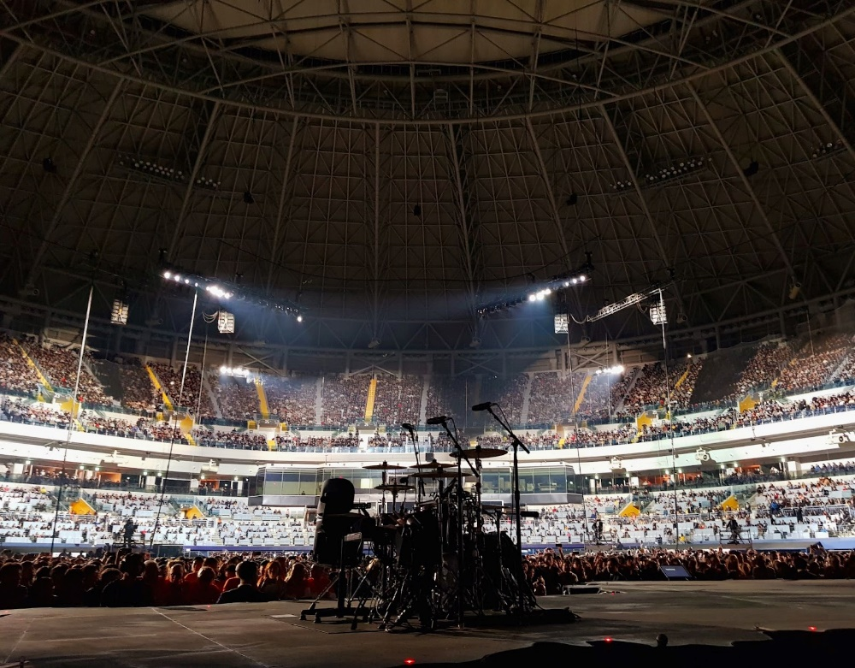
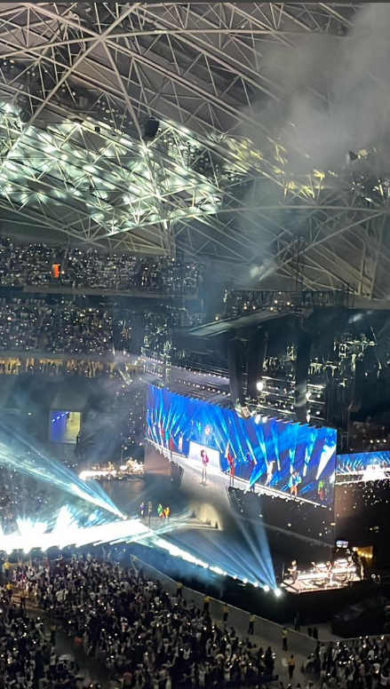

References

Bottrill, C., Liverman, D., & Boykoff, M. (2010). Carbon soundings: greenhouse gas
emissions of the UK music industry. Environmental Research Letters, 5(1), 014019. https://doi.org/10.1088/1748-9326/5/1/014019
Circle Economy Foundation. (2023). Billie Eilish is fighting climate change through 2022
“Happier Than Ever” tour and Overheated event. Circle Economy Foundation.https://knowledge-hub.circle-economy.com/wctd/article/17533?n=Billie-Eilish-is-fighting-climate-change-through-2022-%E2%80%9CHappier-Than-Ever%E2%80%9D-tour-and-Overheated-event

Gerretsen, I. (2019, June 25). How not to trash the planet at a music festival. CNN. https://edition.cnn.com/2019/06/25/world/plastic-waste-emissions-music-festivals- intl/index.html#:~:text=In%20the%20United%20States%2C%20festival%2Dgoers% 20produce%2053%2C000%20tons%20of
Horton, A. (2024, February 22). Live Nation reports 2023 biggest year ever for concert turnout and ticket sales. The Guardian. https://www.theguardian.com/music/2024/feb/22/live-nation-concert- attendance?CMP=share_btn_url
Jeantet, D. (2023, November 18). Taylor Swift fan dies at Rio concert as fans complain about high temperatures and lack of water. NBC Connecticut. https://www.nbcconnecticut.com/entertainment/entertainment-news/taylor-swift-fan- dies-at-rio-concert-as-fans-complain-about-high-temperatures-and-lack-of- water/3152547/
Leibfried, S., Huber, E., Lange, M., Levy, J. D., Stephens, J. D., Genschel, P., & Seelkopf, L. (2014). The Competition State: The Modern State in a Global Economy. In The Oxford Handbook of Transformations of the State (pp. 237–252). Oxford Academic. https://doi.org/10.1093/oxfordhb/9780199691586.013.12
Limb, L. (2022, June 13). ‘It’s not all on you’: Billie Eilish appeals to Gen Z at her first-ever climate event. Euronews. https://www.euronews.com/green/2022/06/11/it-s-not-all- on-you-billie-eilish-appeals-to-gen-z-at-her-first-ever-climate-event
NOAA (2024). 2023 was the world’s warmest year on record, by far. National Oceanic and
Atmospheric Administration.
https://www.noaa.gov/news/2023-was-worlds-warmest-year-on-record-by-far
Petski, D. (2023, December 27). Taylor Swift Fan Ana Clara Benevides Machado’s Cause Of Death Revealed. Deadline. https://deadline.com/2023/12/taylor-swift-fan-ana-clara- benevides-machados-cause-of-death-1235682381/
Singh, R. (2024, March 9). Why the Singapore government struck a “deal” to host Taylor Swift’s Eras Tour. The Indian Express. https://indianexpress.com/article/explained/explained-global/singapore-deal-taylor- swift-eras-tour-9203760/
Zero, N. (2022). Creative Industries and the Climate Emergency

