Please, review structure of the piece to make it more focused and avoid repetition
We have cut out repetitive phrasing.

Please consider adding a direct comparison of the climate costs of a tote-bag and plastic bag
We have added direct comparisons of the climate costs of a tote-bag vs plastic bags.
Our Images & Videos:
- Stack of Tote bags from Hannah Smyth.jpeg
  - Caption: A stack of totes
- [https://www.istockphoto.com/en/photo/woman-is-holding-bag-canvas-fabric-for-mockup-blank-template-gm1148884819-310414466?searchscope=image%2Cfilm
- [YouTube Video: Reality check on cotton tote bags and their environmental impact l GMA ]

Tote Bag

Kaira Noor Azwa, Sam Simkin & Hannah Smyth

In 2024, you probably have at least ten tote bags at the back of your cupboard. The humble tote bag has a knack of accumulating in a way like no other. Yet, while these reusable cotton bags may seem good in principle, they have a much larger environmental impact than appears at first glance.

[https://www.istockphoto.com/en/photo/woman-is-holding-bag-canvas-fabric-for-mockup-blank-template-gm1148884819-310414466?searchscope=image%2Cfilm]

While marketed as an environmentally conscious choice to discourage the use of plastic, the tote bag has a far more sinister impact on climate change. As such, seemingly sustainable products might not actually be environmentally friendly. A 2018 Danish study found that cotton tote bags contain a significantly higher emissions output when compared to plastic bag production. According to the study, organic tote bags need to be reused at least 149 times, and regular cotton tote bags need to be reused at least 52 times, to equal the emissions emitted by the production of a plastic bag. To better recognise climate costs, a direct comparison is required. Cotton tote bags, a staple of the fast fashion business, require a lot of energy and materials, resulting in a significant carbon footprint. In contrast, plastic bags made from oil byproducts use less energy, resulting in lower emissions. While neither is perfect, analysing the differences reveals the environmental intricacies of both options. This stark distinction emphasises the importance of thoroughly evaluating the underlying climatic costs of both tote bags and plastic bags, rather than adopting superficial ideas of sustainability. These are some significant differences in the emissions output between the two items despite the cultural narratives depicting very different perspectives on disposable and reusable bags.

Much of the tote bag’s production remains within the ‘fast fashion’ industry. Textile production is one of the highest polluting industries in the world, emitting approximately 1.2 billion tonnes of CO2 emissions per year. This represents around 10% of global emissions annually. The energy and materials required for the production of cotton is one key reason behind this, resulting in a high carbon footprint. In fact, a 2014 study found that cotton has the worst environmental performance over other textiles including nylon, elastane and polyester. This is due to the high energy requirements needed for the production of cotton. Plastic bags alternatively, are produced from by-products of the oil industry and thus require less energy to produce the raw resource. This results in an overall reduced emissions output for these bags. Evidently, the emissions discrepancies do not highlight that the plastic bag has ‘good’ environmental outputs but instead showcases the inconsistencies between the perspectives on both items.

Another significant explanation behind these high CO2 emissions is the globalisation of production. Instead of the stages of a product life cycle occurring in a localised place, the various aspects of production occur at multiple different locations globally. Cotton tote bags, like much of the products in the ‘fast fashion’ industry, are made not in areas in close proximity to its consumers, but instead in regions where the product can be produced the cheapest.

In this industry, this is largely seen in areas in East and Southeast Asia where relaxed labour laws result in low production costs. The products are then shipped globally, by multiple different transport systems, including sea freight, and plane, resulting in enormous CO2 emission outputs. High rates of fossil fuel emissions are thus embedded into the global trade regime. It is estimated that approximately 6.4 billion tons of CO2, representing 23% of global emissions, are tied into globally traded goods. While local production may reduce climate change impacts, the costs involved disincentive this switch resulting in items like the simple tote bag holding a much larger carbon footprint than expected.

[YouTube Video: Reality check on cotton tote bags and their environmental impact l GMA ]

The Tote Bag: From Eco-Hero to Consumerist Symbol?

Tote bags are now caught up in the fast fashion industry's high production and consumption dynamics and it has come to represent a culture of reckless consumption. Despite its admirable goals, tote bags have fallen victim to the same consumerist frenzy that drives the fast fashion sector, where items are produced at an unsustainable rate and trends change quickly.

The tote bag was formerly a practical grocery bag tool, but these days it's a sought-after fashion piece. On these previously modest bags, brands prominently display their logos, frequently accompanied by a "sustainable" tag. Their broad availability and frequent giveaways or low-cost sales contribute to an issue known as overproduction. This is similar to the fast-fashion business model, in which manufacturing is unsustainable and trends change quickly. Although perceived as environmentally friendly, they represent the paradox of a society that struggles with excessive consumerism but longs for eco-friendly alternatives.
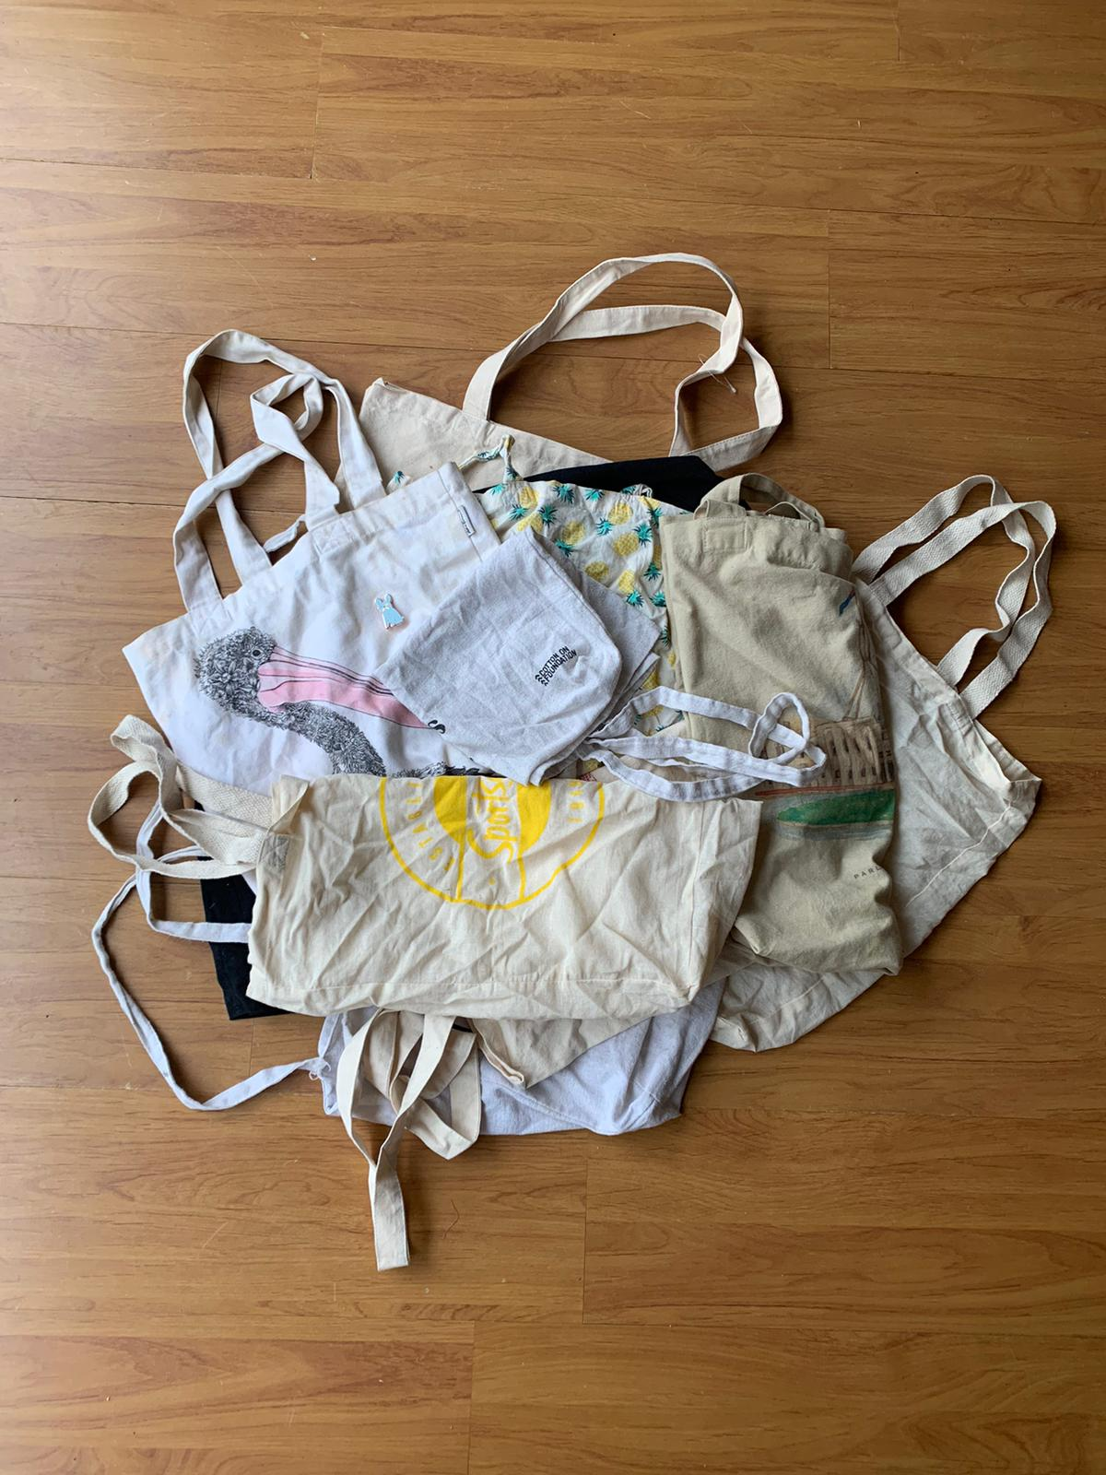
Photo Description: A stack of totes by Hannah Smyth

The tote bag phenomenon can be interpreted as an expression of global consumerism from the standpoint of International Political Economy (IPE). The market for tote bags worldwide is predicted to grow to USD 3.76 billion by 2031 and is driven by a variety of uses, including fashion statements and supermarket shopping. The escalating popularity and appeal of cotton tote bags as trendy accessories are key drivers propelling this growth. Simultaneously, the simple tote bag has evolved into a socially competitive venue. Businesses capitalise on the need for individuality by offering trendy designs, fostering a fast-paced cycle of consumption similar to the one seen in fast fashion. However, the eco-friendly reputation of the tote bag adds to its appeal. It is perceived as a substitute for throwaway plastic bags and a symbol of sustainability for environmentally conscious consumers. However, a paradox emerges in our quest for sustainability, as evidenced by the overproduction and excessive consumption of tote bags. This contradiction underscores the complex relationship between consumerism and sustainability, challenging us to reassess our consumption habits and their impact on the environment.

Grappling with Greenwashing: Tote Bag Exposé

At the same time, these consumption habits are encouraged through corporate greenwashing, where brands undertake deceptive marketing strategies to mislead consumers into believing products are eco-friendly to entice eco-conscious consumption. Misleading labels, bold sustainability claims and green narratives create the façade of environmentalism, obscuring the true environmental and social impacts of the brand’s practices. The tote-bag has become a key marketing tool for brands to showcase this ‘eco-consciousness’, whilst continuing to perpetuate the environmentally devastating and socially exploitative practices evidenced above.

The Australian brand, Cotton On, proudly states that their products are: “Effortless, on-trend and affordable – made responsibly, to be loved and lived in every day.” Core to the brand’s image is this idea of ‘responsibility’ to the extent where their 2022 annual report was entitled “The Good Report”, espousing the rhetoric of eco-consciousness. Attached to this image of ‘responsibility’ is the Cotton On 'recycled cotton tote bag’.

Yet, Good On You, an Australian sustainability rating platform that evaluates fashion brands, found that, "Despite its declarations of sustainability and ethical practice, Cotton On still has a long way to go before it can truly back up its claims". Unfortunately for the 5.5 million consumers of Cotton On’s ‘recycled cotton tote bags,’ it seems those purchases were not quite as sustainable as they may have thought.

The brand retails their ‘recycled cotton tote bag’ for £3 each on their UK website. The name implies that the tote is made entirely from recycled materials, however the small print reveals only 50% of the cotton is recycled. At only £3 each, it is no surprise that the brand revealed in “The Good Report” that in 2022 alone, 5.5 million ‘recycled cotton’ tote bags were sold globally. More conflicting statements come from “The Good Report”, with Cotton On making a subsequent claim that 100% of their cotton is ‘sustainably’ sourced. In contradiction to this, the brand later stated that 64% of the cotton sourced is conventional cotton, with 3% of cotton sourced being recycled. As explored, there is a consensus that conventional cotton farming is not a sustainable practice, so how can Cotton On claim to have sourced 100% of their cotton sustainably, when 64% of their cotton is farmed conventionally? Like many brands, Cotton On’s bold claims of sustainability just aren’t matching up with the reality revealed in “The Good Report”.

From Single-Use to Responsible Use: Developing Conscious Consumption for Our Climate

The question, 'Do I have enough tote bags at home?' is more than just a personal inventory check; it reflects our role in the political economy that is driving the climate problem. Tote bags, which are frequently collected and rarely reused, represent the conflict between sustainable aspirations and consumerist realities. Our shift from plastic to cotton has yet to address the root cause of a disposable culture driven by mass manufacturing and consumption. This behaviour adds to resource depletion and increased carbon emissions, which are at the heart of the climate catastrophe. To truly address this, we must implement collective resource-sharing activities, such as bag-sharing programmes, and rethink our consumption habits. A surplus of bags at home acts as a tangible reminder of excess. So, the next time you're offered a free tote, remember: Just Say No.

1487 words

Tote Bag Resources
Academic Article:
Davis, S. J., Peters, G. P., & Caldeira, K. (2011). The supply chain of CO 2 emissions. Proceedings of the National Academy of Sciences of the United States of America, 108(45), 18554–18559. https://doi.org/10.1073/pnas.1107409108
Filho, W. L., Perry, P., Heim, H., Dinis, M. a. P., Moda, H., Ebhuoma, E., & Paço, A. (2022). An overview of the contribution of the textiles sector to climate change. Frontiers in Environmental Science, 10. https://doi.org/10.3389/fenvs.2022.973102
Macdonald, K. (2012). Global Production: An overview. In WORLD SCIENTIFIC eBooks (pp. 57–71). https://doi.org/10.1142/9789814366984_0005
Van Der Velden, N. M., Patel, M. K., & Vogtländer, J. G. (2013). LCA benchmarking study on textiles made of cotton, polyester, nylon, acryl, or elastane. The International Journal of Life Cycle Assessment, 19(2), 331–356. https://doi.org/10.1007/s11367-013-0626-9

Annual Report:
Cotton On Group. (2022). The Good Report 2022.
https://cottonongroup.com.au/wp-content/uploads/2022/12/THE-GOOD-REPORT-2022-1.pdf
The Danish Environmental Protection Agency. (2018). Life Cycle Assessment of grocery carrier bags. https://www2.mst.dk/udgiv/publications/2018/02/978-87-93614-73-4.pdf

iStock Photo:
Artit_Wongpradu. (2019, May 15). Woman is holding bag canvas fabric for mockup blank template [Photograph]. iStock. https://www.istockphoto.com/en/photo/woman-is-holding-bag-canvas-fabric-for-mockup-blank-template-gm1148884819-310414466?searchscope=image%2Cfilm

Online Resources:
Dillon, N. (2016, September 2). Are Tote Bags Good for the Environment? The Atlantic. https://www.theatlantic.com/technology/archive/2016/09/to-tote-or-note-to-tote/498557/
Gan, T. (2021, September 23). Commentary: A tote bag sounds like the eco-friendly option – but it isn’t always. CNA. https://www.channelnewsasia.com/commentary/cotton-tote-bag-plastic-single-use-waste-recycle-reuse-climate-change-2194151
Nguyen, J. (2024, March 20). How the tote bag became the hottest fashion accessory around. Marketplace. https://www.marketplace.org/2024/03/19/how-the-tote-bag-became-the-hottest-fashion-accessory-around/
Robertson, L. (2023, June 21). How ethical is Cotton on? - Good on you. Good on You. https://goodonyou.eco/how-ethical-is-cotton-on/ ‌

Website:
Plastic, Paper or Cotton: Which Shopping Bag is Best? (2020, April 30). State of the Planet. https://news.climate.columbia.edu/2020/04/30/plastic-paper-cotton-bags/
Tote bags Market Size, scope, Opportunities & Challenges by 2031. (2024, March 1). Data Bridge Market Research.
https://www.databridgemarketresearch.com/reports/global-tote-bags-market?SR&trk=article-ssr-frontend-pulse_little-text-block

YouTube:
Good Morning America. (2022, April 23). Reality check on cotton tote bags and their environmental impact l GMA [Video]. YouTube. https://www.youtube.com/watch?v=svQivjsTtG4

