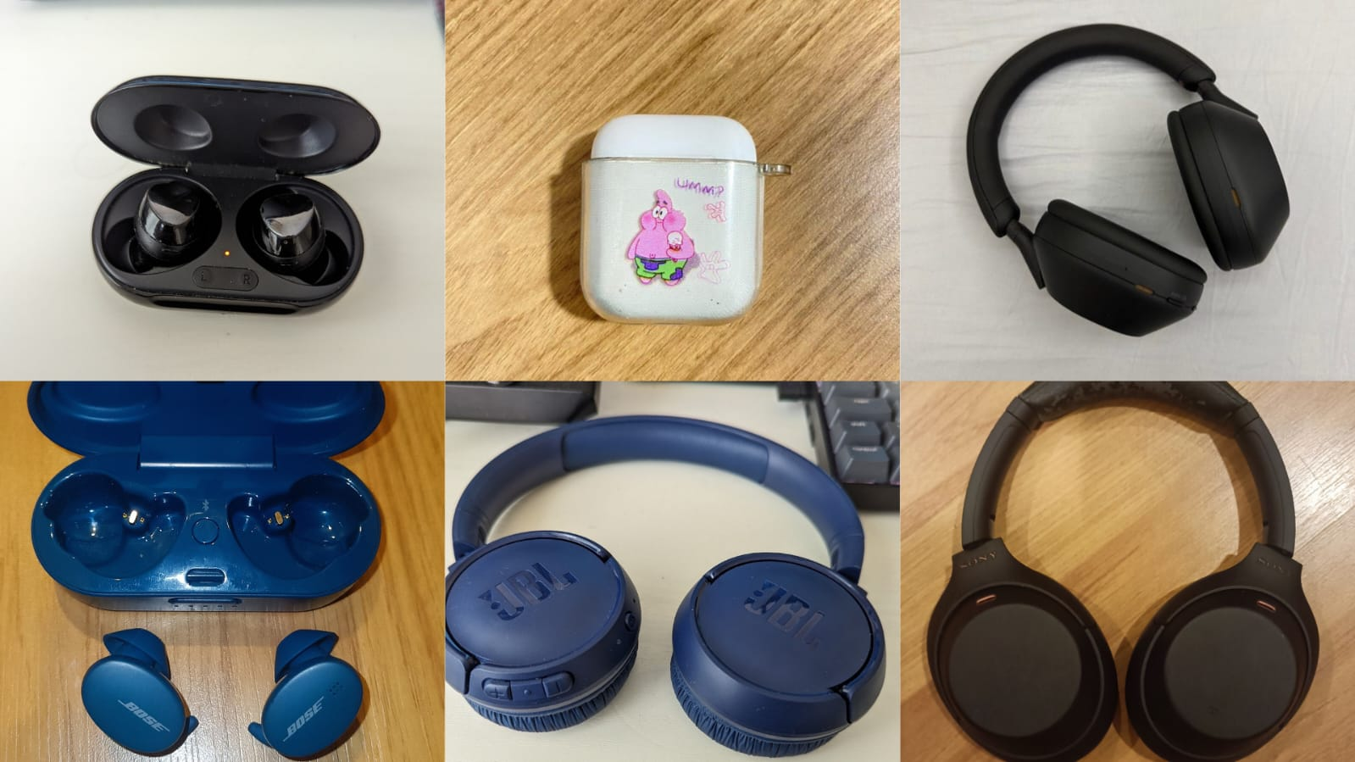

“Unplugged: The Environmental Detriment of Bluetooth Headphones”

Bluetooth headphones are essential and addictive, you might even be using a pair now. Headphones are intrinsically linked to the capitalist obsession with enhanced productivity and the modern desire for escape. Headphones have become widely used, and garnered cultural significance with subcultures like hip-hop, making Bluetooth headphones fashion accessories and status symbols. Therefore creating a thriving market for affordable and luxury models. This surge in popularity has made headphones the core of an industry characterized by rapid innovation.

Headphones rely on two key components: Bluetooth connectivity that utilizes high-frequency electromagnetic radio waves to wirelessly transmit music, while lithium-ion batteries enable wireless mobility. However, the broad market means infinite variations with different functions. Virtual assistants and noise-cancelling for example are used for privacy and productivity, while high-end metals may make headphones more fashionable. As we can see, there are now more iterations of headphones with differing features than consumers would realistically need.

Best Bluetooth Earbuds for 2024

Bluetooth headphones became mainstream and replaced wired headphones with the popularisation of Apple AirPods. While we are quick to herald the latest innovations in technology, what is often overlooked is the disruptive obsolescence that follows it. Apple Airpods' widespread adoption was driven by Apple's revocation of support for wired headphones, indicating forced obsolescence by technology manufacturers. This contributes to a cycle of pollution centered around headphones that we, as paying consumers, have become complicit in.

This article explores how Bluetooth headphones serve as a central example of how technology in a capitalistic system lends itself to creating exponential pollution and requires significant policy intervention on a global scale. We first explore how the materials used in headphone production, particularly plastics and lithium-ion batteries, lead to exponential pollution. We then look into how the global processes of mining and manufacturing headphones also contribute to the exponential pollution in developing regions. We then delve into potential solutions that consumers and manufacturers can use to create positive change.

E-Waste

As we embrace the convenience of technologies like wireless earbuds, it's crucial to consider their environmental implications. A compelling example of the broader issue of e-waste is the Agbogbloshie dumpsite in Ghana, where approximately 250,000 tons of sorted electronic waste are dumped annually, much of it from Western countries. This situation escalated after initiatives like Ghana's 2004 "One Laptop Per Child" policy aimed to bridge the digital divide with affordable used electronics. The lifecycle of products like wireless earbuds, often discarded due to non-replaceable batteries and planned obsolescence, contributes significantly to such e-waste challenges.

This relentless influx of e-waste is vividly exemplified by the staggering 300 to 600 shipping containers of electronics that arrive in Ghana each month, leading to severe environmental contamination. At Agbogbloshie, the impact on the local environment is dire, with various toxic substances contaminating air, soil, dust, water, and human contamination. Notably, chicken eggs from the area have recorded the highest levels of brominated dioxins and the second-highest levels of chlorinated dioxins ever reported. The consumption of just one such egg could exceed the European Food Safety Authority's tolerable daily intake for chlorinated dioxins by 220-fold, underlining the critical human health implications of such pollution. As these devices end up in landfills within just a few years of use, they pose a substantial environmental risk, mirroring the issues seen at Agbogbloshie.

Unfortunately, the cycle at Agbogbloshie, where approximately 40,000 people live and work, continues unabated, fueled by poverty, economic incentives, and insufficient regulatory frameworks. The high levels of toxic exposure at the site pose severe health risks, including increased cases of cancer among the predominantly young workforce and residents. This threatens individual health and significantly diminishes the working-age population, undermining the community's economic stability and growth potential.

Mining and Manufacturing

Lithium-ion batteries have been deemed so necessary for modern life that they were awarded the Nobel Chemistry Prize in 2019. They are rechargeable, have high energy efficiency and a longer life cycle than traditional rechargeable batteries. This makes them less costly and produces less waste than conventional rechargeable batteries. Furthermore, the main mineral needed, lithium, is accessible in large amounts under the surface across the globe. It is estimated that by 2040, it is expected that demand for lithium will grow more than 40 times if the world is to meet the requirements of the Paris Agreement. It is usually seen as an environmental good.

Many reserves known for producing the material are based in South America. Lithium is dissolved in salt flats, where water evaporates salt to separate the minerals. One mine in Bolivia uses 50,000 litres of water daily, creating environmental and social disasters due to the few resources left for local populations.

It is also heavily mined in Australia in hard rock mines. This is closer to traditional mining, whereby it is pulled out of the ground with other compounds. This typically produces higher carbon emissions due to the diesel engine tools that extract the minerals. These minerals are primarily processed in China, exacerbating the carbon used.

Lithium mining has a dark side, with the low levels of regulation that rule. This is particularly demonstrated in the Congo, home to lithium and large-scale cobalt mining (another key component to headphones).

Stock photo to be added here - https://www.istockphoto.com/photo/miners-underground-mining-in-africa-gm458110113-22700789

Congo’s cobalt resourcing is symptomatic of global supply chain demands with high rates of child labour, labourer decease and water pollution. Artisanal miners face challenging conditions, excavating trenches by hand to satisfy the demand of supplying 60% of the world’s cobalt. There have been biological implications as a direct result with surges in antenatal deformities and affliction.

Manufacturing hubs in China subscribe to the same malpractices and abuse of labourers, factories overworking their employees with little reward. Upon reception of the raw materials from Congo, the central tenet of increasing supply with increased demand pervades, leading to obstruction of labour rights throughout the production scheme.
Economic inequalities further permeate the consumer sphere via skewed accessibility of products due to the high market prices. Thus, Marginalised communities have disproportionately attained headphone technology, perpetuating somewhat of a digital class divide. This results in greater consumption of even cheaper technologies that are sourced in an environmentally unethical way, producing high turnovers and greater climate impact.

Environmental repercussions of the lithium-cobalt industry are just as bleak. Natural resource extraction and exploitation produce obvious pollutants, the transformation from mineral to product deteriorates the atmosphere, placing further emissions on China’s production list. Whilst, China’s eco-standards deteriorate at the hands of this technology, the West enjoys the luxuries of their capital gain. This precipitates the North-South divide, as Wallerstein’s World Systems Analysis describes.

With these developing nations now financially dependent on the industry, Congo’s provision of cobalt and lithium has become its economic backbone, as it must continue to perform, in turn jeopardising the well-being of its peoples. Environmental damage is then a by-product of this calamitous cycle in which nations are cemented in a state of periphery, whilst core states such as the US benefit from the neoliberal capitalist regime. Global governance thus transpires through indirect economic influence.

Collective environmental governance attempts have also been made, including the Kyoto Protocol, however, with little advance. In these international agreements, developed states are subject to harsher climate regulations but benefit from the lesser emission targets of developing countries by keeping their production overseas. Therefore, creating a loophole in climate security. Despite these various efforts, the North tightens its grip on developing nations for their natural resources, and climate concerns surrounding Bluetooth headphones will cease to remedy.

Solutions
Several changes could help to impact the environmental problems caused by Bluetooth headphones, requiring collaboration between consumers, regulators, and production companies.

A straightforward solution could be to educate consumers on how these products are created, their environmental impact, and how best to care for them. This could prevent the growing throw-away culture and increase the longevity of devices.

The production of cobalt creates mixed results in the environment. The mining processes associated with the material could be subject to greater environmental governance scrutiny. This is partly because of the Kyoto Protocol because cobalt is mainly found in Global South nations. However, this would complicate these nations' economic growth and industrialisation and needs to be approached carefully. Therefore, it may be possible to place such onuses on manufacturers, who overwhelmingly benefit from global supply chains and the exploitation of Global South nations.

The mining of lithium creates similar challenges. Problems exist, especially for resources mined in Australia and sent abroad for pollutant-filled processing. Despite this, lithium mining is positive for the environment, increasing the life of the batteries.

Plastics remain the largest polluters associated with Bluetooth headphones. Companies suggest recycling obsolete or disused headphones; however, most of these products end in landfills overseas. Therefore, the global governance community should act by outlawing the exports of e-waste to countries like Ghana and pushing manufacturers to find alternatives.

Of course, a final solution is to swap to the less environmentally impacting, by ever unfashionable wired headphones.

