Title: Plant-based Milk

Question: Are alternative milks a suitable replacement for dairy milk?

Theory: Ethical Consumption and commodification
Sub-section:
- Nutritional
- Environmental
- Agro-business/Production

Introduction
Plant-based milks have rapidly evolved from niche alternatives to mainstream staples, reflecting a significant shift in consumer preferences and dietary habits. Within both coffee shops and supermarkets, consumers encounter a diverse selection of non-dairy alternatives derived from plant sources, including but not limited to soy, oat and almond. Its significant upward trend reflects broader shifts in consumer preferences towards health, sustainability, and ethical consumption. The surge in popularity is driven by various factors, including lactose intolerance, veganism, environmental concerns, and a general trend towards healthier living.

As consumers become more aware of the environmental footprint of dairy farming, the appeal of plant-based milks has intensified. Dairy farming is resource-intensive, associated with high greenhouse gas emissions, significant water use, and land degradation. In contrast, alternative milks appeal to eco-conscious consumers with a more sustainable profile, depending on the specific crop and farming practices used. Nutritionally, plant-based milks offer diverse benefits, often fortified with essential vitamins and minerals to match or exceed the nutritional profile of cow’s milk, providing versatile options for a wide range of consumers. This is bolstered by rapid innovation and investment in the sector, leading to a proliferation of flavours and formulations that enhance their culinary versatility, making them more appealing and accessible to a broader audience.

However, it remains pertinent to assess whether plant based milks actually provide a more ethically consumable alternative to traditional dairy products, especially as consumer knowledge and expectations become more supportive of farming practices that promote sustainability, fairness and humane treatment.

Environmental
Making the switch to plant-based milks presents both advantages and disadvantages for the environment in the fight against climate change. When compared to dairy milk, plant-based substitutes often have a smaller environmental impact since they consume less energy, water, and land and emit fewer greenhouse gases. In contrast to methane-intensive dairy farming, soy and oat milks are recognised for their efficient use of resources and reduced carbon emissions.
Approximately 80% of agricultural land worldwide is used for dairy farming, which produces just 18% of the world's calories but contributes significantly to greenhouse gas emissions, especially methane from cows. According to studies, the production of one litre of cow's milk results in roughly three times as much greenhouse gas emissions as the production of one litre of any plant-based milk substitute. By using cow manure for crop fertilisation and crop leftovers as feed, integrated farming systems that combine the production of crops and dairy products can lower their resource consumption and adopt a more sustainable farming method.

There are obstacles even with plant-based milks' advantages for the environment. In areas susceptible to drought like California, almond milk's substantial water input requirements may not be sustainable, even with its reduced greenhouse gas emissions. Monoculture farming methods are frequently used in the production of coconut milk, which causes problems including deforestation and biodiversity loss. Comparably, extensive soy farming for milk production has been connected to deforestation in areas like the Amazon, which exacerbates the loss of biodiversity and increases greenhouse gas emissions.

Sustainable farming methods are necessary to optimise the environmental advantages of plant-based milks. Crop rotation systems can benefit from the addition of soy and oat cultivation to improve soil health and biodiversity. Concerns regarding corporate responsibility have been brought up by the increased demand for plant-based milks, though, since mass production could result in intensive agricultural methods, degraded soil, and dwindling local water supplies. By selecting companies that uphold moral standards through certifications like organic, fair trade, and non-GMO, consumers may encourage sustainable consumption.

Making educated decisions that take into account a product's whole lifecycle is a key component of ethical consumerism. Care must be taken throughout the development of plant-based milks to make sure that the environmental damages that these products are meant to alleviate are not replicated or made worse. Furthermore, encouraging sustainable farming methods in all food production is crucial to the overall preservation of the environment. Despite plant-based milks having an array of environmental benefits over dairy products, production techniques must be carefully considered to prevent unforeseen environmental effects. In order to lessen the environmental impact of our food choices and to promote long-term environmental sustainability, supporting sustainable farming practices and responsible consumption choices, not simply limited to the milk sector is paramount. However, the accompanying YouTube video provides valuable insights that can assist individuals in determining the most suitable milk choice for their specific needs.
Which type of milk is best for you? - Jonathan J. O’Sullivan & Grace E. Cunningham

Nutritional Value
Plant-based milk is frequently questioned and criticised for its perceived lack of nutritional benefits compared to traditional dairy milk. However, what drives consumers to choose this alternative might be influenced by several different factors. Next, we will delve into the nutritional aspects of plant-based milk and how they play a role in driving people to make this choice.
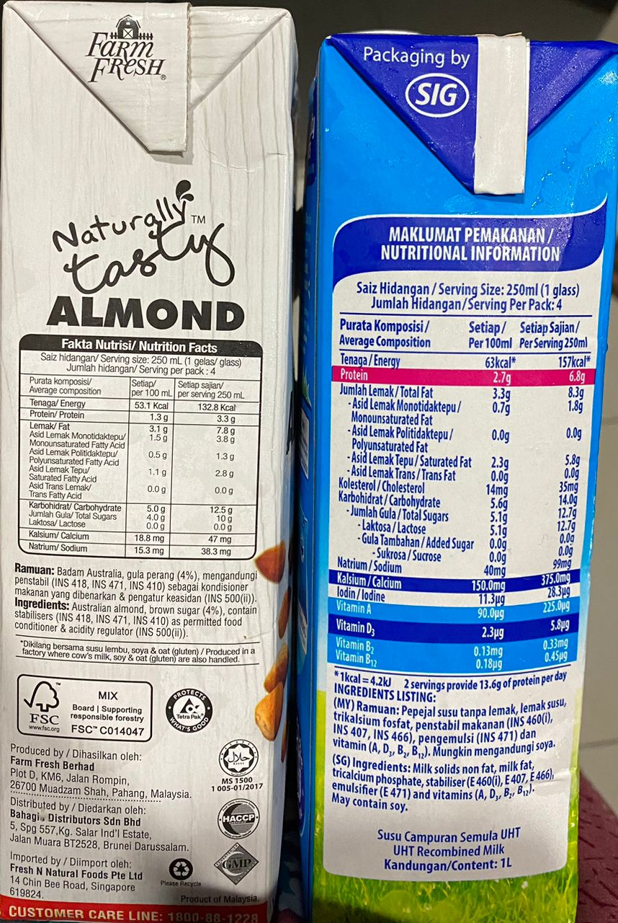(Taken by one of the member)

By examining the nutritional information from the above picture of almond milk and dairy milk, we can better understand their differences. Dairy milk has notably more protein and typically has higher calorie content. For example, 100 ml of cow's milk has about 3.4 g of protein, but just 0.5 gram in almond milk. In this case, the almond milk pictured has 0.7 g of protein per 100ml, which is much lower than the 2.7 g found in dairy milk. Furthermore, dairy milk provides a complete protein source, including all essential amino acids, which is frequently regarded as a vital nutritional benefit. In contrast, almond milk contains fewer calories, with 53.1 kcal per 100ml compared to 63 kcal in dairy milk. Likewise, plant-based milks are commonly fortified with vital vitamins and minerals, oftenly Vitamin D.

Next, plant-based milk alternatives provide a varied range of options for those with dairy allergies or lactose intolerance, and the drive for consumers to purchase them often stems from their lactose-free nature. The selection is significant given that lactose intolerance affects an estimated 36% of the US population.
Unlike cow's milk, which comprises lactose as its main carbohydrate, plant-based drinks are sweetened with sucrose and glucose. Interestingly, the carbohydrate composition differs amongst plant-based choices; some are higher in sucrose, while others are higher in glucose. Additionally, soy milk is the most popular plant-based milk among consumers who are lactose intolerant and allergic to milk protein, owing to its cardiovascular health benefits.

One can argue that plant-based milk may be perceived as more expensive than dairy milk, especially for those with lactose intolerance. The difference in prices could be due to the high production cost for manufacturing and processing of the plant-based milk and it is significantly more expensive. However, it is also worth noting that while many plant-based milks are significantly more expensive than regular dairy milk, they may be more affordable than lactose-free milk, which can cost 50% more than regular milk.

Although plant-based milks have different nutritional qualities from dairy milk, people with dietary constraints like lactose intolerance can greatly benefit from them. Ethical consumption entails making well-informed decisions that take into account individual health needs, making sure that selections are in line with dietary guidelines and general wellbeing.

Agribusinesses
The commodification of agribusinesses in plant-based milks is a trend driven by shifting consumer preferences and environmental awareness. As a result, plant-based milks have become highly marketable commodities, currently a $13.24B market but predicted to expand into a $30.79B market by 2031.
Marketing strategies also play a crucial role in the commodification process. Plant-based milks are positioned as premium products, frequently marketed with health claims and environmental benefits. This positioning allows companies to charge higher prices compared to traditional dairy products, retailing at nearly double the price of dairy milks. A study based in Walmart revealed that whilst traditional milk retails at 2c per ounce, almond milk retails at 4c and oat milk at 6c. This price affluence is supported further by the extra charges brought in at cafes. Brands have invested heavily in branding and advertising, highlighting the nutritional benefits and lower carbon footprint of their products, with Califia Farms stating in an advertisement “good for you products that are also good for the planet.” This marketing not only attracts health-conscious consumers but also taps into the growing market of environmentally conscious buyers who are willing to spend the extra money for a more ethically viable option. A key feature of marketing strategy is social media engagement which targets younger and more conscious consumers with campaigns such as ‘veganuary,’ prompting a noticeable shift towards alternative milks in gen z consumers with a 35.7% increase in consumption since 2013.
Innovation and product diversification are also central to the commodification process. Companies are continuously developing new flavours and formulations to cater to diverse consumer tastes. This includes fortified versions with added vitamins and minerals, barista blends tailored for coffee shops, and different flavours. The variety and versatility of plant-based milks have far surpassed those of traditional dairy, enabling agribusinesses to capture a larger market share and meet the needs of various consumer segments.There are growing concerns about preservatives used to increase product longevity and its potential health impacts, consumers consume more manufactured preservatives than ever before and demand is growing for natural products.

(Stock image)

Conclusion

Ethical consumption involves more than simply making a purchase decision on plant-based over dairy; it involves an extensive approach that takes into account production ethics and sustainability. Consumers can drive demand for more responsible and sustainable products by supporting brands that prioritise organic, fair trade, and non-GMO practices. This presents a promising opportunity to reduce the environmental impact of our dietary choices, particularly in terms of resource consumption and greenhouse gas emissions. This consumer-driven change has the potential for encouraging the agricultural industry to embrace environmentally friendly methods while also promoting social equity. As the plant-based milk market grows, fueled by health and environmental motivations, it is essential to remain vigilant about the broader impacts of these products. By making informed and responsible choices, consumers can contribute to a more sustainable food system that supports long-term environmental health and social responsibility.

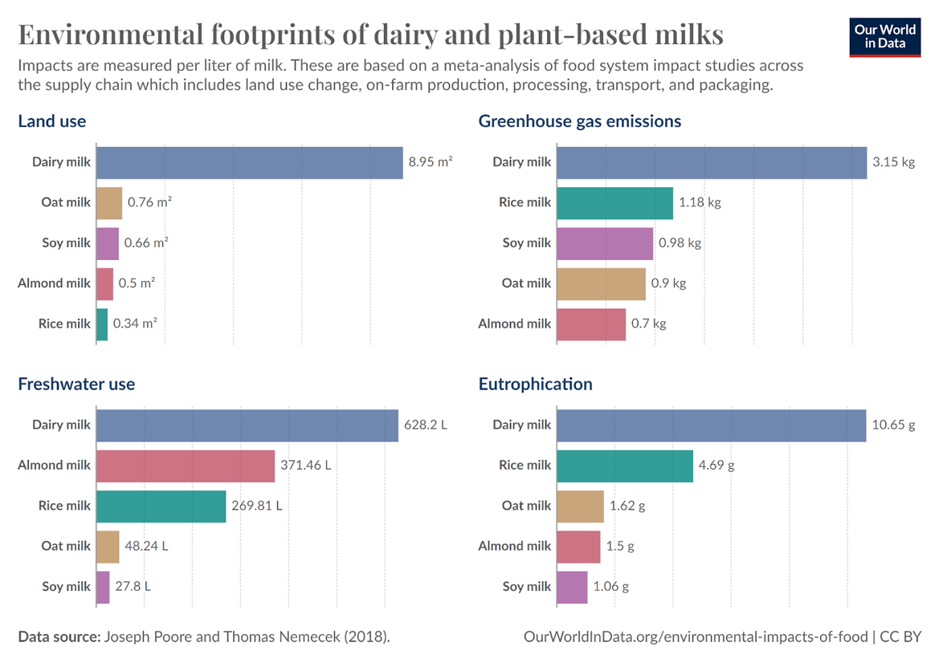

Research

Environmental - Ethical Consumption (Lupo) - 430 words
- One of the largest concerns about alternatives such as soy milk is that they drive deforestation in the Amazon region. It’s true that the growing demand for soy has been one of the drivers of Brazilian land-use change. Although, by far, the largest driver has been pasture for beef production.
- 95% of Brazilian soy is used for animal feed. Globally, more than three-quarters of soy, by mass, is used for animal feed. The other main co-product is soybean oil. This means that very little of Amazonian land-use pressures from soy have been driven by crops for direct human consumption; most is for animal feed.

Nutritional - Ethical consumption (Aziqah) - 430 words
- Dairy milk tends to be higher in calories, and importantly, contains more protein. 100ml of cow’s milk will contain around 3.4 grams of protein, versus 0.5 grams in almond milk. The protein in dairy is also a more ‘complete’ protein source, which means it has the full profile of essential amino acids.

- One of the benefits of plant-based milks is that they are often fortified with vitamins and minerals. Vitamin D, for example, is often added. Cow’s milk naturally contains very little vitamin D, although it is possible to buy fortified varieties. Vitamin B12 is one micronutrient that only occurs in animal products; vegans are therefore at risk of deficiency without supplementation. However, most plant-based milks are now fortified with vitamin B12.

- Unlike milk, whose sole source of carbohydrate is lactose, plant-based drinks contain sucrose and glucose as the main types of carbohydrates. Most plant-based drinks with high sucrose concentrations had low glucose contents and vice versa,
- All plant-based milks are preferred over cow’s milk by consumers who are lactose intolerant or are allergic to milk proteins because of their common benefits of being lactose free, cholesterol free and low in calories.
- In the USA, an estimated 36% of people have lactose intolerance with higher prevalence among African Americans, American Indians, Asian Americans, and Hispanic/Latinos
- It was also popular amongst the populations who are allergic to milk proteins and are lactose intolerant -
- Soy milk was widely consumed as the alternative for cow’s milk especially in the populations suffering from milk allergies and lactose intolerance.
- which are considered good for cardiovascular health. It serves as an inexpensive, refreshing and nutritional beverage to the consumers.which are considered good for cardiovascular health.
- Lactose-free milk is the most expensive of the dairy milk categories—on average, it cost more than any of the plant-based milk
- Many plant-based milks are significantly more expensive than dairy; however, for those with lactose intolerance, they may be more affordable than lactose-free milk, which may cost 50% more than milk.
- Lactose-free milk is the most expensive of the dairy milk categories—on average, it cost more than any of the plant-based milk alternatives represented in the Nielsen purchasing data and 150% that of dairy milk.

Agrobusiness/Production - Commodity (Anishika) - 430 words
- Different purchasing patterns for dairy and plant-based milks impact affordability especially for financially constrained households. Many plant-based milks are significantly more expensive than dairy; however, for those with lactose intolerance, they may be more affordable than lactose-free milk, which may cost 50% more than milk.

Pictures

