Travel allows us to witness the stunning beauty of diverse places around the world, from serene beaches to bustling cityscapes. However, this joy of exploration comes with a significant downside. The travel and tourism sector, while contributing a substantial 9.1% to the global GDP in 2023, poses a serious threat to our environment. According to Green Choices, travel is one of the greatest environmental threats, primarily due to greenhouse gas (GHG) emissions from the aviation industry. Tourism is responsible for 8% of global GHG emissions. Despite its economic benefits, including job creation and integration into the global supply chain, it is crucial to address the environmental cost. To ensure the continued growth of the tourism industry without compromising our planet, we must adopt sustainable travel practices. We'll explore three ways you can travel more sustainably: eco-tourism, carbon emissions offsetting, and global environmental projects. Additionally, we'll discuss how governments can support and encourage sustainable tourism through potential regulations and subsidies.
1. Ecotourism destinations

One way to make your travel more sustainable is to choose destinations which focus on protecting the environment: ecotourism empowers local communities, fosters cultural exchange, and educates visitors about the importance of safeguarding our planet's biodiversity. We detail two of the top destinations for sustainable travel below.

Our first recommendation is Costa Rica, where travellers are offered a unique opportunity to explore the wonders of nature while fostering its preservation. Ecotourism has become the cornerstone of the country's tourism industry, attracting visitors who want an immersive and responsible travel experience. This sustainable approach prioritises minimising environmental impact and maximising positive contributions. One might stay at an eco-lodge constructed from local materials, powered by renewable energy, and blending seamlessly into the surrounding landscape. Profits from tourism directly support local communities, providing employment opportunities and encouraging the protection of natural resources. By choosing ecotourism in Costa Rica, one becomes an active participant in environmental conservation, ensuring that future generations can experience the magic of this ecological paradise.
https://www.youtube.com/watch?v=F0g_9kA01SM&pp=ygUNY2h1bWJlIGlzbGFuZA%3D%3D
Our second recommendation is a Zanzibari island called Chumbe. This island is dedicated to sustainability, with the profits it makes from visitors being invested in its Coral Reef Sanctuary and Forest reserve. Additionally, like the locations in Costa Rica, the accommodation was designed with sustainability in mind: the island hosts 7 bungalows which are fully powered by solar energy, and were made using eco-friendly, sustainably sourced materials. Of course, with this island only containing 7 bungalows, each just with a double bed, it is not a full solution for ecotourism as it gets fully booked quickly.
If other locations can be inspired by this model, then there could be many more sustainable travel options. Although companies may initially be reluctant to set up places like this instead of traditional hotels due to the potential for lower profits, governments could use subsidies to incentivise more destinations like this to be set up. Governments could subsidise companies to make their accommodation eco-friendlier, or lessen taxes for those that want to invest their profits into local biodiversity.
2. Carbon Emissions Offsetting
An alternative to ecotourism is emissions offsetting. Offsets are a cheap alternative to reducing the use of fossil fuels in aviation, directly tackling the most polluting part of travelling. Offsetting is frequently available at check-out when purchasing flights, with travellers being asked to pay more to compensate for their flight’s emissions, which is then used to reduce emissions elsewhere. This leads to a short-term net reduction in the impacts of emissions. Despite its positive impacts, offsetting isn’t immune to criticism: it is commonly referred to as greenwashing - travel has wider impacts on emissions than flight emissions alone. Major companies are taking advantage of it and setting a financial scheme within the capitalist world. Airlines emit in their business operations more generally, and many offsetting programs that they fund lack quality or transparency. For instance, Virgin Atlantic had the Oddar Meanchey offset program in its portfolio, yet the forests supported by the project were cleared by the Cambodian military, rendering the offsets useless. Forest offsets only work if trees remain intact for a century, as trees store carbon by incorporating it into their tissue as they grow. Thus, offset purchasers reap the moral benefits immediately, but the debt is not yet repaid, and it sometimes never is. One option climate-conscious travellers have is to spend more money on a flight that emits less CO2, using sites like Kayak, Momondo, and Skyscanner to find and compare the emissions of these flights. Of course, this does not eliminate emissions entirely, and it’s important to keep in mind that many cannot afford to travel consciously due to high costs. Evidently, flights make up the majority of travel-related emissions, but the world lacks infrastructure for flight-free travel and this is impossible in many cases, such as from coastal countries like Australia. So, how do we travel in an eco-friendlier way if carbon offsets are so flawed?
3. Global environmental schemes
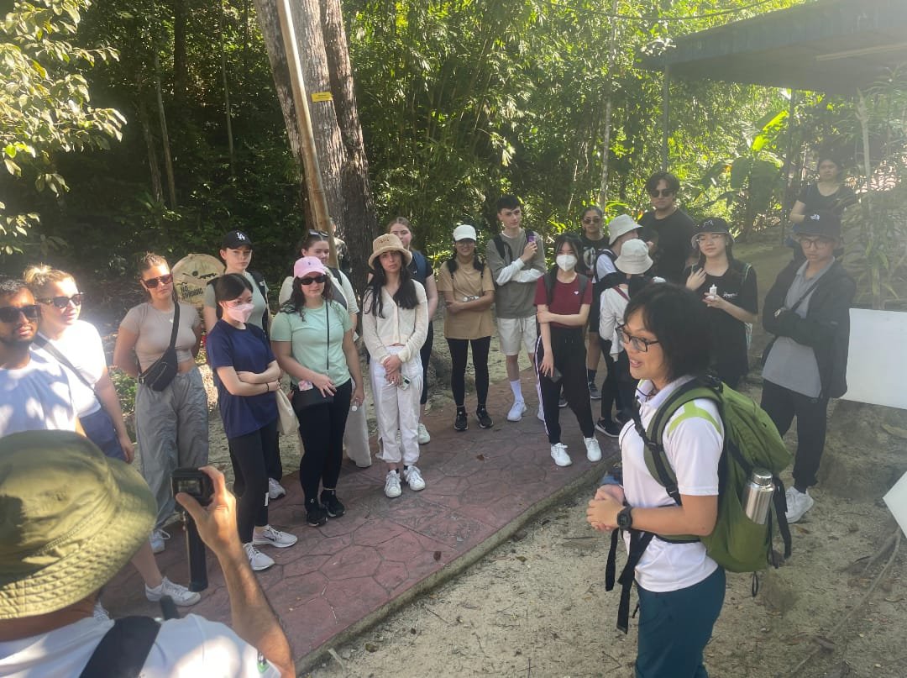
Programs like Journeys for Climate Justice (JCJ) work as alternatives to carbon offsetting, as traveller participants donate the money they would be spending on emissions offsetting, specifically to aid climate change mitigation projects. Rather than merely paying off one aspect of travel, volunteers are able to holistically make a difference, addressing the impacts of climate change themselves. JCJ allows donors to fund projects that lead to long-term behavioural change in the Indo-Pacific region, and allows volunteers to help run events. For instance, instead of simply planting trees to directly offset emissions alone, JCJ donations support young leaders in climate change-affected communities with less opportunities to combat environmental and climate injustice. Projects include adaptation for climate refugees, leadership camps, and community engagement and education programs. Donors can also sponsor youth leaders for Yathra training programs. By funding projects like this, tourists are able to make a real, measurable, and lasting impact on the effects of climate change.
There are many similar volunteer programs making a substantial impact globally. You can find projects in all countries that need volunteers to help preserve the local wildlife and biodiversity. So, whether you choose to take up a volunteer opportunity abroad instead of just travelling for leisure, or you choose to donate money to these projects, you will be helping the fight against climate change!
4. Government Regulation & Schemes
Combatting the impacts of travel on climate change cannot merely rely on well-meaning citizens’ efforts. Governments and enterprises play a significant role in causing GHG emissions. Of course, governments prefer to rely on fossil fuels due to the money raked in by non-renewable resources and lobbying, and take advantage of dodgy carbon offsetting schemes, and airlines use carbon offsetting as it is cheaply available. Hoteliers prefer to remain less eco friendly for the same reason - environmentally friendly changes do not necessarily attract more guests, and are expensive, such as implementing solar panels or providing guests with visitor education partnership tours. Governments should implement regulations and subsidies to incentivise tourists and make it easier for them to choose to lower their impact on climate change when travelling, and make it more profitable for airlines and hotels to implement eco-friendly schemes. With strict regulation, it is also less likely that airlines will be contracting with dodgy offsetting projects. In terms of government intervention to encourage the aforementioned volunteer and ecotourism programs, we would recommend subsidies for people who want to get involved as they can be quite expensive, especially if you need to pay for flights and/or accommodation. Furthermore, states could encourage similar projects to be set up locally, so that their citizens can make a difference without having to travel miles away, by offering funding or tax relief for these companies, as has been done in Queensland. Local governments are also key to providing sustainable tourism, as they have moved away from their traditional neoliberal role of providing basic infrastructure, to taking an active role in policy and management strategies, such as the implementation of the Sustainable Planning Act 2009 in Queensland, which requires accountability with regard to the minimisation of negative environmental impact in development. Similar regulations should be passed in all states. It must be noted that sustainable tourism agendas tend to face criticism due to their focus on economic outcomes and marketing rather than actionable, real impact on the environment - a problem that has cropped up throughout this entire blog post.
Conclusion:
Choosing ecotourism destinations instead of traditional ones, carbon offsetting flights, and participating in or donating to climate-related projects are all key ways that you can travel without harming the environment, thus we recommend all three of them. However, due to the issues associated with carbon offsetting, our other recommendations may be comparatively better in terms of making your travels more sustainable. We also recommended government intervention to make all three of these solutions more commonplace, feasible and accessible. This cannot be overlooked in the fight against climate change, as the burden cannot rest merely on citizens.

