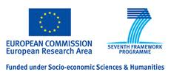
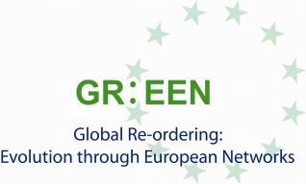

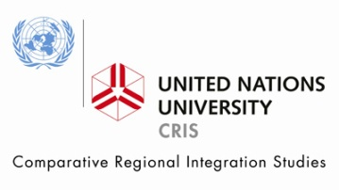

CALL FOR PAPERS
Workshop on “Quantitative Indicators of European Power”
Workshop on “Indicators of Regional Influence”
Bruges, March 26-27th 2012

Context and Purpose of the Workshop on “Quantitative Indicators of European Power”
This workshop is part of WP2 “The European Union and Global Governance: Multilateralism in an Emerging Multi-Polar World”, and more specifically, of Sub-WP 2.2.1 “Quantitative Indicators: European Power through a Taxonomy of its Multilateral Capacities”. The workshop will be followed by a CSIF, to be organized by ULB in Month 24.
Based on the work package description, the aims of the workshop are:
- To clarify the measurable dimensions of power in an inter-regional and global context;
- To contribute to the assessment of power in (international) networks;
- To develop a comparative set of indicators to monitor and assess European power in a inter-regional and global context;
- To quantitatively assess Europe’s relative position in international institutions (multilateral organizations and transnational networks);
- To discuss availability and quality of relevant data on resources invested by the EU in international organizations and networks; be they financial, political, human, regulatory or military;
- To present cost-benefit analyses of EU external policies.

Synergies will be sought with sub-workpackage 3.1 of WP3 because of the substantial linkages with sub-workpackage 2.2.1.

Context and Purpose of the Workshop on “Indicators of Regional Influence”
This workshop is part of WP3 “The Role of Regional Leadership in Multi-Polarity: the EU, the Americas, Asia, Africa & the Pacific”, and more specifically, of Sub-WP3.1 “An Assessment of Regional Influence”. Although in the original proposal a CSIF was foreseen to start the activities of sub-WP 3.1, it is suggested to start with a closed workshop in order to have a parallel development as sub-WP 2.2.1. For the same reason, the workshop will be followed by a CSIF (originally foreseen as a workshop in Month 21), organized by ULB.
Based on the Work package description, the aims of the workshop include:
- To clarify the (measurable) dimensions of power, hegemony, leadership and influence in a regional context;
- To contribute to the assessment of regional centrality and power in various types of (international) networks;
- To develop a comparative set of indicators to monitor and assess the power of regional leaders (especially the BRICs) in their respective regions;
- To develop a comparative set of indicators to monitor and assess regional leadership (especially of the BRICs) in international organizations;
- To quantitatively assess the long-term dynamics of regional leadership;
- To discuss availability and quality of relevant data on resources invested by the BRICs in regional organizations and networks; be they financial, political, human, regulatory or military;
- To apply modelling techniques to analyze regional leadership.

Synergies will be sought with sub-workpackage 2.2.1 of WP2 because of the substantial linkages.

Submissions and participation
Participation in these workshops is restricted to researchers affiliated to one of the GR:EEN partner institutions and selected invited experts. Researchers affiliated to GR:EEN are invited to submit a one-page abstract by December 5th to: pdelombaerde@cris.unu.edu and mzwartjes@cris.unu.edu. Please add affiliation and short bio and indicate to which workshop(s) you are submitting your abstract(s). Selected authors will be notified by December 15th. Depending on the number of submissions, we will be in a position to cover travel and accomodation expenses of one or two participants per GR:EEN partner institution. Additional participants and non-paper presenters are welcome but expenses will not be covered by the organizers.
Lead academic contacts: mtelo@ulb.ac.be and pdelombaerde@cris.unu.edu.
For practical information, please contact: mzwartjes@cris.unu.edu.

