Registering for Seminars of MyPaIS

For the 2012/13 academic year, undergraduates are required to sign up for seminars on the department portal MyPaIS:

https://mypais.warwick.ac.uk/index.php?

Important Information before you start:

You will need to have already registered for your optional modules on EMR (the module registration system), which is done by logging into MyWarwick. You will automatically be enrolled onto core modules. The MyPaIS system needs to update over-night once you have registered for your modules on EMR, before the relevant seminars become available for you to sign up to on MyPaIS.

Seminars in MyPaIS are allocated on a first come, first served basis.

Choose you seminar carefully. If you need to alter your seminar you will need to visit the PaIS Office, Room S1.45 in the Social Studies building to see if there is any space in an alternative seminar. If the seminars are full, you will be responsible for finding someone willing to swap seminar places with you.

Attendance is recorded at seminars. Do not attend the wrong seminar or your attendance will not be recorded. Failure to attend your allotted seminars can lead to disciplinary action.

Legitimate absence from a seminar must be condoned by your seminar tutor (for example; sickness).

For 2nd and 3rd Year Students seminars will become available for you to sign up to on MyPaIS at approximately 11AM on Friday 28th September.

For 1st Year Students seminars will become available for you to sign up to on MyPaIS at approximately 11AM on Monday 1st October.

Continued….
How to select your seminars.

Go to the MyPaIS portal. This can be done by going to the PaIS webpage:

http://go.warwick.ac.uk/politics

In the green Current Students box, select the top link, “Undergraduates”. You will need to sign in using your Warwick Username and Password to view this page. Once logged in, the same credentials will be used to automatically log in to MyPaIS. On the left hand side of this page is a link to the MyPaIS portal.

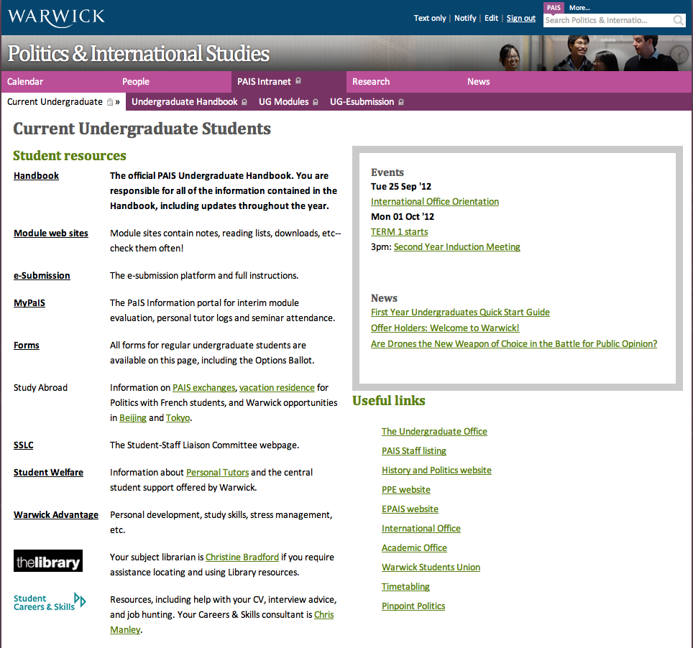

Continued….
Once you have successfully logged into the MyPaIS portal, you will need to click on the “Teaching” link across the top. This will then display the teaching links down the left hand side – select the “My Seminars” option:

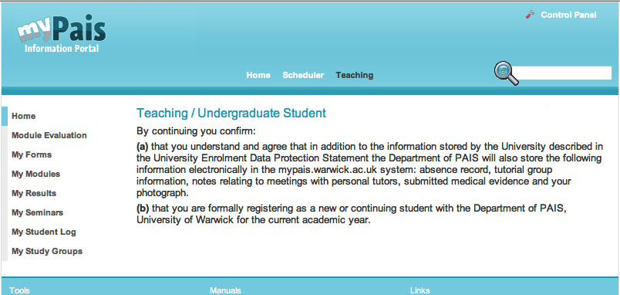

From the “My Seminars” page you will need to click on the “Registration” option. This will show a list of seminars that are available to you, according your module registration on EMR. In the example below there is one module to join, PO380, but you may see multiple modules. To view the available seminar times for a specific module, click on the module code:

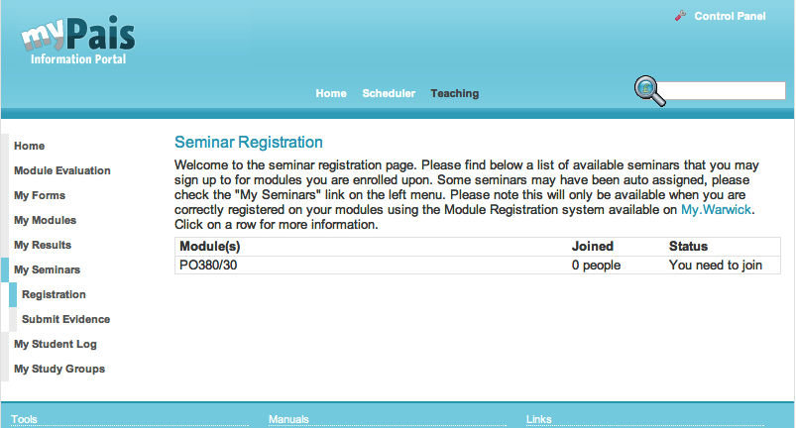

Continued….
To view which seminar groups are available for the module, click on the “View Groups” link. Taking note of the weekly time slot and location, choose the seminar that you wish to join by clicking the “To join this group click here” link:

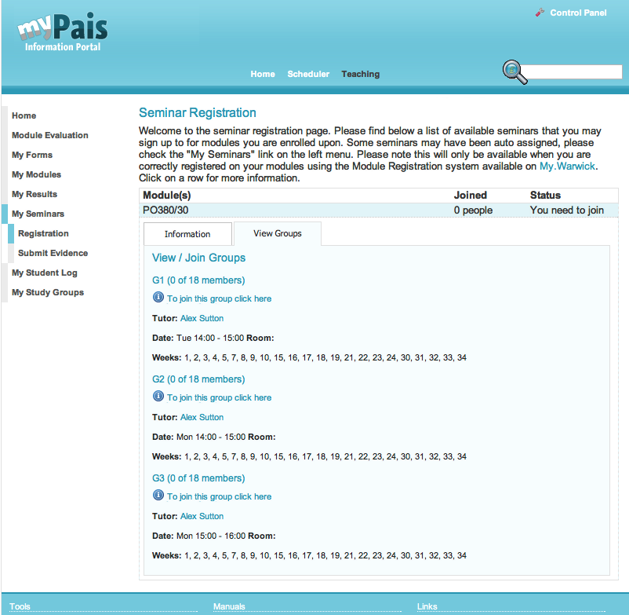

You will receive conformation of joining the seminar.

To refresh the page and register for your next seminar, click on “Registration” link under the “My Seminars” link on the left hand side.

You can return to MyPaIS to monitor your seminar attendance.

Remember to log out of MyPaIS once you have finished using the portal.

Finish.

