Seminar 2
Week 3- Lecture 2
Realism
Saadia Gardezi

Hans Morgenthau (1948):
The principles, paraphrased:

- Political realism believes that politics, like society in general, is governed by objective laws that have their roots in human nature.
- The main signpost of political realism is the concept of interest defined in terms of power, which infuses rational order into the subject matter of politics, and thus makes the theoretical understanding of politics possible. Political realism avoids concerns with the motives and ideology of statesmen. Political realism avoids reinterpreting reality to fit the policy. A good foreign policy minimizes risks and maximizes benefits.
- Realism recognizes that the determining kind of interest varies depending on the political and cultural context in which foreign policy is made. It does not give "interest defined as power" a meaning that is fixed once and for all.
- Political realism is aware of the moral significance of political action. It is also aware of the tension between the moral command and the requirements of successful political action. Realism maintains that universal moral principles must be filtered through the concrete circumstances of time and place, because they cannot be applied to the actions of states in their abstract universal formulation.
- Political realism refuses to identify the moral aspirations of a particular nation with the moral laws that govern the universe.
- The political realist maintains the autonomy of the political sphere; the statesman asks, "How does this policy affect the power and interests of the nation?" Political realism is based on a pluralistic conception of human nature. The political realist must show where the nation's interests differ from the moralistic and legalistic viewpoints.

Critique?
Is it true that states, whatever their regime, pursue the same kind of foreign policy, amounting to no more than the struggle for power?
If one answers yes, then the proposition (put forth by Morgenthau) is incontestable, but not very instructive.

E.H. Carr:
According to the idealists, war is an aberration in the course of normal life and the way to prevent it is to educate people for peace, and to build systems of collective security such as the League of Nations or today’s United Nations. Carr challenges idealism by questioning its claim to moral universalism and its idea of the harmony of interests. He declares that “morality can only be relative, not universal” (19), and states that the doctrine of the harmony of interests is invoked by privileged groups “to justify and maintain their dominant position” (75).

K. Waltz:
- Competition spawned by the structure of the international system conditioned states to emulate the successful practices of others- converge = Balance of power
- Balancing as a form of alignment that “occurs when a state brings its policies into close cooperation with another state in order to achieve mutual security goals.
- In international politics, states will observe what the strong states do and emulate them. This process of emulation will lead to a convergence of capabilities, which will result in a balance being formed between the Great Powers.
- Does Waltz’s theory work? Stephen Walt‘s challenge: Statesmen consider factors other than capabilities in foreign policy. “Rather than allying in response to power alone states will ally with or against the most threatening power.” Balance of power or balance of threat?

Does the world need a hegemon?

Prisoners’ dilemma and realism:

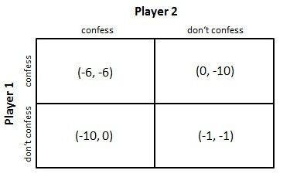
- List and discuss events in recent history that could be used as an example of the classic prisoner’s dilemma.
- Think of the liberal variants to the prisoner’s dilemma. Do you think that one of the factors—striving for mutual goals, trust built by interaction, etc.—would be more effective at changing the outcome of the game than the others? Think of real-world examples in international affairs to support your claim.
- Recall the “anarchy is what states make of it” argument. Do you support this notion? Why or why not? If so, do you think the world is becoming less anarchical?
- Clean air is usually listed as the archetypal collective good, but think of others. Are international institutions or mechanisms in place to protect or provide these collective goods?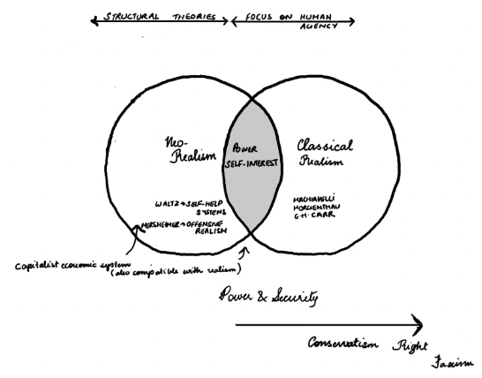
Presentation next week:
The problem with Liberalism.

