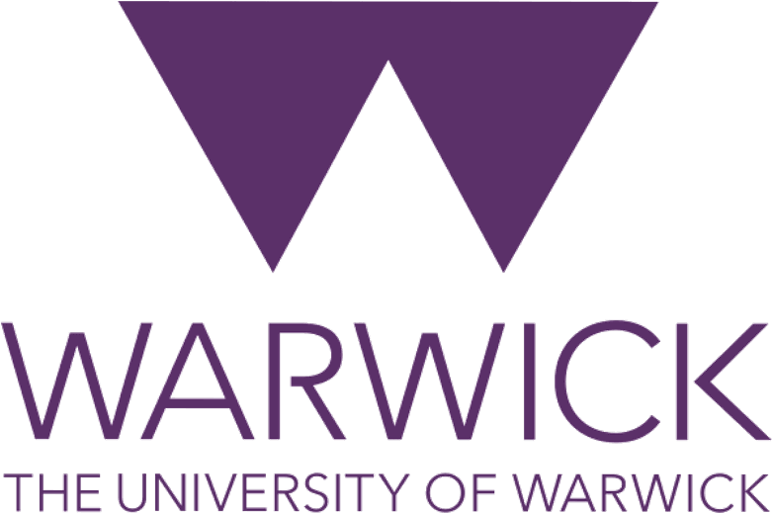

Warwick Philosophy Postgraduate Conference

Saturday 28th September 2024
Room: S0.21

10:30AM-11:30AM
Eve Poirier, “'Anti-Anti-Empathy: Art as Imagination Under Constraints'”
Commentator: Eliza Little

11:45AM- 12:45PM
Lumeng Liu, “On the Essential Indexicality of ‘You’ Thinking”
Commentator: Hemdat Lerman

12:45- 1:45PM
Lunch

1:45AM-2:45PM
Fridolin Neumann, “Heideggerian Intentionality, Being, and Entities”
Commentator: Andrew Huddleston

2:45PM-3:15PM- Break

3:15PM-4:15PM:
Emily Boocock, “Making Sense of Extremist Groups”
Commentator: Lorenzo Serini

