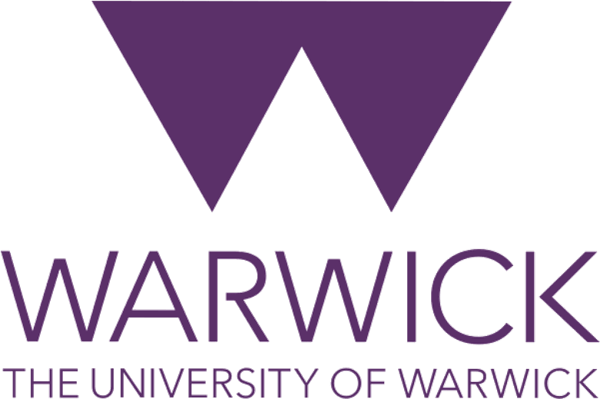

Warwick Philosophy Postgraduate Workshop

Friday 3rd October 2025
Room: MS0.3

10:30AM-11:30AM
Ignacio Pena Caroca “Intentions and Mental State Theories of Consent: Discussing the ‘Decision Model’”
Respondent: Nadine Elzein

11:30AM-11:45AM - Pause

11:45AM- 12:45PM
Ying Xue, “Two Challenges to the Banality of Evil and a Solution in Kant’s Religion.”
Respondent: Tim Stoll

12:45PM-1:45PM – Lunch (Provided)

1:45PM-2:45PM
Sebastian Leyton Blanco, ‘Foucault in Iran: Political Spirituality and Emancipatory Transformation’
Respondent: David James

2:45PM-3:15PM- Break

3:15PM-4:15PM
Chris Hall, “Cetacean minds and the case for methodological pluralism in comparative cognition”
Respondent: Lucy Campbell

