ELIZABETH AND VINCENT MEYER

THE CENTRE FOR RESEARCH IN PHILOSOPHY, LITERATURE, AND THE ARTS

UNIVERSITY OF WARWICK

SYMPOSIUM AND CONCERT

14 JANUARY, 2011
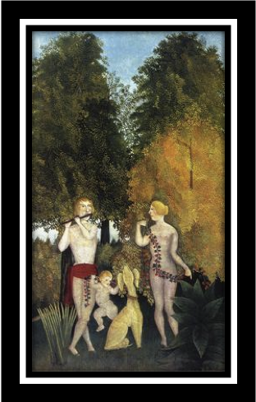  Happy Quartet, Henri Rousseau (1902)  by permission of ARTSTOR | THE FIGURE OF FOUR  MUSIC, PAINTING, LITERATURE, POETRY  For further information, please contact:  Lydia Goehr (lg131@columbia.edu)  Miguel Beistegui (m.j.beistegui@warwick.ac.uk)
CHAIR: MIGUEL BEISTEGUI  (Philosophy, University of Warwick)  10.00-11.00 LYDIA GOEHR  (Philosophy, Columbia University, New York and Elizabeth and Vincent Meyer Visiting Professor in the Philosophy of Music, Warwick University)  “PARAGONAL FIGURES OF FOUR”  11.15-12.15 MARTIN WARNER  (Philosophy, University of Warwick)  “T. S. ELIOT'S FOUR QUARTETS AS QUARTETS: FOUR VOICES IN THE CONVERSATION OF MANKIND” | CHAIR: SIMON SHAW-MILLER  (History of Art & Music, Birkbeck College)  1.30-2.30 GABRIEL JOSIPOVICI  (Novelist and Critic)  “HOW TO MAKE A SQUARE MOVE”  2.45-3.45 CHARLOTTE DE MILLE  (Courtauld Institute of Art, London)  “VIRGINIA WOOLF’S “QUARTET”, HER SISTER, AND KANDINSKY”
6.00-7.00 PRECONCERT TALK CHRISTIAN THORAU  (Institut für Musik, University of Potsdam, Germany) “LISTENING TO FOUR. THE VERY IDEA OF A STRING QUARTET CONCERT”  Venue: The Creative Space at the Arts Centre, The University of Warwick | 7.15 COULL QUARTET  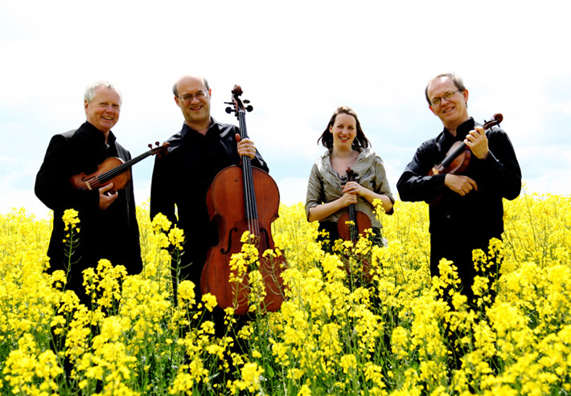  (Quartet-in-Residence, University of Warwick)  Franz Schubert Quartettsatz  Anton Webern Quartet, Opus 28  Hugo Wolf Italian Serenade
Post-Concert Reception, hosted by Warwick Institute of Advanced Study

