APA Pacific Division Meeting
30th March-2nd April, 2016, San Francisco
Phil Gaydon

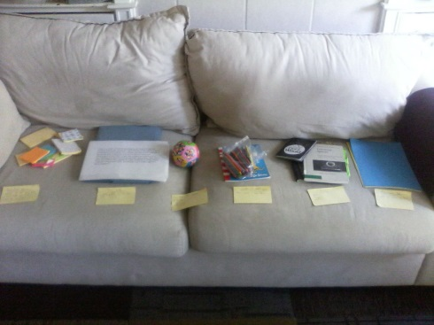
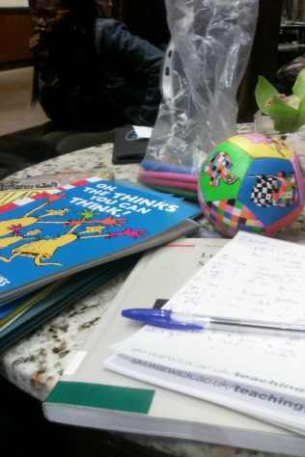
For the above dates I attended the APA’s Pacific Division meeting in San Francisco. The APA Division meetings are impressively large conferences that bring together philosophers from around the world and cover an array of philosophical topics. Indeed, parallel sessions ran from 9am until around 10pm on every day of the schedule. As part of this conference I presented a session at the American Association of Philosophy Teacher’s track entitled ‘All Philosophy begins in Wonder’; these pictures are from my talk in planning. This was a practical session which showcased several tasks that I use during philosophy sessions in universities and schools. These tasks, amongst other things, attempt to spark a sense of wonder in students and are scaffolded to facilitate their transition from that sense of wonder to wondering and then on to philosophising. I take this route to philosophising with my students as I believe it heightens motivation and engagement by personalising the module and grounding it in the student’s own, intuitive sense of what is interesting, important, and worthy of attention in the world.

Amongst the plethora of sessions and talks at the conference, the ones which I found particularly useful were: the panel on the philosophy of science in high school curricula which introduced me to more stimuli for philosophy of science sessions and helped me develop my arsenal of buzzwords and ideas when making arguments for increased primary and secondary school philosophy based upon current curricula and educational standards; a talk by Amy Kind on imaginative vivacity which will be very beneficial for adjusting the philosophy week I teach on the IATL ‘Applied Imagination’ module; a talk by Yujia Song on open-mindedness as a moral virtue (open-mindedness as an intellectual virtue is a core concept of my PhD and so how Song attempted to distinguish the moral and intellectual values was stimulating); a panel on childhood and autonomy which introduced me to some texts and concepts (as well as an academic vocabulary) which will be useful for my ‘Ethical Beings’ module as students on that module often feel that autonomy is an end that should be aimed at when raising children but find it difficult to defend why; and, of course, the other talks given alongside my own – particularly Chad Mohler’s talk on ‘Mapathon’ which I’m sure is a technique and app I can use in my own teaching in exciting ways. I also relished the opportunity to engage with more Eastern philosophy (particularly the panel on disgust and shame) as this is something that appears to be lacking in British philosophy courses.

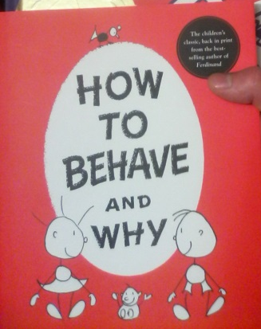
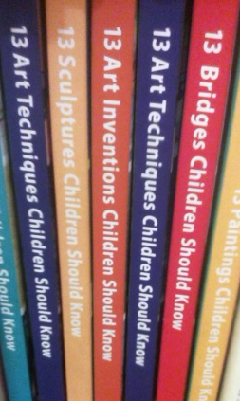
Outside of the conference, a trip to City Lights Bookstore revealed some fantastic finds which I will be using on my ‘Ethical Beings’ module. How to Behave and Why is billed as needing a contemporary reprint due to its subtle but timeless lessons yet, given that review, many will be struck by its overt didacticism. And finding a series of books based upon taking a list of 13 things from a given area that children should know is going to set any philosopher of childhood and education thinking!

