My first term at the University Of Warwick studying Sociology

By Geraldine Asare-Darko
First Year Sociology Student

My first term at Warwick being a Sociology student has been enjoyable, interesting and challenging. I am really enjoying learning about different aspects of Sociology. The modules I am currently undertaking include International Perspectives on Gender and Social Welfare In Britain which I have become really interested in, because I have been able to expand my knowledge on many topics such as patriarchal and feminist issues during the apartheid in South Africa and communist movements in China; to health policies during and after
World War 1.

Being a Sociology student at Warwick has enabled me to gain opportunities to broaden my horizon by participating in extra- curricular activities, adding some salt to my social life or preparing for the future. For example, the Sociology department have held events such as ‘What can you do with a degree in Sociology?’ where past and present students and staff spoke about their experience at Warwick and how studying Sociology has helped them reach their goals. In addition, the Sociology Society hold exciting events for students and also hook you up with a mentor which has been beneficial for me because my mentor has been able to give me advice on queries such as planning or structuring an essay.

I have been able to meet people from different cultures and countries around the world which has made the experience worthwhile, the staff are very friendly and the university as a whole is just brilliant.
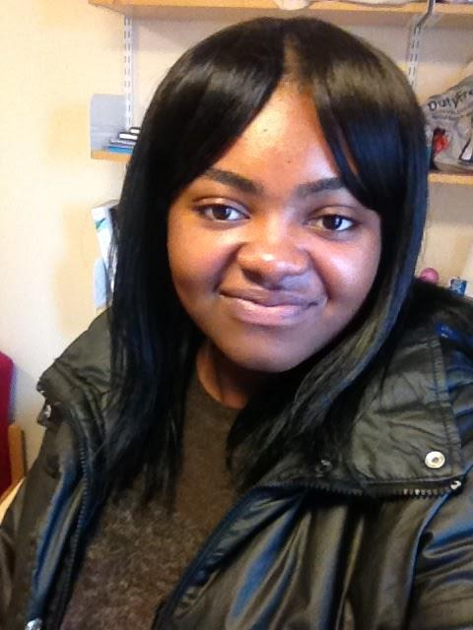
Studying Sociology so far has been...
Wicked, Active, Refreshing, Wonderful, Intellectual, Cool and Knowledgeable!

Geraldine Asare-Darko

