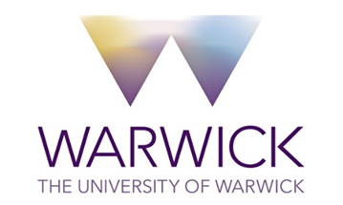

Are you in year 11?

Do you consider yourself as having a disability?

Do you have autism, dyslexia or cerebral palsy?

We would love to hear from you, if you answered ‘yes’ to all the above questions. We are a team of researchers at the University of Warwick who are looking into the post-16 educational transitions of disabled young people. We are interested in learning more about the work and educational pathways of young people at the age of 16.

Taking part in this study would involve participating in 2 interviews, one year apart. Each interview would take around an hour, and we would ask you questions about your experience at school, future ambitions and plans for after your GCSEs. The first interview would take place before your GCSEs and the second, a year after. This will allow us to see the various choices you made in the year after your GCSEs.

If you are interested in taking part or would like to find out more, please contact Dr Angharad Butler-Rees at
disabled.transitions@warwick.ac.uk or phone +44(0)24 765 22034.

Research Participants
Needed

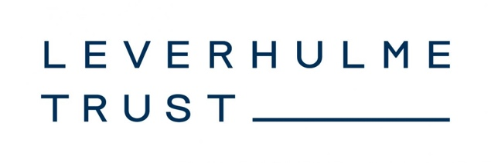

This project has been funded by the Leverhulme Trust.

